Fire History Studies in Union County

Fire’s interaction with the environment has played a significant role throughout history. Historical fire records indicate that prior to effective fire suppression, large fires frequented the Blue Mountains of eastern Oregon. Fire studies conducted in the Blue Mountains (Blues) of Eastern Oregon have demonstrated the frequent fire return intervals for the geographic area. The Blue Mountains extend over a large portion of eastern Oregon with 4,060 square miles of land mass. The Blue Mountains include the Strawberry Mountains, Elkhorn Mountains, Eagle Cap Mountains and many consider the Wallowa Mountains part of the Blues (Wikipedia, 2015). Although the Blues have an extensive geographic range, the primary focus for this plan will be study results near Union County.

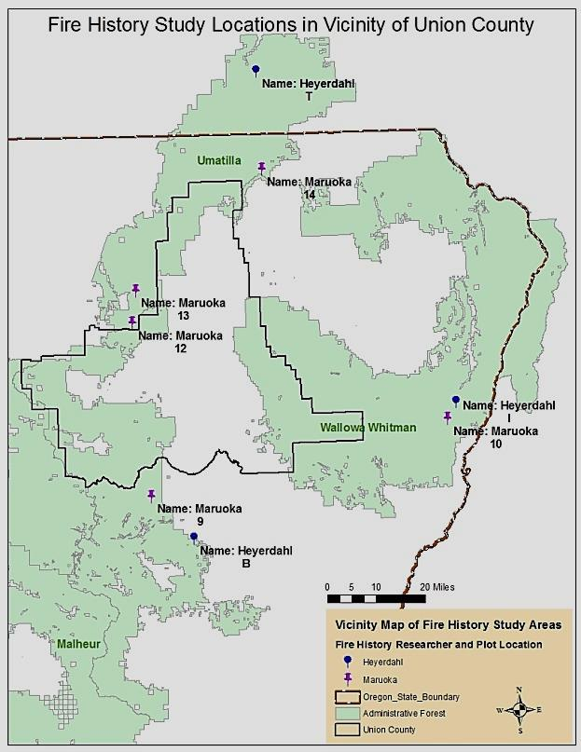
A study was completed in 1994 by Kathleen Ryoko Maruoka called, "Fire History of Pseudotsuga menziesii and Abies grandis Stands in the Blue Mountains of Oregon and Washington." At the time of her study little fire history studies had been conducted within the Blue Mountains (Maruoka 1994). Maruoka's study focused on mixed conifer where ponderosa pine is co-dominant with Douglas-fir and grand fir (Maruoka 1994). During the study she established 15 plots in the Blue Mountains. Out of 15 study plot site areas, 5 of sites were in relative close proximity to Union County with the closest at less than 2 miles from the county line just 7 miles west of Mount Emily. Elevation of the sites ranged between 3500 to 6000 feet. Maruoka analyzed the mean return interval between fire events. The 5
Figure Appendix B - 1. Fire history study plot locations for
Kathleen Maruoka and Emily Heyerdahl. Maruoka plots are numerical and Heyerdahl’s plots were alphabetical.
plots listed in Figure Appendix B - 2 displays finding results for this area.

Plot # | Plot Name | Total # Fire - Years Detected | MFRI  (years) | Range of Interval (years) | Most recent fire | Elevation  (feet)
9 | Anthony Burn | three –  from 1845 to 1877 | 16 | 4 – 28 | 1878 | 6000
10 | Imnaha River | fourteen -  from 1784 to 1913 | 9.9 | 2 - 29 | 1900 | 4200
12 | Spring Mountain | **seven –  from 1791 to 1976 | 30.8 | 18 - 68 | 1977 | 3500
13 | Finley Sale Area | five –  from 1800 to 1899 | 24.8 | 9 - 39 | 1900 | 4000
14 | Troy | eleven –  from 1746 to 1940 | 19.4 | 5 - 36 | 1941 | 4990
Figure Appendix B – 2. Kathleen Maruoka plot findings in close proximity to Union County**
Site 12 was in proximity to Whitman Trail and the recorded fire in 1977 maybe part of a harvest operation. (Maruoka 1994)

Two years later in 1996 Emily Heyerdahl studied fire history in northeast Oregon providing results for both fire intervals as well as an estimated large fire sizes. Three of the four areas were in relative close proximity to Union County. During the time span of 1687 through 1994, these sites revealed that the median fire intervals were 23, 25, and 11 years for Tucannon, Imnaha, and Baker respectively. Between 1687 and1994 every site experienced 13 or more fires ranging from 1000-4999 acres in size and the Baker site experienced 12 or more greater than 5000 acres. Fire size estimates were considered conservative largely due to the low density sampling areas, periods of low severity burning where fire scars did not occur on trees, and an average of 3 trees per sample plot were taken creating potential for missed data.
This resulted in a likelihood of an under-estimate of fire recurrence (Heyerdahl, 1996).

Fire Regime Condition Class

The three primary regimes of Union County are categorized based on frequency, severity of a burn, and impacts to dominant overstory. The CWS identifies Union County as predominately represented by Fire Regime Groups I, II, and III with a high proportion of the county falling into regimes I and III.

Fire Regime Group | Fire Frequency | Fire Burn Severity | Severity Description
I | 0 – 35 years | Low/mixed | Generally low-severity fires replacing less than 25% of the dominant overstory vegetation; can include mixed-severity fires that replace up to 75% of the overstory
II | 0 – 35 years | Replacement | High-severity fires replacing greater than 75% of the dominant overstory vegetation
III | 35 – 200 years | Mixed/Low | Generally mixed-severity; can also include low-severity fires
Figure Appendix B - 3. Source: Barrett and others (2010). Original table shows all five fire regimes. Three are shown for this purpose to represent the primary ones within Union County.

Evaluating and observing current conditions on the landscape in terms of existing intervals of fire events, vegetation structure and composition, fire severity with reference to pre-EuroAmerican can be beneficial to fire managers. When current conditions are not consistent with historical landscape conditions alterations to fire size, fire intensity (fire behavior in terms of heat, flame lengths, rates of spread) and burn patterns can also be expected. This deviation from historic environments is divided into three corresponding condition classes of low, moderate, high depending on the degree of departure from the baseline.

- Class 1
Fire regimes are within the natural or historical range of variation and risk of
losing key ecosystem components is low. Vegetation attributes (composition and
structure) are intact and functioning.

- Class 2
Fire regimes have been moderately altered. Risk of losing key ecosystem
components is moderate. Fire frequencies may have departed by one or more
return intervals (either increased or decreased), potentially resulting in moderate
changes in fire and vegetation attributes.

- Class 3
Fire regimes have been substantially altered. Risk of losing key ecosystem
components is high. Fire frequencies may have departed by multiple return
intervals, potentially resulting in dramatic changes in fire size, fire intensity, and
fire severity as well as landscape patterns. Vegetation attributes have been
substantially altered (Hardy and others 2001; Schmidt and others 2002).

Fire's environmental role has been significant in many ways. Historically, the forest composition was largely determined by fire disturbance regimes and influences such as topography, elevation and aspect.

This often resulted in fire tolerant species such as ponderosa pine and Douglas fir dominating the overstory in mid to low elevation timber stands while ponderosa pine, Douglas fir, and western larch comprised mid to higher elevation stands in fire-frequented areas. Frequent fire often cleansed the landscape of new saplings and surface fuels allowing for open stands, healthy overstory and low accumulations of down woody material. Shade seeking conifers that had a low tolerance for fire were often found in isolated patches across the landscape as compared to what exists today (Hessburg and Agee, 2003). Wildfires role can be likened to a periodic vacuuming of one’s carpet, if halted over an extended time period a buildup of debris takes place. Today, regardless of aspect, dense patches of multi-layered shade-tolerant conifers such as grand fir are now found dispersed throughout the landscape regardless of physical landscape characteristics and past overstory species dominance. (Hessburg and Agee, 2003). The dense conditions have stressed stands making them susceptible to insect and disease as well as a substantial increase in “ladder fuels”, vegetation that occupies forest surfaces, undergrowth (saplings), and higher limb density in crowns promoting the movement of fires into the crowns of the overstory trees resulting in high severity wildfires. Through successful fire exclusion and active forest management since the early 1900s a buildup of surface fuels and excessive stocking levels of trees and ladder fuels are now impacting our forests (CWS 2013). Union County is no exception.

The 1940's brought the development and improvement of technology for wildland firefighting and resources became increasingly effective in suppressing approximately 98% of fire starts. Since the 1940s, large fires became less frequent in the area, at least, until the 1980's where wildfire size began to increase even with fire suppression efforts.

