**West Wide Risk Methodology**

This document applies the Fire Risk Framework, described in Chapter VI and Chapter VII, along with other pertinent local issues to determine areas of priority, particularly in regard to at-risk communities relative to other geographic areas in the County. The level of expectant fire interaction at which these communities may encounter are exhibited in Chapter VI leading to overall Fire Threat Index (FTI), Fire Effects Index (FEI), and Fire Risk Index (FRI).

To identify and prioritize wildland-urban interface areas-at-risk in Union County, an assessment of factors contributing to large wildfire events was conducted. This section will outline the process used and highlight any unfamiliar definitions.

In 2013 the West Wide Risk Assessment (WWRA) released a final report through the Oregon Department of Forestry on behalf of the Council of Western State Foresters (CESF) and the Western Forestry Leadership Coalition. This report provides results conducted for a wildfire risk assessment for 17 western states, including Oregon, and some U.S. associated Pacific Islands (ODF-WWRA 2013). The initial risk analysis was completed at a large scale by the Sandborn Map Company incorporating the 17 western states, called the West Wide Wildfire Risk Assessment (WWRA). The detailed data was collected and applied at the landscape level to accommodate not only the state levels but the local geographic county level within each state. An analytical process was designed to quantify wildfire risk (State of Oregon, Department of Forestry 2013). There were multiple key input datasets assigned in the Risk Model Framework (Figure D – 2) to be geographically applied through GIS mapping. The datasets used were building blocks to new data sets or used in combinations to generate five sub-set output layers. These sub-sets are used to develop Fire Occurrence, Fire Behavior, and Fire Suppression Effectiveness which are main components to developing the Fire Threat Index (FTI). The remaining two output layers, Values Impacted Rating and Suppression Difficulty Suppression Difficulty Rating provided data toward the Fire Effects Index (FEI).

Figure Appendix D – 1. Common Color Ramp. Consistent colors were used for West Wide Assessment classes. Break Values displayed here are specifically for Fire Occurrence Area, however color scheme is consistent for all primary data mapping.



Many other “values” are present and were considered but were not used in the WWRA, such as threaten and endangered species (ODF-WWRA 2013). The WWRA provides this framework concept in a progressive approach to risk.

The FTI and the FEI were used in calculations of the final Fire Risk Index (FRI). In an effort to simplify the concept of least of concern to highest concern in the majority of the sub-set maps a consistent color scheme was applied by the WWRA developers to each of the nine categories (Figure D – 1).

Many other “values” are present and were considered but were not used in the WWRA, such as threaten and endangered species (ODF-WWRA 2013). The WWRA provides this framework concept in a progressive approach to risk by using the individual sub-sets as a foundation for building up to Fire Risk.

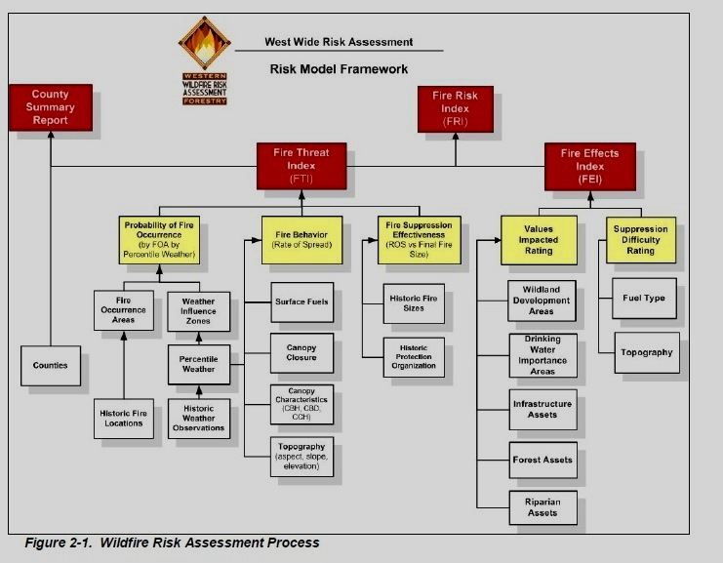

Figure Appendix D - 2. Risk Model Framework. State of Oregon, Department of Forestry

West Wide Wildfire Risk Assessment Final Report, March 31, 2013 13 Confidential and Proprietary, © 2012 The Sanborn Map Company, Inc., ALL RIGHTS RESERVED Any and all graphics included in this response are for illustrative and representative purposes only and shall not be relied upon as depictions of the final deliverables.

FRI, FTI, and FEI are the three primary outputs generated using the WWRA process. The “possibility of suffering harm or loss” is represented by the Fire Threat Index (possibility) and the “harm or loss” is the Fire Effects Index (ODF-WWRA 2013).

* The FTI takes several elements that influence the likelihood of a fire occurring in a given geographic area based on the 10 year fire records. Weather conditions, based on historical trends, were separated into 4 conditions that influence how fuels will burn from Low, Moderate, High, and Extreme. The potential for fire spread (fire behavior) took into account vegetation and land topographic conditions, where the fire start(s) would likely occur, and the effectiveness of fire suppression resources based on historic fire sizes and fire behavior.
* The FEI also takes into account the topographic and vegetation conditions that influence suppression resources ability to construct fireline and suppress a fire then identifies geographically important values that can be impacted by a fire in that area. These two indexes are vital to identifying the overall risk of an area.

With the Risk Index as the overall desired outcome it is important to understand how the five sub-sets fit into the calculations of FTI and FEI that are used in determining a final overall fire risk for the county.

**WWRA Fire Threat – Subset Data**

WWRA provided a thorough analytical method to calculate the probability of an acre burning when developing the FTI. Detailed analysis with calculations and formulas can be found in the final report of the WWRA; an overview is examined here for Union County. The WWRA developed the FTI by integrating the probability of an acre igniting and the expected final fire size based on the rate of spread of the fire in four weather percentile categories (ODF-WWRA 2013). Another words historical fire start locations and historical large fire size were considered with how a fire will burn under various weather conditions for an average fire season.

**Fire Threat Index FTI**

Knowledge of fire spread and the potential expected fire size was applied to calculate Fire Theat. A relationship between the rate of spread and final fire size was developed using the data from federal and state fire reports. NFIRS data for entries of final fire size were limited and therefor was unable to be used (ODF-WWRA 2013). The predicted annual acres burned are similar to the historic expected acres burned developed from the fire occurrence reports. This was done by taking the proportion of fires for each weather category and multiplying it by total number of fires per year. Further calculations were completed taking into account annual expected acres burned for each of the four weather categories and the total acres within the fire occurrence area and weather influence zone to produce the probability of an acre burning and the Fire Treat Index for each weather category. An example of calculations can be found in figure D – 6 and section 3.3.4, Fire Threat Index (FTI) pages 42 – 44 of the Final WWRA report.

**Weather**

In order to accurately represent local fire season weather information, WWRA used historical information from local weather stations such as remote weather stations (RAWS) and analyzed it then divided the weather into four separate fire weather condition categories. For instance, weather stations analyzed for OR08, which includes Union County, considered the average fire season to be from June 15th through October 15th in order to best represent an average wildfire season. A 20 year historical timeframe of weather data was used to obtain four ranges of environmental weather and fuel conditions.

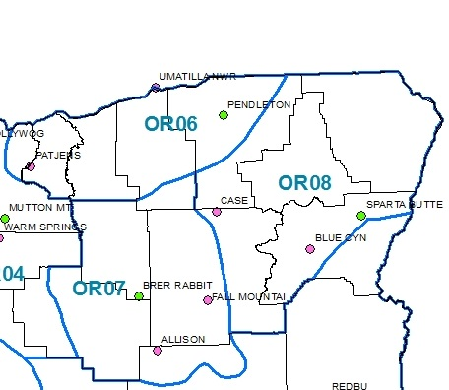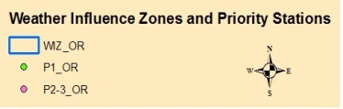

Figure Appendix D - 3. Union County is part of the OR08 Weather Influence Zone (WWRA). Weather stations most representative and used for weather data in determining fuel moistures and 20 foot wind speeds to assist in fire behavior calculations. Weather Stations: Case, Blue Canyon, and Sparta Butte.

Weather has a direct impact on curing of grasses and vegetation, these ranges include how moist or dry the forest fuels (live and dead vegetation) are and the number of days over the timeframe June – October that conditions meet a specific criteria range that result in herbaceous curing levels for each range. Weather influences curing, in turn resulting in how on site conditions contribute to wildfire behavior.

The four categories of data provide the number of days during a typical fire season, based on historic weather and fuels conditions, that a fire could potentially exhibit very low, moderate, high or extreme fire behavior. The weather and fuels conditions were represented by the following percent and number of days for each category between June 15th and October 15th for OR08:

* low 15% – 18 days - 20% proportion of the herbaceous cured.
* moderate 75% - 92 days - 60% of herbaceous fuels contributing to fire spread.
* high 7% - 9 days - approximately 90% of herbaceous fuels cured
* extreme 3% - 4 days - 100% cured herbaceous

Each historical fire starts was assigned a fire spread component based on the fire’s start date and then a correlation was made assigning each historic fire to one of the four weather categories based on the fire start date. The percent of fires that occurred for OR08 for each condition range were as follows: low represented 10.74% of the fires starts, moderate - 81.32%, high - 6.17%, extreme - 1.77% of the fire starts (ODF WWRA Addendum I - 2013).

The following Figure Appendix D – 4 identifies the level of fuel moisture in the four weather percentile categories ranging from Low, Moderate, High, and Extreme. The lower the fuel moisture the more readily the fuel will burn and the more intense the fire behavior characteristics.

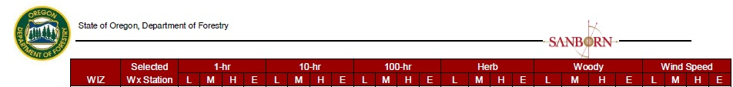

Figure Appendix D – 4. The Selected Weather Station is the local Remote Automated Weather that was identified as mimicking historic large wildfire conditions for the four percentile categories.

Fire Season dates were also applied for the local Weather Influence Zone (WIZ). The following figure shows that June 15 through October 15 was considered the average fire season for this area.

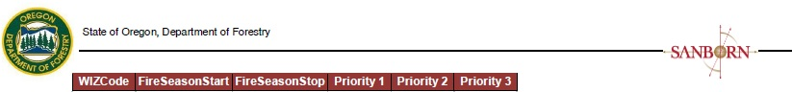

Figure Appendix D – 5. Weather Influence Zone with the fire season start and stop dates. Priority 1, 2, 3 weather stations were identified as the most represented for historic fire size and projection.

**Fire Occurrence - Probability of an Acre Burning**

Historical fire records from 1999 – 2008 were used in developing the probability of fire occurrence. These dates provided consistent data across 17 western states allowing an accurate comparison between states. This information was carried one step further to meet individual state needs of prioritization and data distribution. Data from the WWRA found that Union County wildfires for the 10 year period totaled 558 fires with ignitions sources of 62% lightning and 38% human

Each map cell (30-meter by 30-meter) has the same likelihood of igniting (Fire Occurrence Area FOA) as well as expected weather based on the WIZ. Numbers were calculated based on the number of fires per a 1000 acre area on an annual basis. Another words the number of fires per 1000 acres per year – fires/1000 acres/year. All of the fires (100%) for the time frame of 1999 - 2008 were separated out based on the weather conditions under which they started. These starts were proportionally separated into each of its representative four weather percentile category. The estimated rates of spread, final fire size, and annual acres burned were also identified based on the percentile weather to determine the Fire Threat Index.

|  |  |  |  |  |  |  |
| --- | --- | --- | --- | --- | --- | --- |
| Row | Item | Percentile Weather | | | | Total |
| Low | Moderate | High | Extreme |
| 1 | Proportion of Fires | 0.10 | 0.80 | 0.08 | 0.02 | 1.00 |
| 2 | Number of Fires | 10 | 80 | 8 | 2 | 100 |
| 3 | Rate of Spread  (chains/hour) | 2 | 5 | 12 | 24 | N/A |
| 4 | Final Fire Size (acres) | 1 | 6 | 98 | 900 | N/A |
| 5 | Annual Acres Burned | 10 | 480 | 784 | 1800 | 3074 |
| 6 | Fire Threat Index  FTI | 0.00001 | 0.00048 | 0.000784 | 0.00180 | 0.003074 |

Figure Appendix D – 6. Fire Threat Index Calculation-Example of how calculation process was used, showing the role fire occurrence and fire behavior help in determining the overall Fire Threat Index. Numbers DO NOT represent those of Union County.

**Fire Behavior**

When wildland fire burns on the landscape it is influenced by a numerous environmental characteristics, that when in aligned, will dictate the expected fire behavior

Landscape conditions such as fuels, vegetation, and topography were obtained from the LANDFIRE project (ODF-WWRA 2013). Multiple information layers of data was used to determine fire behavior potential for the county. These individual layers depicting the

County’s biophysical conditions were built into developing the Fire Behavior sub-set of FTI as well as an elemental input into the Fire Suppression Effectiveness sub-set.

Fire Behavior results were derived through multiple data sets representing Union County. To determine areas within Union County that would best represent today’s landscape conditions such as fuels, vegetation, and topography data was obtained from the LANDFIRE project (ODF-WWRA 2013). Multiple information layers of data were used to determine fire behavior potential for the county. These individual layers depicting the County’s biophysical conditions were built into developing the Fire Behavior sub-set of FTI as well as an elemental input into the Fire Suppression Effectiveness sub-set.



Figure Appendix D – 7. Data layers of topography, fuels, and stand conditions to

determine fire behavior Rates of Spread.

**Elevation, Slope and Aspect**

Elevation was a straightforward approach based on distance above sea level. Highest elevation lies in the southeastern corner of the county inside the Eagle Cap Wilderness on Glacier Peak at approximately 9,595 foot elevation. The highest elevation outside of the wilderness is Mount Fanny due east of La Grande overlooking the valley from approximately 7125 foot elevation. The lowest elevation point is located in the La Grande Valley near the airport at approximately 2700. This change in elevation is indicative to the variation of changes from the valley floor to the ridgelines within the county. Steep dissected country provides a high degree of elevation changes influencing both fire behavior and suppression efforts.

Slope break classes were developed based on the Fireline Handbook’s (National Coordinating Group 2004), Appendix A, page A-34 which defines the classes as follows: 0-25%, 26-40%, 41-55%, and 56-74% (ODF-WWRA 2013) and a fifth class of 75% or greater was added for the WWRA.

Aspect was used to represent the azimuth of sloped surfaces across the landscape. Aspect is representative of compass bearing with North at 00 and South at 1800. These were grouped (reclassified) into four sets 0, 90, 180, 270 with the classes sufficient to support fire behavior modeling (ODF-WWRA 2013).

**Fuel Models**

Fuel model information was obtained through the 2005 Fire Behavior Prediction Systems fuel model set which includes the 40 fuels models as defined by Scott and Burgan (2005), (<http://www.fs.fed.us/rm/pubs/rmrs_gtr153.pdf>).These fuel models represent a more “dynamic” fuel, which means that their herbaceous fuel load can change or shift between live and dead characteristics depending on the specified live moisture level in the plant. Herbaceous fuels typically fall into three categories: annual, biennial or perennial. Herbaceous have leaves and stem typically dying every year when weather changes moving them from a live fuel (takes more heat to ignite) to a cured dead fuel that burns more readily. Herbaceous are important because they can significantly affect fire behavior once they shift from live to dead.

The calculated herbaceous fuel moisture was not used (ODF-WWRA Addendum I 2013). Instead Climate Classes were assigned to each WIZ and given a live to dead loading transfer for each climate class and each weather category. This was directly linked to assigned herbaceous fuel moisture for each weather category. This provided consistency in herbaceous fuel moisture values and control of the fuel loading transfer in dynamic fuel models (ODF-WWRA Addendum I 2013). Tables of the fuel models displaying loading transfer into cured (dry fuels) are located on page I – 3 Tables I-1, I-2 of the Addendum.

Data for fuel models were derived from LANDFIRE Refresh program which includes four non-burnable fuel models to represent areas of urban, agriculture, barren, and water. LANDFIRE provides a landscape scale geo-spatial products to support cross-boundary planning, management, and operations (LANDFIRE 2015). Some areas identified as non-burnable in the LANDFIRE mapping were reviewed with WWRA staff and state representatives to reassign some areas to burnable (ODF-WWRA 2013).

Fuels play an instrumental role in fire behavior for many reasons.

* Fuels can impact wildfire rates of spread particularly in fine dead fuels (0 – ¼” in diameter) and also material of 3” diameter and smaller because they ignite more readily, burn faster, and leafy material can be lofted into the air in the form of hot embers
* Larger stems 3” and above may take slightly longer to ignite but once burning can generate higher levels of heat (intensities) and have a longer burn time in one location (residence time).

Figure Appendix D - 9 shows the distribution of fuel types in Union County with each type, assigned by Scott and Burgan, a list of characteristics such as:

* tons per acre of different size material
* a dynamic fuel or not
* depth of fuel bed in feet
* and numerous other attributes

These characteristics combined with a common fuel moisture level scenario (dryness of live and dead fuels), a mid-flame wind speed of 5 miles per hour on flat ground. These individual fuel type scenarios fell into one of six possible predicted fire behavior definitions with potential ranges in fire rates of spread and expected flame lengths.

Adjective class definition for predicted fire behavior.

Adjective Class Rate of Spread (*ch/h) Flame Length (ft)_

Very Low 0 – 2 0 - 1

Low 2 – 5 1 – 4

Moderate 5 – 20 4 – 8

High 20 – 50 8 – 12

Very High 50 – 150 12 – 25

Extreme > 150 > 25____

Figure Appendix D - 8. Information from Scott and Burgan 2005. * ch = chains, 1 chain = 66 feet

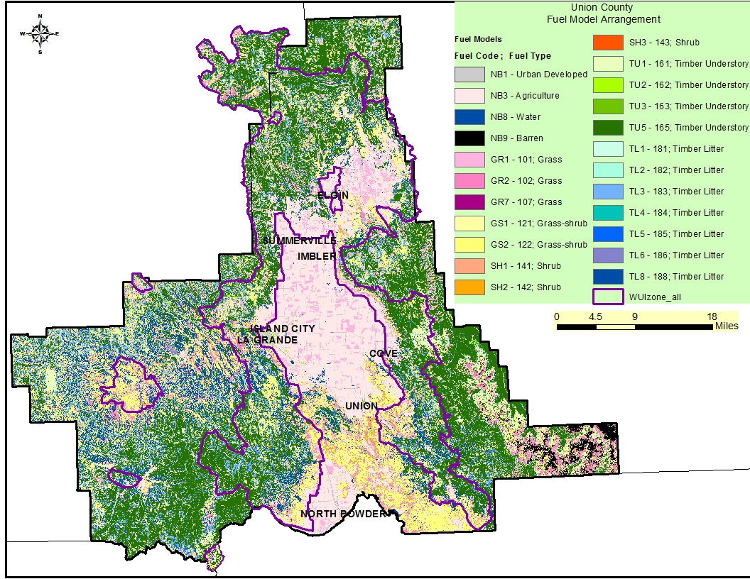

Figure Appendix D - 9. Union County distribution of fuels models used as an element to predict wildfire behavior in developing FTI. Data Source: ODF-WWRA 2013 with utilization of LANDFIRE data. NB = No Burn.

The characteristics used for fire behavior provide a means to understand the fuel type under given conditions and a relative comparison between fuel types. Knowledge of topographic features and frequent steady winds in the La Grande Valley and surrounding foothills will likely exhibit higher rates of spread and flame lengths than those given in Figure D - 10 if fuel moisture characteristics remained the same. The WWRA utilized the fuel type in combination with the stand canopy conditions and the four weather categories to determine overall fire behavior.

Rate of Spread (Chains per hour*)

|  |  |  |  |  |  |  |
| --- | --- | --- | --- | --- | --- | --- |
| Flame Length (feet) | 0 – 2  Very Low | 2 – 5  Low | 5 – 20  Moderate | 20 – 50  High | 50 – 150  Very High | >150  Extreme |
| 0 – 1  Very Low | TL 2 |  |  |  |  |  |
| 1 – 4  Low | TL3 | SH1, SH2,  SH3, TU1  TL1, TL4, TL5 | GR1, GS1  GS1, TU2,  TL6, TL8 |  |  |  |
| 4 – 8  Moderate |  |  | TU5 | GR2, GS2, TU3 |  |  |
| 8 – 12  High |  |  |  |  |  |  |
| 12 – 25  Very High |  |  |  |  | GR7 |  |
| >25  Extreme |  |  |  |  |  |  |

Figure Appendix D - 10. Rates of spread and Flame lengths are strictly based on Scott and Burgan Criteria for fire behavior identified in RMRS GTR – 153 2005, Section: Fuel Model Selection Guide bullet 4. Page 9. * 1 Chain = 66 feet. NOTE: This is not reflective of overall resultant fire behavior from the WWRA.

Although the valley center is peppered with a grass fuel model, many areas identified as NB no burn are either irrigated during the fire season or are a grass fuel model with a short burning time frame during the summer months, this is particularly true for wheat fields prior to harvest.

**Canopy Fuels**

Fire behavior is often influenced not only by surface fuels but by trees that contribute to the stand structure. Individual tree attributes as well as entire stand characteristics play a role in fire behavior involving tree canopies. For the purpose of this document the word canopy refers to stands of trees that have canopies and crown represents an individual tree.

There are three primary characteristics used to for fire behavior predictions.

* Canopy cover is the percentage of sky obscured when looking from multiple points location in a stand or on a landscape, often expressed in percent. This can influence crown fire sustainability when especially viewed at a landscape level.
* Canopy Bulk Density (CBD) identifies the mass of available canopy (fuels) at a stand level that could potentially contribute to the spread of a wildfire through the crowns. This includes live and dead branch wood of trees, lichen, tree foliage, etc.
* Canopy Base Height (CBH) often described the distance of the lower limbs of a stand to the ground measured in feet. Canopy base height in stands is difficult to measure where multi-storied stands exist. Van Wagner in 1993 defined CBH in terms of its consequences to crown fire initiation as the lowest height above the ground at which there is sufficient canopy fuel to propagate fire vertically through the canopy. This allows for the incorporation of ladder fuels such as shrubs and understory trees.

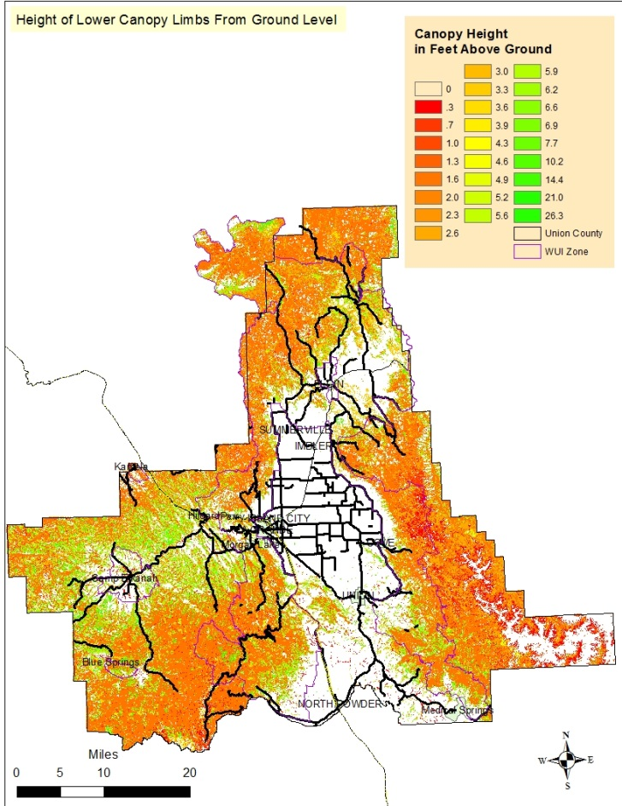

The lowest reading was .3 feet with the highest of 26.3 feet. The canopy base height has a key influence on a wildfire’s ability to transition from surface fire to crown fire. The shorter the distance from the ground the greater chance of a crown fire. (ODF-WWRA 2013 Final Report page 38). A location where low canopy base height is coupled with down woody fuels further increases the likelihood of a crown fire.

Figure Appendix D – 11. These numbers reflect actual distance from the ground to the lower limb canopy foliage of an area. Distances range from .3 to 26.3 feet.

**Fire Behavior Results - Surface and Canopy Fire**

Surface and canopy fuels both influence wildland fire behavior and resulting fire type. Fire behavior scenarios were developed for all four weather categories taking into account dead and live fuel conditions, weather, and topographical features to demonstrate potential rates of fire spread (chains per hour) and flame lengths (feet).

WWRA delineates out the potential areas where a fire is unlikely to burn, a surface fire may occur, or conditions are such that a canopy fire is likely. All three fire types could occur based on input criteria, for practical terms both passive and active fires are collectively referred to as canopy fire (ODF-WWRA 2013). Fire behavior scenarios were developed for all four weather categories taking into account dead and live fuel conditions, weather, and topographical features to demonstrate potential rates of fire spread (chains per hour) and flame lengths (feet).

In order to demonstrate an “expected” fire behavior outcome the four weather

categories were used with a weighted average using the probability of a fire occurring in each of the weather categories. This provided the likelihood of a cell, in the GIS layer, igniting and facilitated generating the expected fire behavior (ODF-WWRA 2013).

Fire behavior using all four weather categories combined is provided displaying the expected fire rates of spread, flame length generated, and the probability of a canopy fire.

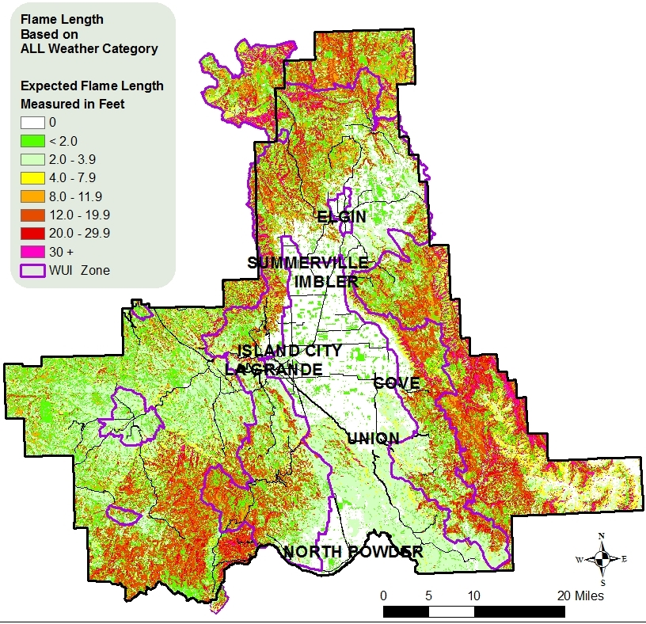Flame lengths play a significant role in tactical decision of suppression resources. Flame length and fireline intensity are directly related to the effectiveness of control forces (Andrews and Rothermel 1982).

Fireline intensities are measured by the amount of heat released by a square foot of fuel that is actively burning within the flaming zone.

Fuels models have a direct correlation to the amount of heat (fire intensity) released by a fire, the flame lengths exhibited, and the rate at which the fire spreads.

Figure Appendix D – 13. Expected flame lengths based on calculations using all four weather categories.

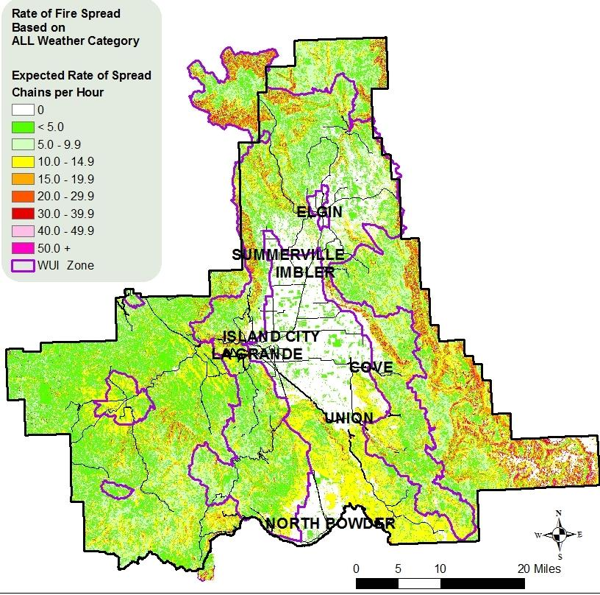Factoring in weather and topographical conditions many areas within the WUIZ of Union County are expected to exhibit flame lengths that necessitate water engine type resources, figure D - 12.

Surface fires that exhibit flame lengths less than 4 feet can often be directly attacked by hand crews, meaning close proximity to flames by firefighters can occur and crew constructed fire lines should hold. When flames are between 4 and 8 foot in length suppression resources typically include pumpers, dozers, and aerial support to provide for both firefighter safety and to ensure effective suppression efforts.

Figure Appendix D - 12. Expected rate of Spread using all four weather categories. A chain is a unit of measurement in forestry and is equivalent to 66 feet.

|  |  |  |
| --- | --- | --- |
| Flame Length | Fireline Intensity | Interpretation |
| feet | BTU/ft/sec |
| < 4 | < 100 | -Fires can generally be attacked at  the head or flanks by persons using  hand tools.  - Hand line should hold the fire. |
| 4 – 8 | 100– 500 | -Fires are too intense for direct attack on the  head by persons using hand tools  -Hand line cannot be relied on to hold the fire.  -Equipment such as dozers, pumpers, and  retardant aircraft can be effective. |
| 8 – 11 | 500 – 1000 | -Fires may present serious control problems from  torching out, crowning, and spotting.  -Control efforts at the fire head will probably  be ineffective. |
| >11 | >1000 | -Crowning, spotting, and major fire runs are probable.  -Control efforts at head of fire are ineffective.* |

Figure Appendix D - 14. Suppression Resource Effectiveness Chart. Information from Andrews and Rothermel 1982. Suppression resources are most effective with flame lengths less than 4 feet. Engines, dozers, and air support are needed between 4 and 8 foot flame lengths. * The head of the fire is the side of the fire perimeter exhibiting the highest rates of spread (leading edge), and often associated with the location where continuous flaming combustion is taking place.

Three types of fire outputs are used, based on the input of the four weather categories, surface and canopy fuels, and topographical features in this assessment; surface, passive, and active fires.

* *Surface fire* is a fire that spreads through the fuels lying on or near the ground often consisting of needles, dead limb wood material, downed logs, and low standing live vegetation.
* A *passive fire* occurs when a fire is able to spread upward into the crown of a tree or a group of tree crowns. This also is often referred to as tree torching or group torching.
* An *active fire* type occurs when fire spreads vertically into the tree crown(s) and due to contributing circumstances the fire can begin to spread crosswise through the stand of trees often with the support of the surface fire flames and heating. High winds, steep terrain or a combination of both are most frequently the contributing factors assisting active fire types.

WWRA delineates out the potential areas where a fire is unlikely to burn, a surface fire may occur, or conditions are such that a canopy fire is likely. All three fire types could occur based on input criteria, for practical terms both passive and active fires are collectively referred to as canopy fire (ODF-WWRA 2013).

Calculating in all four weather conditions the overall, “expected” probability of a canopy fire was determined. As shown in Figure Appendix D – 16 a large area of the county is predicted to experience a canopy fire at a probability of .75 or greater.

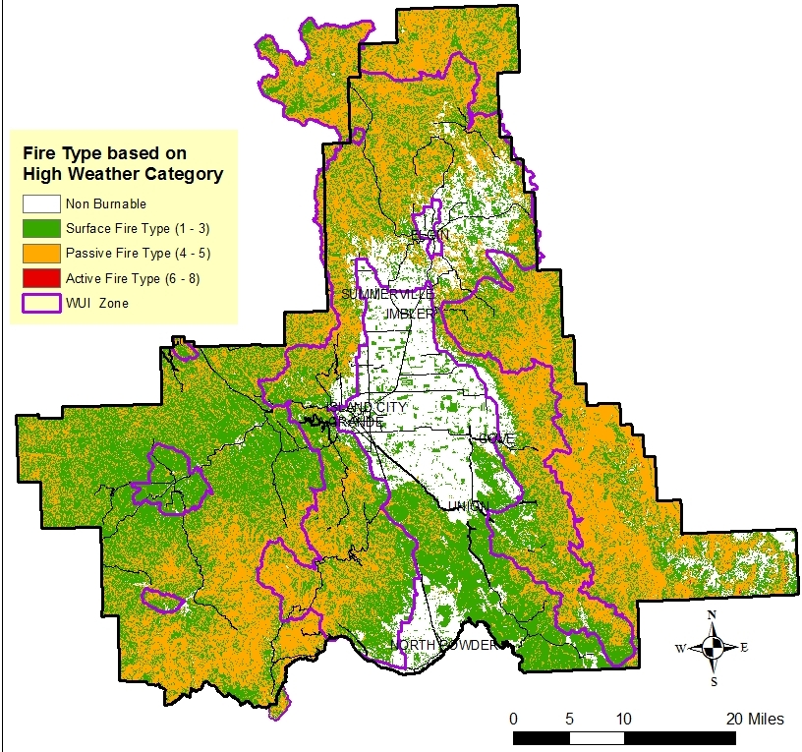

Figure Appendix D - 15. Distribution of surface fire, passive canopy fire, and active canopy fire in Union County. Areas of canopy fire can be expected, in most cases, to also exhibit surface fires in conjunction with the canopy fire.

In reviewing the three fire types the most likely fire types to occur are surface fire and passive canopy fires. This does not imply that active canopy fire types are not possible, what is important is that the canopy is likely to be involved during wildfires in most timbered areas.

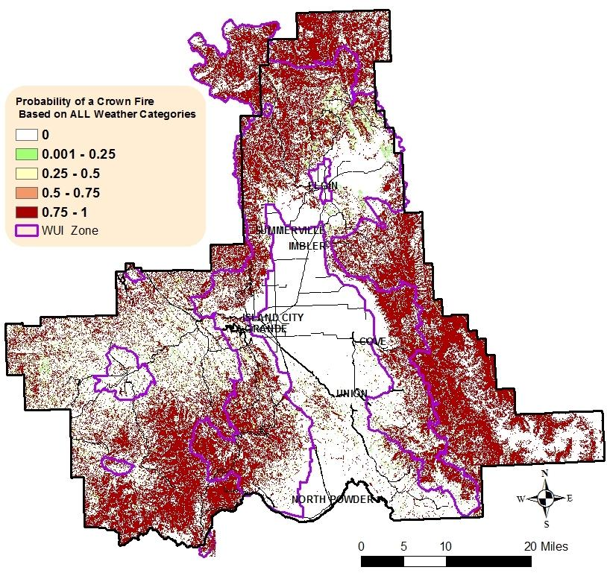

Figure Appendix D - 16. Considering all weather categories the “expected” probability of a canopy fire is at least a 75% or more likelihood in most timbered areas.

**Fire Effect**

**Forest Assets** – These values were categorized by height, cover, and susceptibility, or response, to wildfire. Rather than attempt to “value” a forest, the WWRA assessed the forest’s potential mortality and response to fire (ODF-WWRA Final Report 2013). Vegetation datasets were used as inputs with a crosswalk of the existing Vegetation Type to a susceptibility class, or a class based on the vegetation fire response.

Vegetation susceptibility to wildfire was categorized into three fire response classes using fire ecologists documented information for the vegetation types. The three possible classes for fire response were:

* Sensitive – these tree species are fire intolerant and sensitive to even low intensity wildfires.
* Resilient – these tree species have characteristics that provide protection and limit damage from wildfires and mature stages can survive low intensity fires.
* Adaptive – These are tree species that are capable of regenerating following a wildfire by either sprouting or serotinous cones.

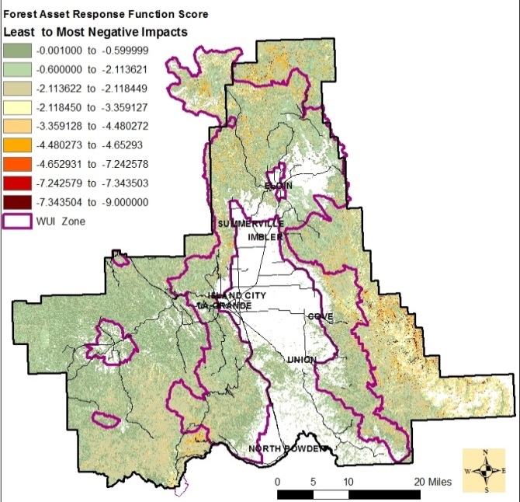

Figure Appendix D - 18. As the response function score rating becomes more negative so too does the adverse fire effects.

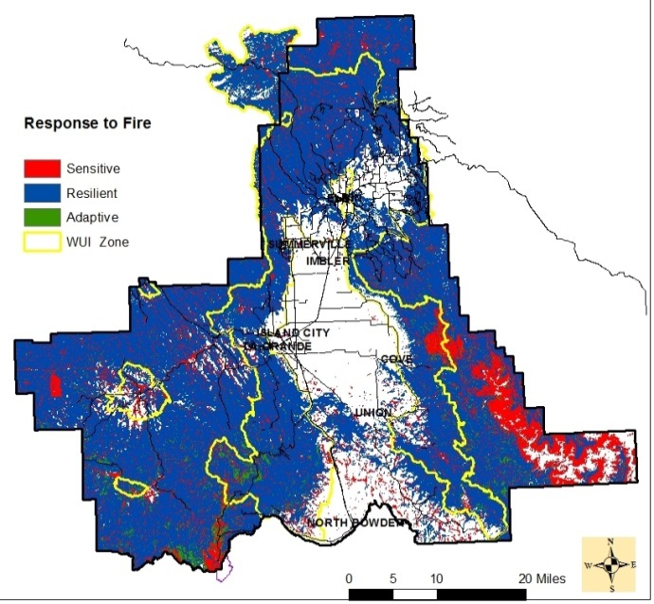

Figure Appendix D - 17. Landscape susceptibility of Union County’s vegetation. Large block of sensitive area in the southeast corner is located in the Eagle Cap Wilderness.

Much of Union County, 84 percent, supports resilient fire tolerant species that historically was often represented by a Fire Regime I, Condition Class I. Frequent fire events did not allow for high increases in the dead down material within the timbered stands and often naturally thinned seedlings that developed between those fire events and promoted fire adapted plant life such as mallow ninebark shrub, big huckleberry, eld sedge, bluebunch wheatgrass, etc. Sensitive forests represents 13% of the county with the majority of areas supporting subalpine fir and lodgepole pine stand types, located at high elevations or microclimate cold pockets in lower elevations. Adaptive fire response comprised approximately 3% of the county.

4) **Riparian Assets** – Complex process with assigned ratings based upon two important riparian functions; water quality and quantity as well as ecological significance. Information was derived from the National Hydrography Dataset, the National Wetlands Inventory, and LANDFIRE’s Existing Vegetation Dataset. Riparian includes terrestrial and aquatic habitat, water quality and quantity, and other ecological functions (OD-WWRA Final Report 2013). Buffers were applied at 150 feet for perennial streams and wetlands while seasonal watercourses were based on a 75-foot buffer. Riparian values were assigned 1 of 3 categories based level of importance as it contributes to the following ecosystem benefits: terrestrial and aquatic habitat, water quality, water quantity, and other ecological functions.

* Value Impacted Category 3 – areas with highest importance such as conifer, hardwood, or riparian vegetation on steeper slopes, erodible soils, and higher annual rainfall; 74% of county.
* Value Impacted Category 2 – moderate importance riparian areas; 21% of county.
* 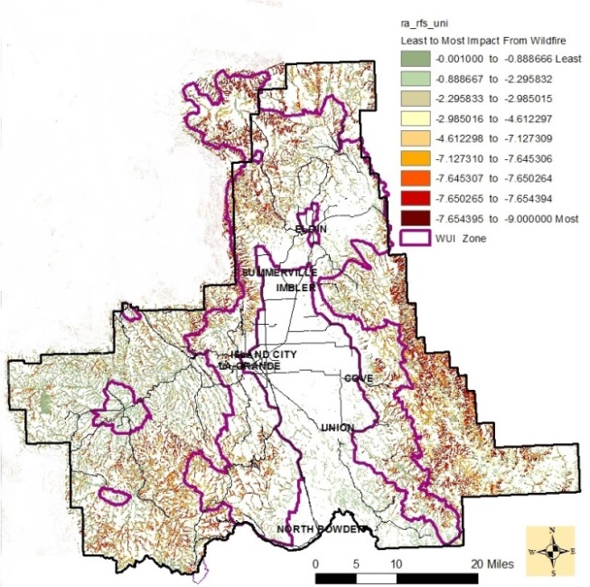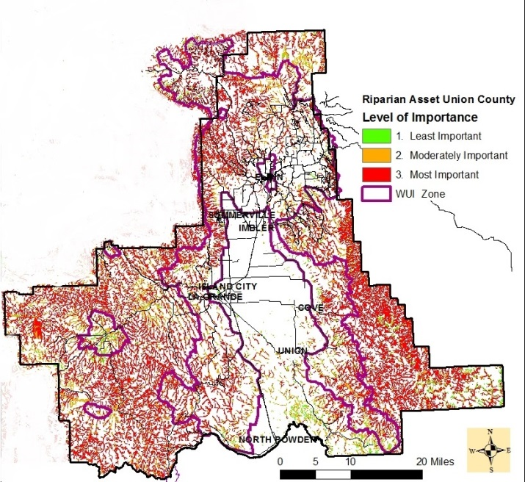Value Impacted Category 1 – riparian areas of lowest importance, such as exotic or grass vegetation; 5% of county.

Figure Appendix D - 19. Water networks based on level of importance in terms of ecosystem contributions and water quality.

Figure Appendix D - 20. Displays the expected riparian response from a wildfire. The more negative the score the increased negative impacts.

Once the importance of the value of the riparian area was displayed, the expected fire impacts were then determined to identify which important riparian areas were most likely to have high IMPACTS or RESPONSE from wildfire.

5) **Drinking Water Importance Areas** – Identifies areas most crucial to sustaining the quality of drinking water. This information incorporates data on water supply, surface drinking water for consumers at the point of intake, and the flow patterns to the surface water intakes. Considerations for drinking water ratings were based on a landscape hydrological unit code 12 (HUC 12) watersheds. A watershed is defined by the surface water drainage systems working together to a point. A HUC 12 is a sub-watershed that ranges from 10,000 to 40,000 acres in size with some as small as 3,000 acres (NRCS 2015). Evaluating the impacts of fire to the HUC 12 allows attention to be given to areas that are a source of drinking water and/or where adverse impacts from fire would be of significant concern.

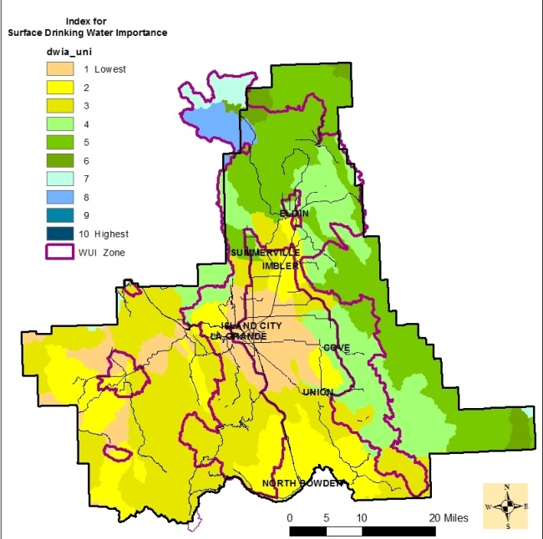

Figure Appendix D - 21. Drinking water sub-basin s based on level of importance.

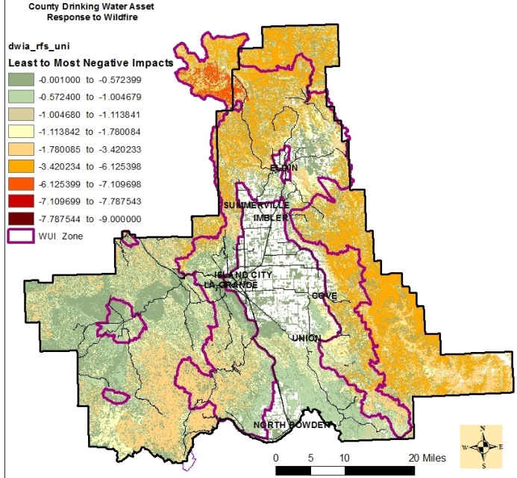

Figure Appendix D - 22. Areas most likely to have the highest negative impacts from wildfire are the north and east side of the county.

Union County currently does not have any drinking water intakes listed according to the Oregon Department of Environmental Quality (DEQ), however it is bordered by on three sides by drinking water intakes of the Umatilla, Wallowa River, and Powder River (Figure Appendix D - 23) (DEQ 2007)

Although there is not a drinking water intake sub-basin within Union County there is a significant amount of reliance, by county residence, on the sub-basin s for subsistence.

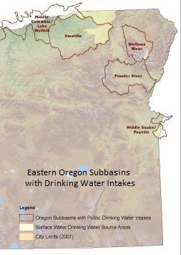

Figure Appendix D - 23. Sub-basins with Drinking Water Intakes for Eastern Oregon according to the Department of Environmental Quality. (DEQ 2007)

According to the DEQ’s Statewide Water Rights Spatial Data there are approximately 6000 identified water rights point locations. These points include water rights for the following reasons: Instream aquatic and fisheries support, Forest Management, Commercial and Business uses, and Fire Protection. The following figures show the spatial distribution of commercial uses and Agricultural uses.

Water right maps for the remaining local uses can be found in Figures D – 24 and D – 25. Throughout Union County there is dependence on local sub-basins condition and functionality to provide protection, commodities, aesthetics, and ecosystem health.

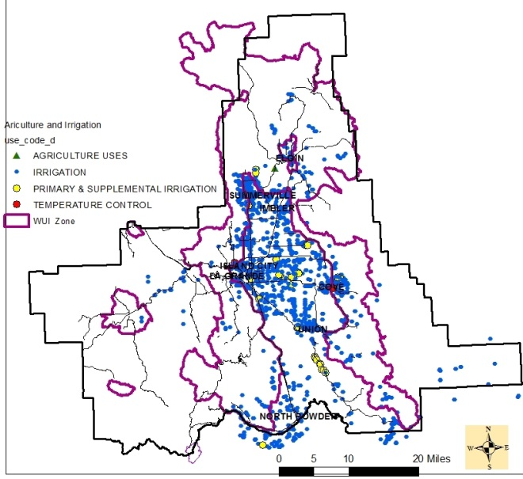

Figure Appendix D - 25. Water rights for Agriculture and Irrigation (does not include irrigation for livestock – located on separate map). Data Source DEQ 2007.

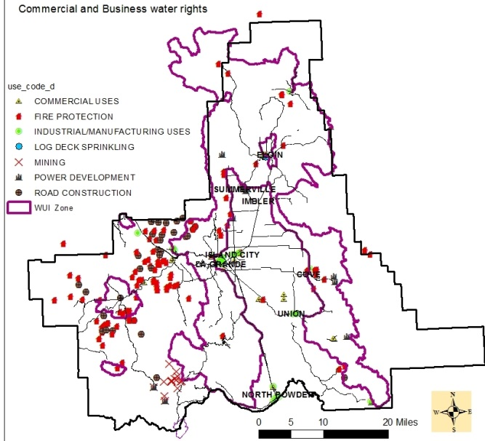

Figure Appendix D -24. Water rights use for Commercial and Business (not including Agriculture or Livestock). Data Source DEQ 2007.

***Wildland Development Areas (Housing Units per Acre)***

The location of people living in Wildland Urban Interface and rural areas is key information for defining potential impacts to people and homes from fire. The data layer used to represent this value was called Wildland Development Areas (WDA) and to develop this data layer, there was a need to develop the Where People Live (WPL) data layer first.

**Where People Live (Housing Units per Acre)**

The Where People Live (WPL) dataset was developed using advanced modeling techniques based on the LandScan population count data available from the Department of Homeland Security, HSIP Freedom Dataset. The HSIP Freedom dataset was available at no cost to U.S. local, state, territorial, tribal and Federal government agencies (refer to the web link in Appendix B to obtain more information about the LandScan data).

Developed by the Oak Ridge National Laboratory, LandScan has been developed using sophisticated algorithms that integrate high-resolution imagery, nighttime lights imagery and other local spatial data to identify daytime and nighttime population distributions. The Oak Ridge National Laboratory LandScan web site has a more detailed description of the dataset (Appendix B).

The WPL and WDA datasets have been derived to represent the number of houses per square kilometer, consistent with Federal Register and USFS Silvis datasets. However, to aid in the interpretation and use of this data, the legends are presented in "houses per acre". This was done to adhere to traditional use and understanding of this data by planners.

The Where People Live data layer includes categories up to or greater than three housing units per acre (Table 3-4). This is greater than one housing unit on 1/3rd of an acre. This, in many cases, includes dense urban areas. Figure 3-46 presents an example of the Where People Live data layer categories for an area of Jackson County, Oregon.

|  |  |  |  |  |
| --- | --- | --- | --- | --- |
| Housing Density Category | From  Houses/sq.km. | To  Houses/sq.km. | Houses per acre | General Name |
| *1* | 0.000001 | 6.177635 | Less than 1 HU / 40 acres | Below Density Rating |
| *2* | 6.177635 | 12.355269 | 1 HU / 40 acres to 1 HU / 20 acres | Very Low |
| *3* | 12.355269 | 24.710538 | 1 HU / 20 acres to 1 HU / 10 acres | Low |
| *4* | 24.710538 | 49.42 | 1 HU / 10 acres to 1 HU / 5 acres | Medium |
| *5* | 49.42 | 123.55269 | 1 HU / 5 acres to 1 HU / 2 acres | Medium-High |
| *6* | 123.55269 | 741.31614 | 1 HU / 2 acres to 3 HU / acre | High |
| *7* | 741.31614 | 100,000 | More than 3 HU / acre | Very High |

Figure Appendix D – 26. West Wide Risk Assessment Housing Density Table 3 – 4 of Final Report. Categories of Where People live based on housing units up to or greater than three housing units per acre.

Because some Communities at Risk in Union County fell below density levels ratings there were occasions where map development was not beneficial for this data.

**Values Impacted Rating Calculation**

Each state rated each of the 5 values against the other and developed a measure of relative importance on a scale of 100, with 100 being of highest importance. The following were the ratings developed by Oregon: Infrastructure 90, Wildland Development Area 100, Drinking Water 80, Forest Assets 100, and Riparian Assets 70.

The Values Impacted Rating (VIR) reflects those areas that have important values at risk to wildland fire. This rating is based on the Five Values Impacted: drinking water importance areas, riparian assets, forest assets, infrastructure assets, and wildland development areas as well as the flame length and fire intensity level. Calculation table can be found in the WWRA Final Report section 3.4.1 beginning on page 46. The VIR values range from 0 to -9, with a more negative number indicating a more negative impact from fire. Positive effects from fire were not considered in the West Wide Risk Assessment (ODF-WWRA Addendum VII 2013).

**Fire Risk Index**

The Fire Risk Index (FRI) defines and provides a measure of wildfire risk. It combines the probability of an acre burning with the expected effects if a fire occurs. This reflects the possibility of suffering loss (ODF-WWRA Addendum VII 2013). It takes into account all the outputs used under the Fire Threat Index and the Fire Effects Index and determines an overall final score. This score is based on conditions of each GIS cells, covering every location on the ground for the entire county, and then incorporates the multiple layers of existing conditions to calculate the overall fire risk relative to other areas. Calculations used in determining overall fire risk index can be found in the WWRA Final Report, Section 3.5, page 70.

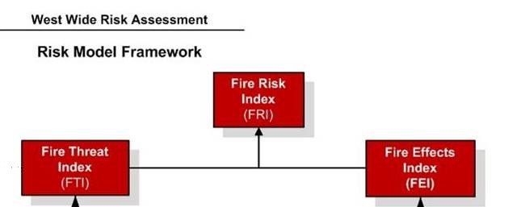

Figure Appendix D – 27. The top section of the West Wide Risk Model Framework. All evaluated attributes are subsets of either Fire Threat or Fire Effects providing the foundation of Fire Risk.

When reviewing the assessment process and in order to understand why areas result in highs and lows it is important to compare the relationship between data sets, values of the data before and after calculations, and the cause and effect of how conditions can influence results. The Fire Risk provides a general idea that the area is in jeopardy to wildfires. Understanding which conditions are driving the outcome will allow managers to make sound decisions and have the greatest impact on protection life and property.