X. Accomplishments and Challenges

Introduction

Since 2005 Federal, State, and private landowners have joined forces in an effort to begin mitigating wildfire risk. Projects included hazardous and ladder fuels reduction, raising canopy base height, and reducing stand densities. Through multiple funding mechanisms these agencies have begun the extensive work of reducing wildfire risk in Union County.

The 2005 CWPP provided avenues for funding for treatments in Wildland Urban Interface (WUI) areas with much of the revenue designated toward an individual WUI area and a specific action.

The new WUI Zone provides some added flexibility for funding distribution toward multiple areas meeting the same criteria. This allows funds to be distributed throughout the County’s WUI Zone giving fire managers increased opportunities for fire mitigation. Cross boundary treatments, through multiple landowner involvement, creates the most effective defensible space for suppression resources. While treatments within the middle ground areas are often a single landowner or just two ownerships. Opportunities for large-scale projects are possible under both scenarios however proximity to private lands can play a role in treatment options. The middle ground locations often provide more diverse options for treatments such as landscape prescribe burning.

Oregon Department of Forestry and Private Lands

Oregon Department of Forestry in cooperation with private landowners has accomplished approximately 10,851 acres of work throughout the county. Nearly 9,510 of these acres are within the new WUIZ with the remaining 1,341 acres scattered about the county. Accomplishment dates for the work vary from 2004 to as recently as 2014. Geographical information system (GIS) mapping entries of project work on the ground were not available at the time of this document. Approximately 3,949 acres of work has occurred along the foothills of the Blue Mountain west of Hunter road between the towns of La Grande and Elgin and another 1,483 acres along Fox Hill. An estimated 778 acres of work has been completed east of Cove as well.

A variety of treatment tools were used on private lands including timber/overstory removal, ladder fuel reduction, thinning, down woody debris pile and burn, mastication, etc. Prescribed burning is occasionally used but less often due to proximity of treatments to structures.
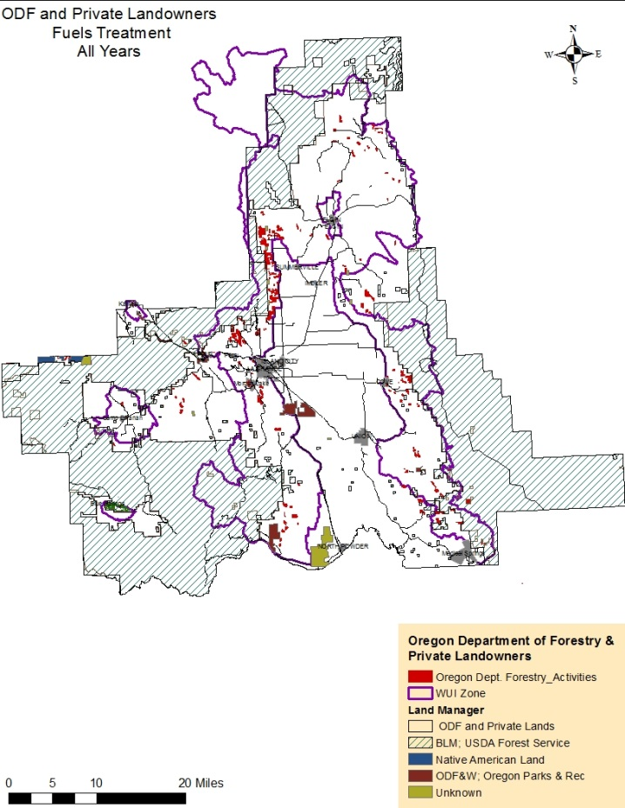

Figure X - 1. Oregon Department of Forestry accomplished acres (red). Majority of acres fall within newly identified WUI Zone.

Wallowa-Whitman National Forest

The Wallowa-Whitman National Forest has complemented these private landowner efforts with some additional cross-boundary fuels and vegetation management projects. The La Grande Ranger District is the representing Forest Service unit involved in the cross-boundary treatments. Projects were planned with both fuels and stand vegetation management activities in mind. These treatment activities were designed for the following purposes: modifying fire behavior potential, reducing surface fuel loadings and ladder fuels, reducing overall canopy density, improving firefighting opportunities by creating and maintaining defensible fire breaks, improving firefighter and public safety, and protecting resource and property values at risk on private and public lands.

Recent projects that supported these treatment activities include:
- Mount Emily II, 2005; Mount Emily
- Blue Fly Fuels Reduction Project, 2010; Blue Springs WUI
- Cove II WUI Project, 2011; Cove WUI
- Rooster Vegetation Project, 2010; Vey Meadows
- Sandbox Vegetation Project, 2013;
- Upper Catherine Creek Watershed, 2016
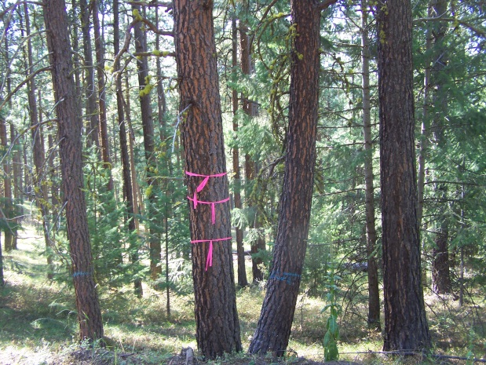
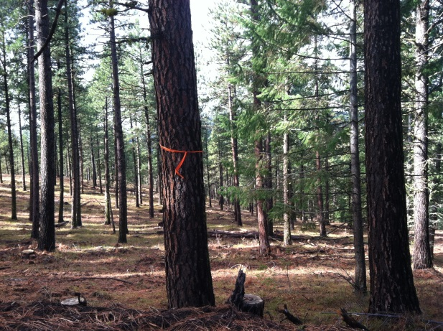

Figure X - 2. Mount Emily WUI project (Forest Service photo). Photo on the left is pre-treatment taken August 2011 and photo on the right is post treatment taken October 2012. Blue painted trees were marked for removal to open the stand and understory was removed as part of ladder fuel reduction.

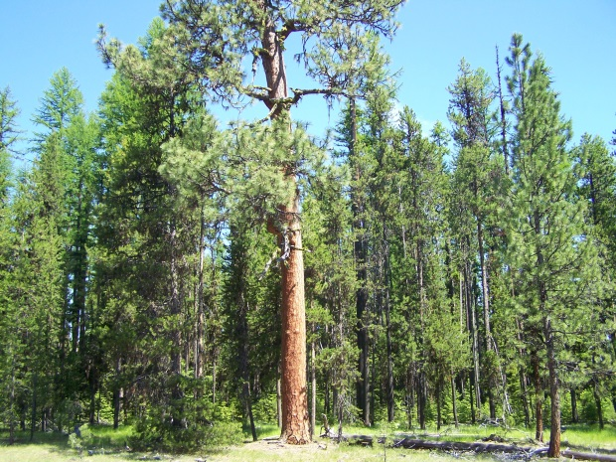
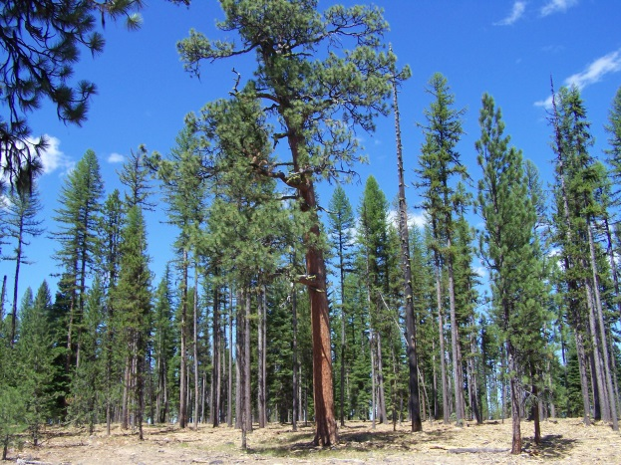

Figure X - 3. Pre-treatment photo (left) taken June 2010, Post treatment photo taken August 2011 (Forest Service photo). Crown density was reduced and canopy base height was increased. Fire tolerant species were retained in an effort to create resilient stands in fire-adapted ecosystems.

Treatment activities are designed with resource goals in mind, causing the same section of ground to possibly have multiple activities for a single goal. For example, fire risk mitigation, depending on site conditions, may require several treatment activities including overstory thinning, ladder fuel reduction, down woody fuels treatment, with a final treatment of prescribed or pile burning. Since 2004, there have been approximately 18 different types of treatment activities implemented for fire risk mitigation within the WUIs identified in the 2005 CWPP. These were associated with 6,618 acres of fuels treatment activities, such as machine or hand piling followed by pile burning or thinning for fuels reduction followed by prescribed burning. Vegetation activities that were associated with aerial fuels treatments account for 7,494 acres implemented under the 2005 CWPP. Treatments included overstory and ladder fuel thinning, pre-commercial and/or commercial thinning, all of which now fall within the newly designed Wildland Urban Interface Zone (WUIZ).

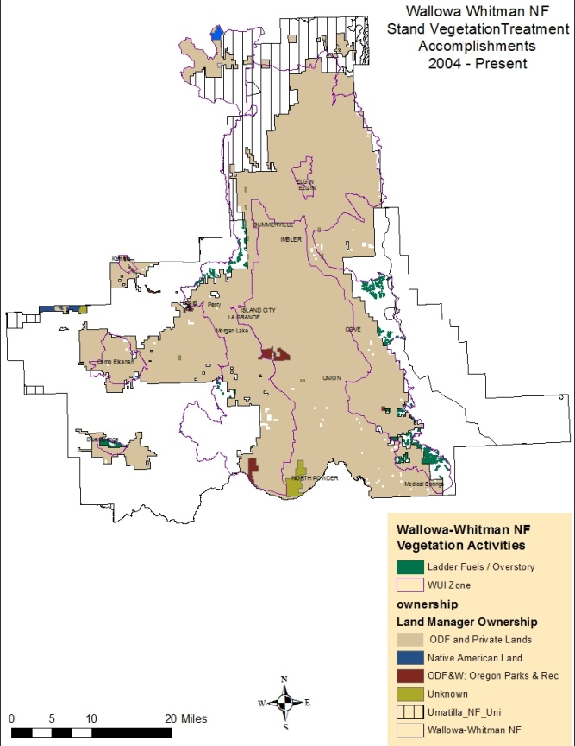
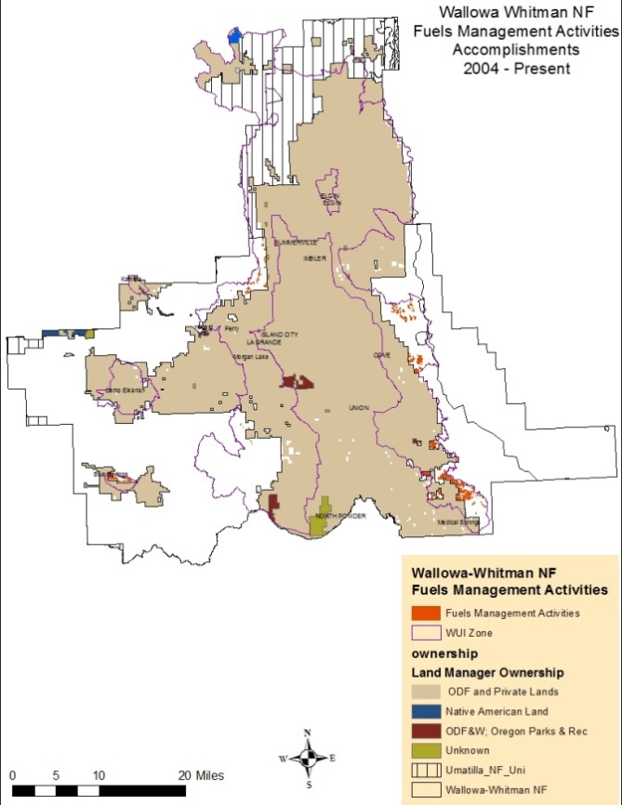
Figure X - 4. Approximately 7,494 acres treated under the 2005 CWPP fall within the current WUIZ. Treatments include: overstory thinning, ladder fuels reduction, pre-commercial thinning, etc.
Figure X - 5. Fuels treatments was applied to approximately 6,618 acres with some locations receiving more than one treatment type. Treatments include: debris piling, then burning of piles, underburning, etc.

Many of the treatment acres received both crown density and down woody fuels reduction activities; multiple management activity types often occurred on the same section of ground. Crown density and ladder fuel reduction occurred under vegetation management, followed up by some type of down woody fuels reduction treatment such as underburning, fuels removal/rearrangement, or machine/hand pile and burn. Treatment activities are designed to complement one another to meet the overall goal of fire risk mitigation.

Umatilla National Forest

Union County and the WUIZ section that extends into Umatilla County hosts approximately 109,372 acres of the Umatilla National Forest, which has accomplished 7,190 acres of fuels and vegetation project since the year 2000. All treatment activities are located northwest of Elgin, where private lands and the Umatilla Forest meet. In addition to the fuels activity projects there are a number of identified firebreaks to the northwest and southwest of Union County that can be used during suppression efforts.

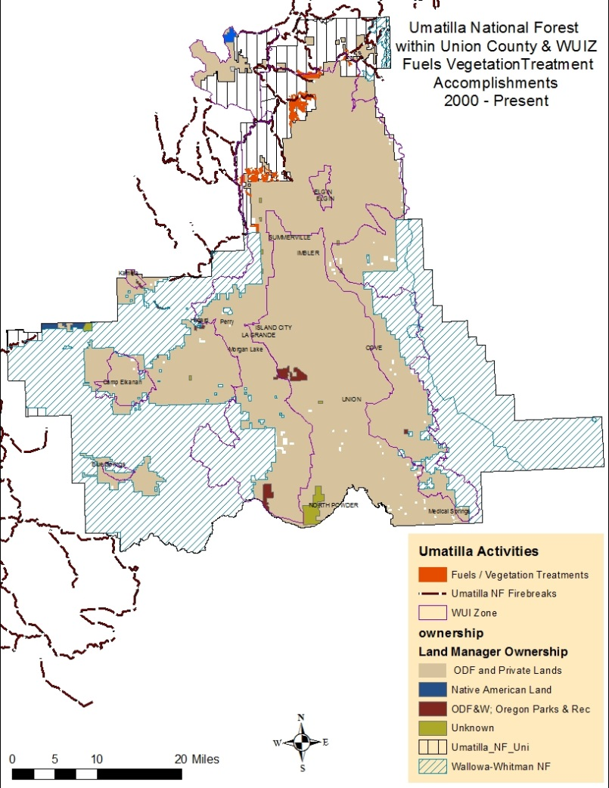
Figure IX - 6. Fuels and vegetation activities accomplished by Umatilla NF adjacent to private lands and identified fire breaks.

Although efforts to minimize fire risk have been initiated, wildfire risk often requires a multiple-phase approach to fully accomplish wildfire risk mitigation. Post-treatment site visits will be needed to assure activities on the ground have met the expectation of wildfire mitigation.

Challenges

Project Planning and Pace and Scale

Over the last decade, the issues of pace and scale continue to be at the forefront as millions of acres of forest lands are blackened annually from wildfires. According to Tom Tidwell, Chief of the USDA Forest Service while addressing the House Committee on Appropriations in 2013, “Between 65 and 82 million acres are in need of fuels and forest health treatments—up to 42 percent of the entire National Forest System.”

Federal agencies, including those in eastern Oregon continue to face challenges when attempts are made to increase pace and scale. In 2014, the Oregon Department of Forestry presented Oregon Senate Bill 357, a report to the state legislature on, Federal Forest Management. Section 1(1) of SB 357 requests, “The identification of potential approaches to diversifying revenue sources and improving the level of revenue available to increase the pace and scale of federal forest management.” In other words, finding ways to expand funding sources and the availability of funds is key to increasing the timeliness and size of forest management projects. The report also indicates the amount of NEPA completed is a limiting factor for increasing the pace and scale of restoration work on federal forest lands. Projects that are implemented are often found to be too small in acreage size or the treatment prescribed is not extensive enough for overall wildfire mitigation upon first entry. Other contributing factors include reduced staff, extensive detailed environmental analysis to avoid litigation, competing priorities (ODF 2014) or actual litigation.

Litigation of projects continues to occur for many Federal Agency projects. In 2015 a U.S. Government Accountability Office (GAO) provided, A Report to Congressional Requesters, on Forest Restoration. Agencies reviewed by the GOA were the Forest Service (FS), Bureau of Indian Affairs (BIA), Bureau of Land Management (BLM), Fish and Wildlife Service (FWS), and National Park Service (NPS). Part of the challenges of project litigation for federal agencies occurs from stakeholders that opted out of collaboration invitations, were not involved from the local area, or from the collaboration participants within the group itself. Litigation is time consuming, costly, strains agency/stakeholder relationships, delays or limits restoration activities and can discourage participation in future projects (GAO 2015).

The GAO report also reviewed 34 collaboration landscape-scale forest restoration projects (projects larger than 50,000 acres with a focus on forests) that occurred over a 10 year period, from 2004 through 2014. The Forest Service reported conducting 24 of the 34 projects; BLM, 8; and NPS, 2. Several project managers in the GAO reported that upfront collaboration during planning resulted in increased pace and scale, however large-scale projects continued to be subject to litigation just like small projects. Litigation often arrives when commercial logging is a key component of fuels reduction projects, however, changing fire on the landscape is ineffective and/or hindered when litigation slows project implementation particularly when mortality rates have increased due to overstocking leading to insect and disease. First entries must be aggressive not only in pace and scale but in thoroughness of treatment applications to avoid the need for additional entries in the near future.

The vulnerability of federal lands is occurring from a wide range of impacts that include, increase in wildfires and drought, stressed forests and vulnerability to insect and disease, and potential loss of critical habitat some of which is being contributed to climate change according to a May 2013 GOA report. As a result, there is growing agreement among land managers that efforts to restore forests should be undertaken at a scale commensurate with the scale at which disturbances, such as unnaturally severe wildfires that burn millions of acres annually, are occurring—that is, at a landscape scale (GAO 2015). The Blue Mountains of eastern Oregon historically experienced a surface fire, resulting in 25% or less mortality in the upper canopy of ponderosa pine plant associations, that burned an estimated 75% of the Fire Regime Condition Class I areas prior to Euro-American settlement (pre 1850). Union county is largely a Fire Regime I as per Chapter VI figure VI-9. To fully meet the GOA’s pace and scale recommendations sub-basin or larger approaches would be needed to adequately address conditions of Union County. Union County CWPP supports landscape scale approaches for both restoration and fire mitigation that not only promote the three goals of the Cohesive Wildfire Strategy, but also provide sustainable forests, recreational opportunities, and economic stability for the community in the future.

The House of Representatives H.R.2647 passed the Resilient Federal Forests Act of 2015, on July 9, 2015. Title I of the Act is designed to expedite environmental analysis and availability of categorical exclusions to accelerate forest management activities. Forest management activities for NEPA included under this act are those developed through collaboration, a resource advisory committee, or covered by a community wildfire protection plan. Primary purposes of the activities include: insect and disease infestation, reduction of hazardous fuel loads, protection of municipal water sources, maintain, enhance, or modify critical habitat to protect it from catastrophic disturbances; increase water yield or any combination of these. The bill is currently awaiting Senate approval.

Maintenance

Many older environmental documents and some recent documents fail to include a plan for maintaining treatment investments. Acknowledgement of retaining post treatment site conditions in plans will preserve accomplished fire mitigation measures and reduce future costs when follow-up activities to sustain initial investments of treatments are needed. Designing a plan to maintain treatment accomplishments and protect costs is identified in Section 102(g) (8) of the Healthy Forest Restoration Act (HFRA) that requires the USDA Forest Service and DOI BLM to develop a process for monitoring the need to maintain treated areas over time. Proposed actions and alternative descriptions should include an estimated maintenance treatment schedule and cost (USDA 2004).

How long before treated areas require re-treatment is dependent on several inter-related factors including:

• Past treatment level (e.g., how much biomass [fuel] was removed initially in the under story and over story);

• Site productivity;

• Rate of fuel accumulation;

• Fuel structure (i.e., condition class)

• Historic fire regime;

• Desired fire behavior (for effective control)

• Climatic regime.

Developing a rotational monitor program that allows for periodic site visits and updating of the CWPP fuels layer allows managers to review risk reduction efforts. The mapping of initial treatment information and fire regime assists in future CWPP updates identifying changes in risk.

Ninety-four percent of wildlands across the conterminous United States is dependent on wildfire as a fundamental ecological component (Stein et. al. 2012). Limited funds and workforce can leave fire managers with critical decision for application of treatments. New wildfire mitigation actions must be augmented with maintenance of previously treated areas to in order to provide the highest level of success.

Inventoried Roadless Area (IRA)

The Wallowa-Whitman National Forest supports a dispersion of designated roadless areas. Roadless areas make up approximately 69,418 acres of public lands within Union County. Forest Service lands within the new WUIZ alone contain 36,914 acres of inventoried roadless areas (IRA) in six separate locations. There is a total of roughly 24 miles of boundary where roadless areas borders private property. (Figure X - 9)

The interface of roadless areas and private lands presents several challenges when attempting to meet the national fire policies for reducing wildfire risk in wildland urban interface areas in order to protect communities at risk. Some of the key challenges include:
- Several roadless areas are displaying some of the highest fire risk ratings near communities (see Figure X - 7 and X - 8). The towns of Cove and Summerville are two examples where the roadless areas are exhibiting extreme fire risk and are located directly adjacent to the private lands. Costs associated with wildfires moving from public lands (roadless in this case) on to private lands are anticipated to be far higher than providing advance treatments.
- There are additional planning and implementation considerations (legal, social, ecological) and costs in order to treat across roadless boundaries for fire risk reduction.
- Past WUI treatments since 2005 have occurred within the Inventoried Roadless Areas of Mount Emily and Cove.
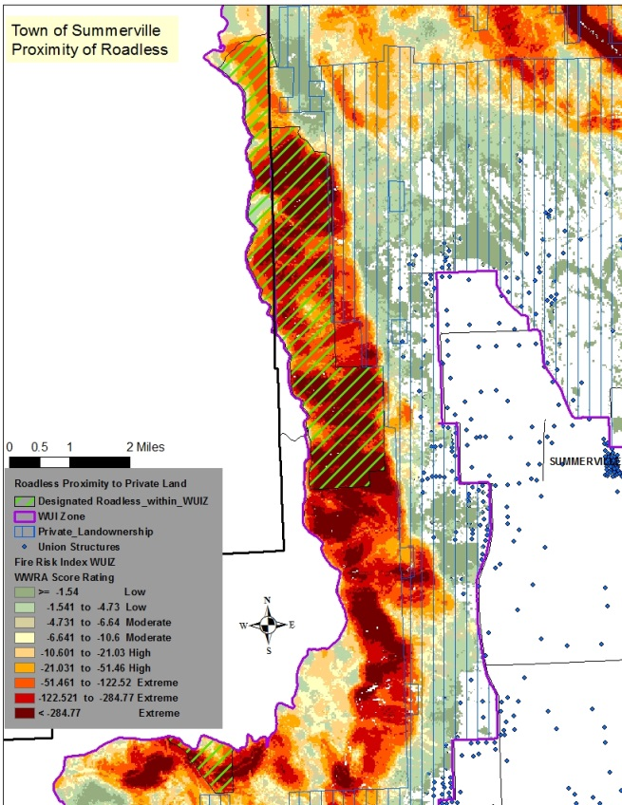
- According to May 31, 2012 letter from the Chief of the Forest Service Road management activities and timber harvest within roadless areas must generally be approved by Chief or the Regional Foresters (see Appendix L).
Figure X – 8. Wildland fire risk west of Hunter Lane, just north of La Grande near Mount Emily. Closest structures are on Dial Lane less than a quarter mile from the roadless boundary.
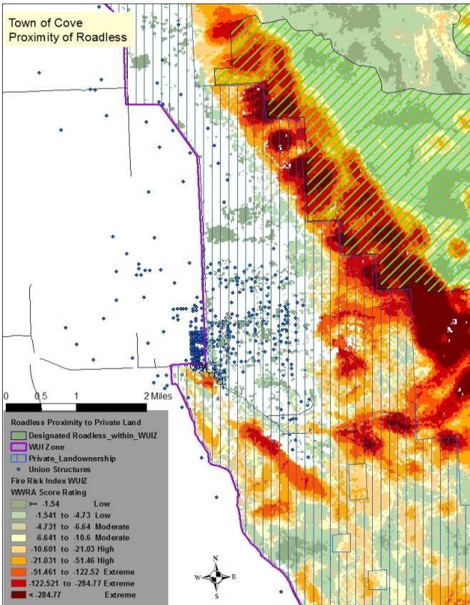
Figure X – 7. Wildland fire risk near town of Cove with roadless areas less than a half mile from nearest residence. Closest structure is located on Fletcher Lane.
Policies and guidelines provide direction on treatments types, material for removal, road construction, and authorities to approve entries within the IRAs. The Forest Service 1900 Manual, Chapter 1920 – Land and Resource Management Planning, lists exceptions regarding the need for approval at the Chief or Regional Forester level in inventoried roadless areas including:
- The removal of small diameter material to maintain or restore the desirable characteristics of ecosystem composition and structure to reduce the risk of uncharacteristic wildfire effects (FS Manual 1925.04a – Chief).
- The cutting, sale, or removal of timber is incidental to the implementation of a management activity and not otherwise prohibited under the land and resource management plan (FS Manual 1925.04a – Chief).
- Decisions when a road is needed to protect public health and safety in cases of an imminent threat of flood, fire, or other catastrophic event, that without intervention would cause the loss of life or property (FS Manual1925.04b – Regional Forester).

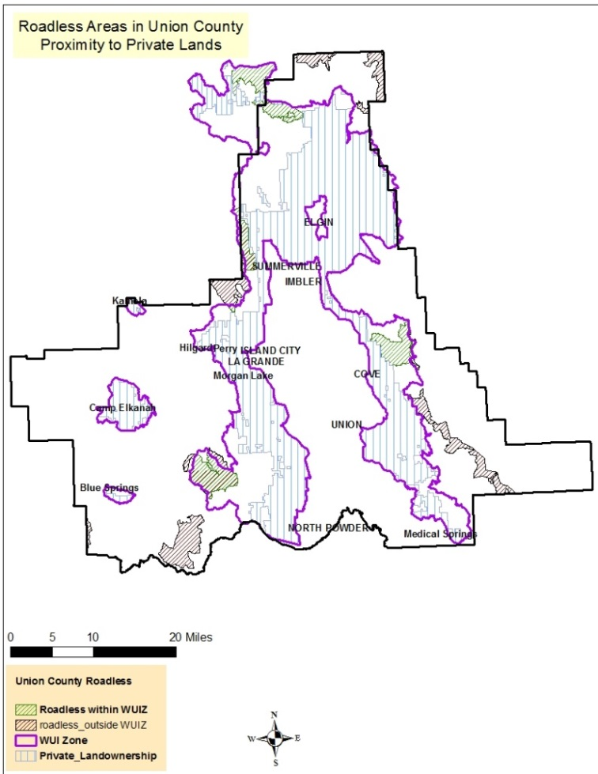
Figure X - 9. Designated Roadless areas within Union County
and within the WUIZ boundary.

The roadless area northwest of Elgin (Figure X – 9) in the corner of the WUI Zone is identified in the Federal Register Vol. 75. No 201, October 19, 2010 as part of the Oregon Tollgate Fuels Reduction Project. The Lookingglass IRA is part of the Forest Service proposal to treat targeted areas along the edge of the IRA boundary where it coincides with private inholdings and Forest Road 6400 (Federal Register 2010). According to the Record of Decision signed in 2014, treatments types were limited in the Lookingglass Potential Wilderness Area (LG PWA) to trees less than 8 inches in diameter and timber stand thinning changed from commercial treatments to non-commercial treatments. The Lookingglass IRA was modified from a commercial option to no commercial component with restrictions of treating trees only less than 8 inches in diameter and with removal of down woody material less than 14 inches in diameter (Umatilla NF 2014).

Union County’s 24 miles of roadless areas bordering private lands presents a number of challenges for both the Forest Service and adjacent landowners. These challenges must be addressed through a collaborative and a responsible program that puts firefighters and public lives first, while improving ecosystem characteristics that support wildfire disturbance. Retention of the current characteristics of the roadless areas is at times contrary to wildland urban interface protection objectives, direction manuals, and ecosystem management direction outlined in the Cohesive Wildfire Strategy.

Infrastructure

Union County hosts one of the few saw mills left in Eastern Oregon resulting in infrastructure challenges associated with material size, haul distance, limited contractors with appropriate equipment for the job, and assurance of products over long term.

Eastern Oregon has very little infrastructure that are capable to utilize biomass. Several challenges exist for biomass use that include potential start up fees for new companies, hauling fees of removing the material from site to the facility, and assurance of supply. Initiating the project is often based on estimates of available supply when considering a business plan and facility. This is often expressed as an assurance that a supply will be available from private, state, and federal lands within a realistic haul radius. The timeliness at which restoration activities occur on much of the public land has been slow due to lack of agreement on forest management and limited funding and staffing in the Forest Service and BLM (Davis et al 2010).

Additionally, finding contractors willing to work with biomass can be difficult partially due to the low value of the product, cost of removal, and in many areas the haul distance to processing sites. Because markets for commercial biomass products such as pellets, mulch, firewood, and animal bedding are limited, it is of little economic value to stewardship contractors, who could otherwise offset the agency’s costs of restoration by taking the value of the biomass as full or partial payment for their work (GAO 2015).

Air quality concerns

Air quality is important for aesthetic, public health, and many outdoor community events. Some project managers, in the GAO report, prescribed burning, one of the primary methods for forest landscape restoration, continues to be a challenge do to air quality and safety concerns.

Public perception of air quality standards and lack of education on smoke emissions trade-offs compared to wildfire, limits the opportunities of prescribed burning in an already restrictive program. In many areas smoke emissions constraint are implemented during community events further limiting the number of days a burn may be within the legal parameters of the burn plan.

According to the Oregon Administrative Rules (OAR) division 48, 629-048-0140, the city of La Grande is listed as a smoke sensitive receptor area which increases the cost of wildfire mitigation if limits are put on prescribed fire, particularly where public lands are concerned and management options are limited. Air quality impacts include both local and offsite sources. Transport winds have been found to carry prescribed fire and wildfire smoke from neighboring lands, further limiting local agencies’ burning opportunities.

Tradeoffs between smoke generated by a prescribed burning under which management-designed prescription conditions are provided, with specific weather and fuels parameters, and summer wildfires in which fire location and conditions are unpredictable are significant. Smoke emission tradeoffs are beneficial where prescribed fires managed at specific times of year produce less particulates than wildfires that burn during the peak of fire season. Roger Ottmar, one of the leading researchers on fire effects, fuel consumption, emissions production, and impacts on air quality and human health uses the following graph (figure X - 10), during a Forest Service smoke management class, displaying the amount of particulate matter (PM) emitted from both wildfires and management prescribed fire.
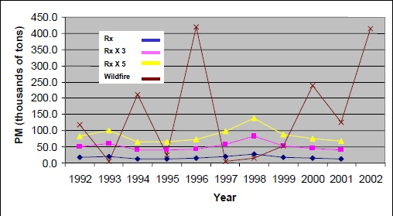
Figure X - 10. Prescribed fires consume less fuel, producing 2 to 4 times less smoke, and can be planned when meteorological conditions are favorable for dispersion, and can include smoke reduction strategies (Ottmar 2002).

There are multiple options available to further reduce smoke emissions to support air quality concerns and impacts to community health. These include:
- Woody biomass utilization
- Mechanical processing/removal
- Firewood programs
- Burn fuel concentrations, creating mosaic burns, pile and burn
- Grazing
- Converting an area; heavy timber into timber/grass
- Burn in advance of precipitation
- Portable incinerators (Ottmar 2002).

Beyond the WUI Zone

This CWPP emphasizes lands within the identified WUIZ for the best protection of local communities, but wildland fire issues do not stop at the WUIZ boundary. Union County is 1,303,680 acres in size, encompassing a WUIZ of 503,575 acres, and leaving an additional 800,105 acres outside the primary focus of this document. However, consideration must be given to outliers not within the WUIZ that may need both fire mitigation and protection actions.

In 2013, Phase III of the National Cohesive Wildland Fire Management Strategy (NCWFMS) was developed called the Western Regional Action Plan. This plan was developed with stakeholder input and is a science-based roadmap to provide a truly western approach to wildland fire that addresses the three goals of the CWS (NCWFMS 2013). An important element of the Action Plan is, “the emphasis on fuels treatments from the community outwards, into the middle lands and toward the wildlands.”

When appropriate, allowance for the incorporation of areas supporting the mitigation actions of this plan can further increase a holistic approach to the CWS goals. Identifying complementing actions that promote a collective and responsible approach to wildland fire mitigation is necessary. This type of approach will assist managers in several ways by:
- Reducing the need for separate funding acquisitions just outside the WUIZ.
- Expanding upon the WUIZ edges when it meets a wildland risk or ecological objective.
- Contributing to the landscape-scale approach.
- Increasing protection for structures not included within the WUIZ.
- Allowing for local, state, tribal, federal agencies as well as the community to support one another by taking into account all lands and acknowledging the interdependence of actions (keeping in mind the differing land and resource management objectives).
- Increasing the economic viability of projects through single NEPA and planning.

With wildland urban interface areas as a focus in current fuels reduction budgets, there is an increased need for creative approaches in spending.

Summary

Since 2005, several thousand acres of fuels reduction have been accomplished in Union County for wildland fire mitigation near communities. This marks the first step for local agencies and landowners in progress toward collectively working together for a common cause. This cause must be carried forward to areas that are still at risk while preserving investments already established.

Through the Cohesive Wildfire Strategy’s emphasis on the inclusion of middle ground areas, the west has the ability to expand fire mitigation actions beyond the initial wildland urban interface areas. This ability to expand into middle ground areas combined with the degree of departure of western fire regimes from historic conditions supports the need for landscape scale projects. Wildland conditions in Union County mirror those fire regimes and ecosystem departures of the western forests prompting a need for action.

This philosophy of scale provides several benefits for suppression resources, communities, and ecosystems. A balance of both utilization and consumption of fuels will address many concerns from air quality, economic stability, and fire risk mitigation.
Through a diverse use of management tools, a variety of treatments can be applied toward management objectives.

However, several issues continue to challenge agencies and landowners in their efforts to reduce wildland fire risk. Small projects are a starting point but are not effective in cost or timeliness against the continued possible threat of severe wildfires. Large-scale approaches that mimic historical landscape disturbance where a diversity of management tools can be utilized will provide not only success in suppression efforts near communities, but support for economic and ecological resiliency in Union County.

Bibliography

Davis, Emily Jane; Moseley, Cassandra; Nielsen-Pincus, Max; Abrams, Jesse; Brady, Cullen; Christoffersen, Nils; Davis, Chad; Enzer, Maia J.;Gordon, Josef; Goulette, Nick; Jungwirth, Lynn; Jungwirth, Jim; Kauffman, Marcus; McCarthy, Tyler; Shannon, Patrick; Sundstrom, Shiloh. 2010. The State of the Dry Forest Zone and its Communities. https://scholarsbank.uoregon.edu/xmlui/handle/1794/10802

Federal Register. October 19, 2010. Notices: Department of Agriculture, Forest Service, Umatilla national Forest, Walla Walla Ranger District; Oregon Tollgate Fuels Reduction Project

GAO Government Accountability Office, April 2015. Report to Congressional Requesters: Forest Restoration, Adjusting Agencies’ Information-Sharing Strategies Could Benefit Landscape Scale Projects.
Graham, Russell T.; McCaffrey, Sarah; Jain, Theresa B. (tech. eds.) 2004. Science basis for changing forest structure to modify wildfire behavior and severity. Gen. Tech. Rep. RMRS-GTR-120. Fort Collins, CO: U.S. Department of Agriculture, Forest Service, Rocky Mountain Research Station. 43 p.

NCWFMS, 2013. Phase III of the National Cohesive Wildland Fire Management Strategy

Oregon Department of Forestry May 2014. Senate Bill (SB) 357.

Ottmar, Roger. 2002. PDF slide show of RX-410 Smoke Management Techniques. Fire and Environmental Research Applications, Fire Science Laboratory, United States Forest Service.

Stein, S.M.; Menakis, J.; Carr, M.A.; Comas, S.J.; Stewart, S.I.; Cleveland, H.; Bramwell, L.; Radeloff, V.C. 2013. Wildfire, wildlands, and people: understanding and preparing for wildfire in the wildland-urban interface—a Forests on the Edge report. Gen. Tech. Rep. RMRS-GTR-299. Fort Collins, CO. U.S. Department of Agriculture, Forest Service, Rocky Mountain Research Station.

Stine, Peter; Hessburg, Paul; Spies, Thomas; Kramer, Marc; Fettig, Christopher
J.; Hansen, Andrew; Lehmkuhl, John; O’Hara, Kevin; Polivka, Karl;
Singleton, Peter; Charnley, Susan; Merschel, Andrew; White, Rachel. 2014.
The ecology and management of moist mixed-conifer forests in eastern Oregon
and Washington: a synthesis of the relevant biophysical science and implications
for future land management. Gen. Tech. Rep. PNW-GTR-897. Portland, OR: U.S.
Department of Agriculture, Forest Service, Pacific Northwest Research Station.
254 p.

Tidwell, Thomas. June 4 2013. Chief of Forest Service statement before the Committee on Energy and Natural Resources, U.S. Senate. Wildland Fire Management

USDA 2004. United States Department of Agriculture; U.S. Forest Service; U.S. Department of Interior; Bureau of Land Management. The Healthy Forests Initiative and Healthy Forests Restoration Act, Interim Field Guide.

U.S. Forest Service. Umatilla National Forest 2014. Record of Decision for Tollgate Fuels Reduction Project. Walla Walla Ranger District, Umatilla and Union Counties, Oregon.

Web Links:

Forest Service 2016. Wallowa-Whitman National Forest Current and Recent Projects. http://www.fs.usda.gov/projects/wallowa-whitman/landmanagement/projects

Oregon State Department of Forestry, 2016. Division 48 Smoke Management, Oregon Administrative Rule 629-048-0140. http://arcweb.sos.state.or.us/pages/rules/oars_600/oar_629/629_048.html

Oregon State 2016. Oregon Administrative Rules, Department of Forestry Division 48 Smoke Management 2016. http://arcweb.sos.state.or.us/pages/rules/oars_600/oar_629/629_048.html

Senate Bill 1072, http://www.oregon.gov/Pages/index.aspx#search?q=Senate%20Bill%201072

H.R. 2647. 2015. House of Representative - Resilient Federal Forests Act of 2015 https://www.congress.gov/bill/114th-congress/house-bill/2647

