**VII. Communities at Risk and WUI Zone Priority Setting**

**Introduction**

Efforts of the National Cohesive Wildland Fire Management Strategy (CWS) are defined by three phases, with phase I involved in establishing the vision statement, national goals, and guiding principles (CWS 2014). In short, Phase II shifted focus to understanding regional and local wildland fire management challenges and opportunities, while Phase III involved a descripted analysis of regional issues contributing to risk. Union County has taken this analysis to the local level to identify key attributes that contribute to wildland fire risk as it pertains to firefighting capabilities, landscape conditions with resultant fire behavior, and community preparedness.

This chapter applies the WWRA Framework, described in Appendix D, with other pertinent local issues to determine areas of priority, particularly in regard to at-risk communities and WUIZ locations that are sustaining conditions that contribute toward negative outcomes. Additional details describing prioritization of data layers can be found in Appendix F.

Supporting data is used to describe the following conditions:

* Attributes Contributing to Wildland Fire Potential
* Likelihood of a fire occurring
* Wildfire behavior – flame length, rates of spread
* Probability of a canopy fire
* Wildfire effects to values
* Fire Protection Capability/Structure Vulnerability
* Protection area structure density
* Protected vs. unprotected
* Where people live
* Values to be protected
* Community preparedness
* Suppression difficulty

Using the definition of the WUIZ, the goals of this CWPP, and identified communities at risk according to federal, state, and local governments, it was important to assess and compare fire risk for each community both in and outside the WUIZ boundary and the WUIZ itself. The WUIZ design allows for prioritizing opportunities for cross-boundary treatment approaches to meet the concept of “all hands, all lands”. The majority of communities addressed are under rural fire protection, so excluding a community even though it fell outside of the WUIZ would not meet the goals and objectives of this document regarding fire response. All communities were assessed for a relative rating against other communities.

U.S. Department of Agriculture in the Healthy Forest Restoration Act (HFRA) defines wildland urban interface as an area within or adjacent to an at-risk community that has been identified by a community in its wildfire protection plan and the HFRA define a “community at risk” from wildland fire as:

* A group of homes and other structures with basic infrastructure and services (such as utilities and collectively maintained transportation routes) in or adjacent to federal land;
* Has conditions conducive to large-scale wildland fire; and
* Faces a significant threat to human life or property as a result of a wildland fire.

Oftentimes, federally-managed public lands are situated in the middle ground area extending well beyond the boundaries of communities at risk, yet these locations are often the source of natural fires that develop into large wildfires that threaten communities.

The WUIZ approach provides Federal agencies some opportunities for treating these areas that are consistent with the Health Forest Restoration Act planning direction described below:

* The HFRA identified a WUI as 1 ½ miles from the boundary of an at-risk community. This area does not require the USDA Forest Service and Department of Interior – Bureau of Land Management (BLM) to analyze any alternative to the proposed action as long as the proposed action recommendations meet the general location and basic method of treatments outlined in this CWPP.
* Areas within the Wildland Urban Interface - for Union County CWPP it would be within the WUIZ - but *farther* than 1 ½ miles from the boundary of an at-risk community, the USDA Forest Service and BLM are not required to analyze more than the proposed agency action and one additional action alternative (Section 104(d)(1)), (HFRA 2004). This area meets the “middle ground” locations consistent with the CWS.

This section focuses primarily on the Communities at Risk CAR and WUIZ with understanding that all of Union County was presented for overall Fire Threat, Fire Effects, and Fire Risk. The Fire Effects portion was displayed as a countywide map, since some infrastructure and forest assets extend well beyond the WUIZ.

Mitigation actions (Chapter VIII) and assessment were primarily applied to locations within the identified WUIZ for Union County and its communities at risk. Mitigation actions outside the WUIZs may be isolated locations of important infrastructure protection or other interests; these were not part of this assessment but can be assessed on an individual basis later or when appropriate to ensure they meet the criteria of mitigation action items presented in Chapter VIII.

Since the conception of the 2005 Union County CWPP, new developments have occurred regarding fire policies and programs. These policies and programs are designed to provide direction on relatively consistent approaches in determining fire risk assessments when revising Community Wildfire Protection Plans. Some key documents referenced for this process, as instructed by the Oregon Department of Forestry:

1. *West Wide Wildfire Risk Assessment.* Was completed onbehalf of the Council of Western State Foresters with funding from the USDA Forest Service. March 31, 2013.
2. *The Final Phase in the Development of the National Cohesive Wildland Fire Management Strategy.* The National Strategy. April 2014.
3. Oregon Administrative Rules 629-044, Oregon Department of Forestry, Criteria for Determination of Wildfire Hazard Zones, June 15, 2016.
4. Fiscal Year 2016 Budget Overview, US Department of Agriculture. Key areas of focus include: restoring resilient landscapes; building thriving communities; managing wildland fires; promoting safety for employees and public. February 2015
5. Senate Bill 357, Report to the Legislature Oregon Department of Forestry. Using stewardship authority to increase the pace of restoration, create jobs, and support local economies. May 2014.

These documents support expanding the assessment of communities-at-risk to also include the assessment of wildland-urban interface zone beyond communities to include surrounding areas.

In Union County, a ***community-at-risk*** is defined as a group of homes or other structures with basic infrastructure (such as shared transportation routes) and services within or near forest land.

In order to understand the fire risks on communities and urban interface areas, it is necessary to recognize the interactions of several elements at the landscape scale. Union County is approximately 1,304,523 square acres in size, supporting a Wildland Urban Interface Zone (WUIZ) area of 504,250 acres with some shared areas across boundaries in Umatilla and Baker Counties. To the northwest, Umatilla County supports the Tollgate area with Spout Springs Ski Area and Resort and multiple vacation homes lying across the boundary in Union County. The Anthony Ski area and Resort is located just inside Union County at its southernmost point, while many vacation homes are just across the boundary in Baker County. The WUIZ area strictly within the Union County boundary line accounts for 458,341 acres or 35% of the land base leaving 45,909 acres of WUIZ shared with the two counties.

The wildland-urban interface zone is not exclusive to communities, but is described as:

*“An area strategically identified that provides effective wildfire defense for communities, infrastructure, and other values at risk that meet or intermingle with wildland fuels and offer opportunities for broadened mitigation measures designed to interrupt wildfire spread and modify wildfire behavior in order to protect social, economic, and environmental interests”.*

Risk, in terms of wildfire, incorporates a multitude of elements that could potentially influence how fire interacts with the environment, the likelihood of a fire occurring and spreading, and values that could be impacted by a fire. Risk includes an array of historical and current information that provides realistic potential outcomes based on expected and past results, particularly fire starts, spread, and size.

The Merriam-Webster defines risk as: “*The possibility that something bad or unpleasant (such as an injury or a loss) will happen; someone or something that may cause something bad or unpleasant to happen”.*

Wildfire “risk” for the purpose of this document, is a product of a multitude of interlinked conditions. It goes beyond just the possibility of a wildfire starting by combining the possibility of a bad outcome from a wildfire with contributing factors that play a role once ignition occurs. Factors such as weather, vegetation, ability to fight the fire, and historical fire size allow management to understand the level of fire threat in all acres across the county. Factors such as infrastructure, where people live, drinking water, and natural resource values combined with the level of difficulty in suppressing a fire start at any given location, provide insight on the values that potentially could be impacted by fire.

**Prioritizing Communities at Risk**

The Grande Ronde Valley Basin, plus anything within one mile of the actual valley, including along the foothills, supports eight communities at risk listed in the Federal Register, with the remaining communities scattered throughout the county.

Each community was examined using an agreed to set of concerns that could influence the outcome in the event a wildland fire occurs, and the probability of one actually happening. A matrix was developed to evaluate the individual communities and their surrounding areas based on these concerns. Nomenclature ratings of Low through Extreme breakouts were assigned corresponding to 1 through 4 numerical values respectively in order to compare communities at risk against one another.

1. Union county’s communities at risk, for this assessment, fell into one of three criteria.
2. An area designated by state or federal register with city limits established,
3. An area designated by state or federal register that did not have city limits established, or
4. An area that supported a population in a remote place recognized by Union County as a community at risk and has no established city limits.
5. In order to assess the communities at risk and their surrounding areas for the assessment, a common boundary design needed to be established for these areas. All communities were assigned a periphery perimeter encompassing the highest populated areas that included city limits and high residential areas extending out to homes in and near forested areas. Assessing these areas required the use of the most current data that incorporated the highest number of structure locations (including residence) in Union County.

Because perimeters were based on populated areas, there was no established acreage size for assessed communities. The WUIZ area, as a whole, was not considered at this time due to the fact that some communities at risk fell both inside and outside of the identified zone. Because of the close proximity and overlapping community buffers, some communities were combined with adjoining communities. The Union County structure layer obtained from the Forest Service contained the highest level of structural accuracy.

1. Once the community perimeters were finalized, a consistent 1.5-mile buffer was established to better meet the policy and guidelines assessment needs for all agencies. The community areas and the 1.5-mile buffer combined were the final analysis size for the *community* ratings. Those communities that were not within the WUIZ but were assessed are, listed from north to south: Imbler, Island City, Union, and North Powder. Those communities buffered 1.5 miles which still do not intersect the WUIZ are Imbler and Island City. Since Imbler when buffered intersects with Summerville, and Island City intersects La Grande, they are included in the rankings of priority and grouped with their adjoining communities.

This CWPP addresses prioritization as an additional method to identify and support mitigation needs. Two individual subsets of wildfire risk were used for prioritization of communities. Features such as high fire occurrence, wildfire rates of spread, flame length, and potential for crown fire are some of the attributes taken into consideration that could potentially pose a threat to community. The “expected” fire behavior results were used to represent what was likely to occur. It was recognized that down woody fuel and vegetation characteristics are some key influences in wildfire fire behavior and can be viewed individually based on anticipated wildfire behavior. A full description of attributes, their breakpoints for low through extreme, and the rationale for their use can be found in Table I of Appendix F. The table provides the 13 attributes assessed for determining community rankings and how the ratings of 1 through 4 were determined.

**Prioritization Overview**

The attributes were divided into two assessment categories concerning wildfire.

1. Wildland Fire Potential – This includes attributes that show the probability of an acre igniting and measure of fire behavior characteristics. It also provides the three key West Wide Risk Assessment (WWRA) outputs that measure;
2. Fire Risk Index - the overall wildfire risk based on all current data.
3. Fire Threat Index - an index related to the likelihood of an acre burning.
4. Fire Effects Index- addresses important values affected by wildland fire and/or that are costly to suppress.
5. Fire Protection and Fire Structure Vulnerability – these attributes demonstrate the potential for suppression resource effectiveness in protecting structure and lands in close proximity to homes. In addition, those areas that have important values that could be impacted and current level of completed preparedness by landowners on pre-wildfire treatments.

Each table attribute was rated from 1 through 4, numbers that correspond respectively to a nomenclature ranking of low, moderate, high, and extreme. Assigned numerical ratings were designated based on the source of the data used. Data sources included the WWRA and agency data from ODF, Forest Service, and Union County Emergency Service. Numerical ratings and the two categories of Wildfire Potential and Fire Protection and Fire Structure Vulnerability allow managers to identify key mitigation actions that will be most effective.

**Overall Fire Protection Capability/Structural Vulnerability**

In order to determine the overall fire protection capabilities and structural vulnerability it was necessary to develop a new category with its own individual sub-tally. Several characteristics were considered when identifying the overall community susceptibility to wildfire. The approach for this category took into consideration six characteristics that contributed to 46 percent of the final score.

1. How predisposed the community structures are to wildfire.
2. Whether the area is currently under protection responsibility.
3. The level of protection capabilities based on suppression resource coverage area and the structure ratio to the size of the protection area.
4. Additional infrastructure values that may be impacted in addition to community structures.
5. Overall fire defense difficulty that would identify areas of impeded fire suppression efforts that may result in wildfire spread into the communities.
6. Current community level of preparedness in the event a wildfire should occur.

All ratings were given a 1, 2, 3, or 4 for corresponding low, moderate, high, and extreme impacts respectively. The table in Appendix F outlines what those represent for each characteristic examined. Final selection of rating was centered on highest percent of land area that fell into the rating category, unless it was deemed that proximity to communities warranted a different rating due to imminent impacts to communities. It was determined that local knowledge was important in finalizing the ratings.

**Communities at Risk Ranking Results**

Union County hosts the several small communities and the third largest town, La Grande, of Oregon’s eight most eastern counties. Twenty residential and/or vacation areas have been identified as either a community at risk or area of concern for wildfire. The State of Oregon has identified 16 of these as communities at risk, with 12 of those also listed in the Federal Register (See Chapter III for listing). Additionally, there are four small, dispersed communities identified as at-risk by Union County: Blue Springs, Kamela, Perry, and Spout Springs Ski Area and its resort cabins.

Once the attributes rating system was finalized, mapping of current conditions was evaluated for communities at risk using local and WWRA data from the Geographic Information System (GIS). Figure VII – 1 displays the comparative results of the CAR. Details of the ranking process can be found in Appendix F.

It was important to evaluate communities and surrounding areas by prioritizing areas to assist land managers and community members with a high degree of information for the most effective use of funds. To meet Oregon Department of Forestry guidelines, the primary final risk maps were given the rankings of Low, Moderate, High, and Extreme. These ratings were assigned numerical values to help managers identify areas that ranked out as having: a. the highest likelihood of a fire occurring, b. potential for wildfire behavior, c. overall fire risk, d. protection status and coverage areas, e. activity vegetation treatments in place, f. the expected difficulty in suppression a wildfire. It provides each category a relative comparison of one CAR to the others.

|  |  |  |  |  |  |  |  |  |  |  |  |  |  |  |  |  |
| --- | --- | --- | --- | --- | --- | --- | --- | --- | --- | --- | --- | --- | --- | --- | --- | --- |
| Communities  At Risk | Wildland Fire Potential | | | | | | |  | Fire Protection and Fire structure vulnerability | | | | | | |  |
| Fire  Occurrence | Flame Lengths | Rate of Fire Spread | Probability of Canopy Fire | Fire Threat | Fire Effects | Fire Risk | Sub Total Score | Protection - Structures to Sq. mile ratio | Protected verse  non-protected | Wildland Development Area | Values Impacted | Level of Community Preparedness | Suppression Difficulty | Sub Total Score | Grand Total |
| Anthony Lakes | 3/H | 4/E | 2/M | 4/E | 4/E | 2/M | 4/E | 23 | 3/H | 4/E | 2/M | 3/H | 4/E | 2/M | 18 | 41 |
| Blue Springs | 3/H | 2/M | 2/M | 4/E | 2/M | 1/L | 2/M | 16 | 4/E | 4/E | 1/L | 2/M | 2/M | 2/M | 15 | 30 |
| Camp Elkanah | 3/H | 2/M | 2/M | 1/L | 2/M | 2/M | 3/H | 15 | 3/H | 4/E | 1/L | 3/H | 4/E | 1/L | 16 | 31 |
| Cove | 3/H | 2/M | 2/M | 4/E | 4/E | 2/M | 4/E | 21 | 4/E | 2/M | 3/H | 2/M | 4/E | 3/H | 17 | 38 |
| Elgin, Palmer Junction | 2/M | 4/E | 2/M | 4/E | 2/M | 3/H | 3/H | 20 | 4/E | 2/M | 3/H | 4/E | 4/E | 2/M | 19 | 39 |
| Hilgard, Perry | 3H | 2/M | 2/M | 3/H | 4/E | 4/E | 4/E | 22 | 2/M | 4/E | 2/M | 4/E | 4/E | 3/H | 19 | 41 |
| Imbler, Summerville | 3/H | 4/E | 2/M | 4/E | 4/E | 3/H | 4/E | 24 | 3/H | 2/M | 3/H | 2/M | 4/E | 3/H | 17 | 41 |
| Island City, La Grande | 3/H | 2/M | 2/M | 1/L | 3/H | 4/E | 3/H | 18 | 4/E | 2/M | 4/E | 4/E | 4/E | 1/L | 19 | 37 |

|  |  |  |  |  |  |  |  |  |  |  |  |  |  |  |  |  |
| --- | --- | --- | --- | --- | --- | --- | --- | --- | --- | --- | --- | --- | --- | --- | --- | --- |
| Communities  At Risk Issues | Wildland Fire Potential | | | | | | |  | Fire Protection and Fire structure vulnerability | | | | | |  |  |
| Fire Occurrence | Flame Length | Rate of Fire Spread | Probability of Canopy Fire | Fire Threat | Fire Effects | Fire Risk | Sub Total Score | Protection – Structures to Sq, Mile Ratio ** | Available Structure Protection ** | Wildland Development Areas | Values Impacted | Level of community Preparedness | Suppression Difficulty | Sub Total Score | Grand Total |
| Kamela | 3/H | 3/H | 2/M | 4/E | 1/L | 4/E | 3/H | 20 | 2/M | 4/E | 1/L | 3/H | 4/E | 2/M | 16 | 36 |
| Medical Springs | 1/L | 2/M | 2/M | 4/E | 2/M | 2/M | 3/H | 16 | 2/M | 2/M | 2/M | 2/M | 4/E | 2/M | 14 | 30 |
| Mount Emily  (mention MERA and recreation use) | 3/H | 4/E | 2/M | 4/E | 3/H | 2/M | 4/E | 22 | 3/H | 3/H | 3/H | 2/M | 4/E | 3/H | 18 | 40 |
| North Powder | 3/H | 2/M | 2/M | 2/M | 2/M | 2/M | 2/M | 15 | 2/M | 2/M | 2/M | 4/E | 4/E | 1/L | 15 | 30 |
| Spout Springs | 1/L | 4/E | 3/H | 4/E | 4/E | 4/E | 4/E | 24 | 3/H | 4/E | 2/M | 3/H | 4/E | 4/E | 20 | 44 |
| Union | 1/L | 2/M | 2/M | 1/L | 2/M | 2/M | 2/M | 12 | 3/H | 2/M | 3/H | 3/H | 4/E | 2/M | 17 | 28 |

Figure VII – 1. Identified communities at risk and their corresponding attribute rankings. ** Does not have a corresponding map for this attribute.

**Interpretation of Results**

The rating output in Figure VII-1 provides insight on both overall conditions and specific issues facing each community analyzed. Rating scores provide a means of relative comparison for the CAR, however **using only the final rating as a rationale in approaching fire risk would result in missed opportunities to address underlying causes**.

All attributes rated under the Wildland Fire Potential were accessed from the WWRA. Additional local information was used to display any data gaps. The attributes of Fire Threat and Fire Effects are the primary sub-sets of Fire Risk. The overall Fire Risk accounts for all attributes combined and assessed in the WWRA framework as shown in Appendix F.

Fire behavior is influenced by fuels (live and dead), weather, and topography; human influence is only applicable to fuels in modifying fire behavior. Knowledge of expected fire behavior provides opportunities for fire behavior modification in advance of an ignition. In areas where flame lengths are High or Extreme, utilization of suppression hand crews alone would be ineffective in fighting fires based on flame lengths over four feet, and would require other resource support such as engines, dozers, and aerial delivery resources. Additionally, knowing flame lengths and the probability of canopy fire provides knowledge of areas where stand conditions are not consistent with “historic conditions” and are likely to promote the transition of surface fires into canopy fires.

Areas with a low fire occurrence (likelihood of a fire start), but displaying extreme fire threat and/or fire risk, such as Spout Springs, indicate that while the chances of a fire actually starting in the general area is low, if a fire were to ignite, the outcome could have dire consequences. Emphasis may not be needed in fire prevention for this location, but funds and efforts might focus on the modification of vegetation conditions that would support extreme flame lengths and canopy involvement during wildfires.

Fire Protection and Fire Structure Vulnerability utilized a combination of county, state, and WWRA attributes. These attributes provide insight to the level of protection capabilities, values, and difficulties facing each CAR.

Fire protection attributes can also be used as stand-alone indicators of conditions and issues facing the CARs. The community of Cove is currently under fire protection, however the structure ratio to protection area is at the highest level, indicating that protection resources would be depleted rather quickly in the event that the community was threatened.

**Management Considerations**

Knowledge of elements that are contributing to the increase in both wildfire potential and vulnerability of the communities provides focal points for reducing the potential for loss during wildfires. Results of the Community at Risk assessment can be beneficial for land managers in a number of ways. Resultant information can be used to:

1. Identify where the most critical wildfire potential is among the CAR.
2. Distinguish between CAR(s) that have fire and structure vulnerability issues in terms of resource response verses those that are more susceptible to extreme wildfire behavior.
3. Decision makers can focus on specific attributes that are contributing to wildfire behavior, thereby influencing reduction of the overall risk to that community.
4. Enables decision makers to take advantage of attributes that present opportunities to expand upon an already existing lower rating.
5. Identifies locations where mitigation actions create a ripple effect, influencing other attributes and possibly expanding the spatial area of treatment.
6. Identifies coverage areas versus number of structures for rural fire departments and areas where there are potential opportunities for remote sub-stations.
7. Provide opportunities for communicating information with community members about wildfire potential and emphasizing the need for shared responsibility among all landowners in reducing wildfire risk.

Individual CAR mapping of attributes corresponding to attributes in figure VII – 1 can be found in Appendix F - Maps.

**WUI Zone and Middle Ground Assessment**

The middle ground area that is incorporated in the WUIZ accounts for a large percentage of the WUIZ land base. The WUIZ ownership is divided among primarily Forest Service and private lands accounting for 34 percent and 65 percent respectively, with Bureau of Land Management and Oregon State making up the last 1 percent of ownership.

As communities recognize themselves as at risk and approach Federal agencies to work collaboratively, joint development of plans and projects will ensure that investments in hazardous fuel reduction are the most economical and effective ways to reduce risk (HFRA, 2004). HFRA plans and projects are supported by the Memorandum of Understanding (MOU) for The Development of a Collaborative Fuels Treatment Program signed by the U.S. Department of Agriculture, U.S. Department of Interior, the National Association of State Foresters, and the National Association of Counties. Its purpose is to:

1. Provide the framework of a process for these agencies to collaborate on the annual selection of a fuels treatment program of work within their respective jurisdictions to provide for community protection and enhance the health of forests and rangelands.
2. Allow the parties to recognize that fuel treatments should be prioritized and selected through a timely collaborative process, and should be coordinated across ownerships and jurisdictions to effectively protect communities and improve forest and rangeland health.
3. Treatments will be accomplished by concentrating on high priority areas: 1) in the wildland-urban interface and, 2) outside the wildland-urban interface that are in condition classes two and three (MOU 2003).

Identifying areas with conditions that promote potential for high rates of spread, flame lengths, and likelihood of crown fires provides locations for concentrated efforts. Knowing the stand conditions such as surface fuels, canopy closure, canopy base height, and crown bulk density offers insight on the types of vegetation management that may be needed to alter fire behavior.

Although Fire Risk takes into account both Fire Threat and Fire Effects, it is important when treating middle ground areas to also know where and what stand conditions are promoting wildfire behavior and where the likelihood of ignition starts will occur. This provides insight on locations to better prepare the landscape toward resiliency and strategically place treatments to support successful suppression efforts.

The intent of this approach is to concentrate management efforts in areas where funding can achieve multiple objectives, while maintaining consistency with the CWS goals and agency(s) direction. The WUIZ provides opportunities to identify locations that strategically make the most sense for resilient landscapes and fire response success, and where environments can realistically be manipulated to meet management objectives across landownerships.

**Landscape Conditions**

It was important to visually display a breakout of the four rankings – low, moderate, high, and extreme – spatially to assess where landscape conditions could be compared and where treatments would be most appropriate. Treating the worst-case conditions would intuitively make sense; however, it may not be the most appropriate approach in all cases due to biophysical conditions (slope/access), funding limitations, or strategic design for increasing the successfulness of suppression efforts. Examples in which a lower-ranked area may benefit more from treatment are:

1. An area in which investments in vegetation modifications have previously occurred or resource response capabilities have been improved; may warrant the need to retain those initial investments and build upon already established work.
2. An area that is of lessor ranking conditions and is spatially located where treatments can be strategically placed to increase protection of life and property, protection of a larger degree of natural resources, or will more likely to provide successful modifications to wildfire behavior.
3. Areas where CWS goals overlap and landscape treatments benefit both community and natural resources.

This is not to imply that extreme areas would not be a priority. In fact, they are particularly important – especially those anticipated to display high rates of spread, flame lengths, and potential crown fires, with the possibility of spreading in or near a community at risk or the resultant fire would have high severity impacts to the ecosystem.

**Attributes for Landscape Conditions**

The WUIZ assessment is similar to communities at risk, consisting of areas of low, moderate, high, and extreme conditions. A key outcome for middle ground assessment is to provide opportunities for modification of fire behavior and fire effects, thereby reducing the magnitude, severity, and intensity of wildfires when they encounter treated areas. In addition, by reducing the intensity at which a wildfire burns, it provides fire management suppression resources a higher opportunity for successful suppression efforts in treated areas.

Several attributes were used in assessing WUIZ landscape conditions that lead to the overall Fire Risk. Many of the attributes were obtained from the WWRA, while others were part of agency (or agencies) protocol to be included in the decision making process. A brief description of the attributes used for the WUIZ assessment is below, with a more detailed explanation of the data and process further described in Appendix F.

1. Fire Regime Condition Class – Departure of ecosystems from what is considered historical ranges. Assists Forest Service (FS) and BLM in meeting the Healthy Forest Initiative and Healthy Forest Restoration Act direction. ODF recognizes FRCC as an interagency standardized tool.
2. Fire Threat Sub-Layers
3. Probability of Occurrence – 10-year historical fire locations form 1999 – 2008
4. Fire Behavior Layers – topographic and stand conditions

* Canopy Base Height – Impacts likelihood of vertical fire movement from a surface fire to crown fire
* Surface Fuel Model – Fuel type, arrangement, and distribution impact both fire behavior and fire suppression. Includes: grasses, brush, timber, and slash.

1. Fire Type – Indicates whether wildfire will likely be a ground fire or has potential to transition into a wildfire with canopy involvement. Impacts spread rates, spotting potential, and safety.
2. Fire Suppression Effectiveness – assumes full suppression of fires, considers fire behavior based on weather, historic fire size growth at those times, and past suppression organizations.

Each of the subsequent condition maps is followed by Management Considerations that correspond to the circumstances being displayed in the WUIZ. Management considerations are not limited to those presented here, but should be consistent with meeting the three goals of the CWS, the proposed mitigation measures in Chapter VIII, and changing policies. This CWPP is a fluid plan that provides flexibility to the CWPP committee to make adjustments as needed.

**WUIZ Assessment Results**

**Fire Regime Condition Class (FRCC)**

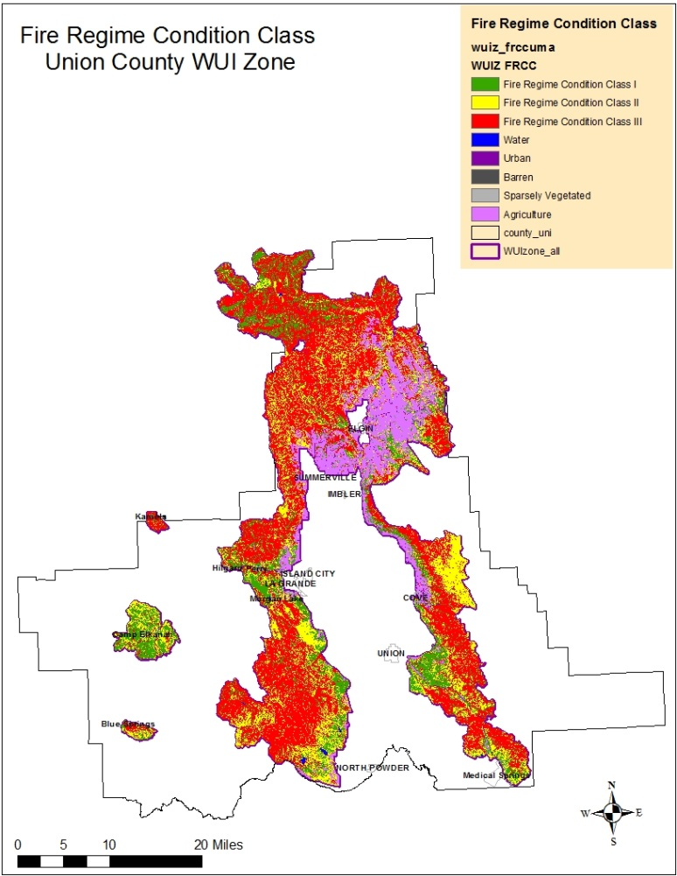

Figure VII – 2. Fire Regime Condition Class (FRCC). Identifies fire frequency of landscape and departure level of landscape conditions from historic conditions. See Appendix B for details on FRCC.

**Management Considerations**

1. There is interagency acceptance of the use of FRCC to identify the departure of forest conditions from historic ranges. FRCC is part of the decision-making process for the U.S. Forest Service and BLM under the Healthy Forest Initiative (HFI) and the HFRA direction. The Oregon Department of Forestry data information and reporting for indicators recognizes FRCC as an interagency, standardized tool for determining the degree of departure from natural (reference) conditions vegetation, fuels, and disturbance regimes.
2. This information will aid decision makers in determining whether the HFI and HFRA authorities are supported through FRCC conditions and the application of planned hazardous-fuel reduction projects or whether other authorities should be used.

**Fire Threat Attributes**

**Probability of Fire Occurrence**

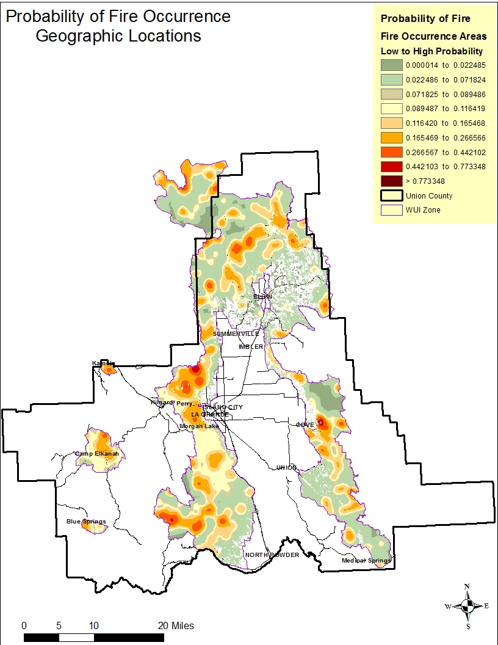

Figure VII – 3. Distribution and probability of fire ignitions in the WUIZ. The closer the numerical value is to the whole number 1, the higher the historic fire density and fire occurrence**.** WWRA layer clipped to Union County WUIZ.

**Management Considerations**

1. Knowledge of concentrated fire occurrence and ignition cause (human starts) allows fire managers to focus attention on public education programs such as: fire prevention, prevention signing, and specific mitigations based on fire cause such as hunter fires, campfires, etc.
2. This is a critical attribute in the Fire Threat Index rating. The ability to identify areas on the landscape likely to have ignitions that overlap areas in need of fuel and vegetation management are opportunities for mitigations to change fire behavior.
3. Provides possible opportunities for resource prepositioning at specific times of the year.
4. Can be useful with other attribute maps such as Values Impacted.

**Canopy Base Height**

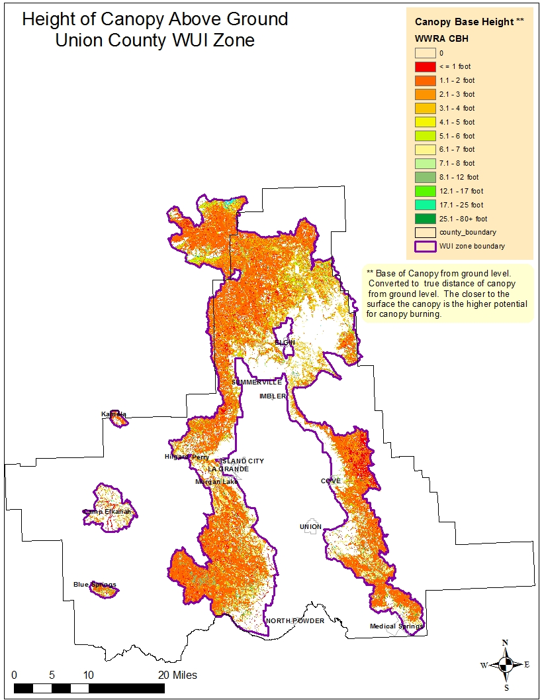

Figure VII - 4. Legend shows approximate height of tree canopy lower limbs from ground level in feet. The closer the limbs are to the ground, the higher likelihood of crown involvement during wildfires.

**Management Considerations**

Height from the ground to the lower limbs of the live canopy, referred to as canopy base height, can influence what type of fire(s) the area will experience. Stands that have a low canopy base height are more susceptible to torching or canopy involvement during wildfires. This information was one input used to determine fire spread potential for canopy fires. Seventy-three percent of the forest areas in Union County support canopies that are 10 feet or closer to the ground. This close limb proximity to ground level provides conditions to: facilitate ignition of the tree crowns from a surface fire; further compound fire spread through spotting; lead to potential crown fires; and increase public and fire fighter safety concerns.

1. This information is beneficial for assessing stand contribution toward canopy fire occurrence and is part of the input for fire behavior predictions in the WWRA. Canopy base heights assist managers with landscape locations where tree canopy conditions (of stands or groups of trees) may support or initiate fire movement vertically into the crowns of trees.
2. Provides locations with potential treatments areas, where raising the canopy base height can aid in reducing the likelihood of vertical fire spread.
3. Raising the canopy base height will also assist in meeting the CWS goal of restoring and maintaining the landscape. Stands that have a higher canopy base height can often withstand higher flame lengths and intensities, increasing survivability of the overstory. Strategically locating treatments may in effect increase suppression options.
4. Combination treatments of surface fuels and canopy base height can result in the reduction in potential surface fire behavior and minimize torching potential, in effect lowering the spotting potential and fire spread distance.
5. Addressing landscape scale treatments where middle ground and community boundaries can be treated simultaneously.

**Surface Fuels**

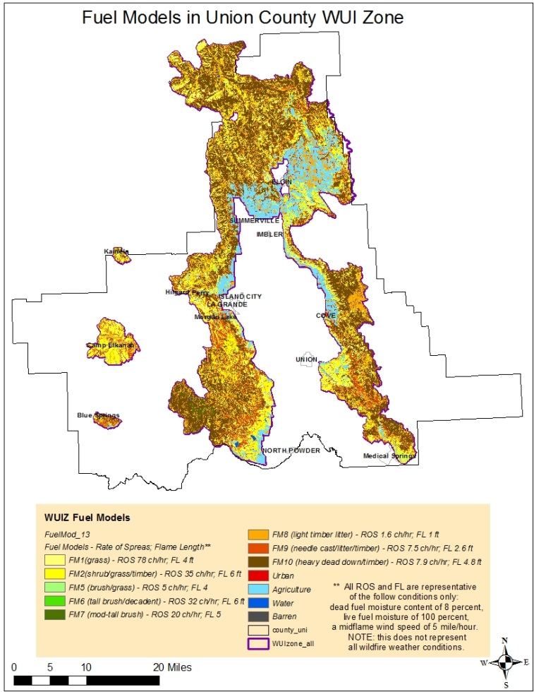

Figure VII – 5. Landscape fuel model distribution in Union County WUIZ. Fire Behavior estimates are based on Hal E. Anderson’s 13 Fuel Models for Estimating Fire Behavior, 1982.

**Management Considerations - Surface Fuels**

Knowledge of current fuel condition provides management with several options in addressing these issues.

1. Managers can conduct mitigation actions in areas where fuel loadings and forest surface vegetation are not consistent with historic conditions and contribute to fire behavior that can pose control issues and threaten communities.
2. Focus on areas with high fuel loads that can be a conduit for tree and canopy involvement.
3. Combine treatment efforts for woody material utilization during stand thinning by removing dead and down material.
4. Utilize options for maintaining a grass and forbs fuel in strategic areas where suppression tactics are crucial for protection, allowing suppression resources to increase effectiveness.
5. Provide opportunities for landscape planning to increase stand resiliency against wildfire.
6. Combine cross-ownership treatment of areas.
7. Establish pilot projects that provide first-hand results for future management reference and opportunities for community education.
8. Connect large open landscapes with neighboring grass slopes, natural barriers, or management created barriers (roads), for increased personnel safety and community protection.
9. Opportunity for re-introduction of fire through prescribed burning on the landscape, particularly when weather conditions can be more favorable to low-intensity burning, and where middle ground areas can support it.

**Canopy Fire Probability**

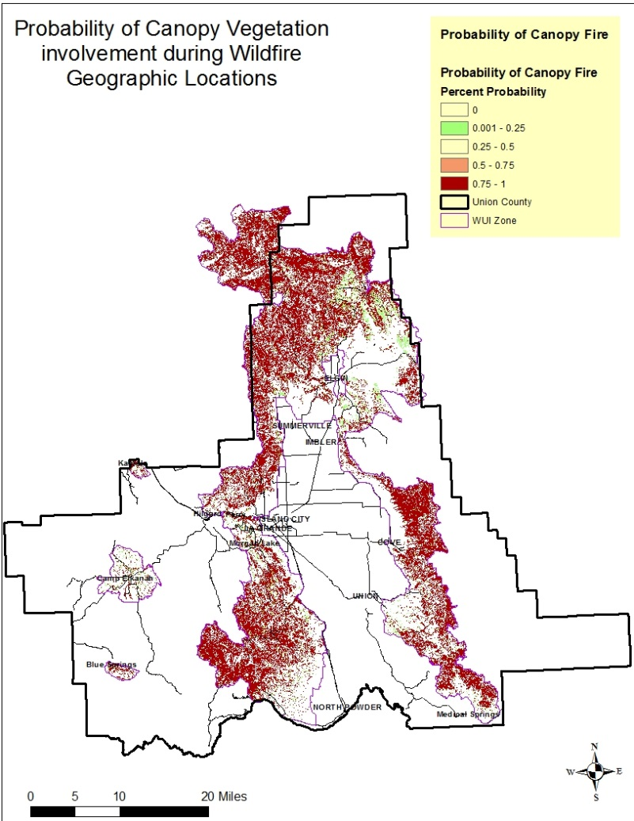

Figure VII – 6. Probability of canopy fire under all four weather percentile conditions.

**Management Considerations – Canopy Fuels**

Probability of canopy fire is directly correlated to canopy base height and surface fuel amounts. Fuels management in forest ecosystems with low and mixed-severity fire regimes can be designed to improve survivability of trees following wildland fires, restore forest structure, and improve the success of fire suppression efforts.

1. Identifies areas in which lower limbs of overstory trees contribute to and provide a conduit for fire spread into the crowns.
2. Opportunities to treat suppressed understory (ladder fuels) to modify fire behavior, reduce spotting potential, and improve fire containment. Utilize material whenever possible.
3. Plan projects/treatments strategically where landscape changes will alter fire spread toward communities, providing increased opportunities for successful suppression.
4. Thin stands to break up horizontal continuity of tree crowns, particularly where canopy fires can occur over large areas.
5. Combine canopy treatments with surface fuels treatments as needed.
6. As needed, design landscape treatments to facilitate active fire suppression at predetermined locations for all tactics.
7. Collaborative efforts between landowners for cross-boundary mitigation efforts.

**Combined Surface Fuels and Canopy Considerations**

Managers can develop preplanning based on expected weather and known topographic conditions, but altering these attributes prior to ignition in an effort to influence fire behavior is unrealistic. Dead woody material and live vegetation, however, can be manipulated and treated in advance of an ignition to alter fire flame lengths and rates of spread, increasing opportunities for suppression resource effectiveness and a more desirable post-fire outcome. Additional information of fuels models and canopy fuels can be found in Chapter VI.

Although behavior and effects of wildland fires can be changed within a particular treatment unit or stand, the behavior and progress of a much larger fire may not be affected by small treatment units (Finney 2004). Approaching fire behavior modifications on a landscape scale is likely to provide the most effective approach. Strategically placed treatments can provide a wider range of landscape impacts, suppression opportunities, and modifications of wildfire behavior. Mark Finney, research forester at the Rocky Mountain Research Station Fire Science Laboratory in Missoula Montana, utilized simulation models as a tool to evaluate the effects of management of vegetation and forest has on large fire growth and behavior (Finney 2004). Finney identifies the general relationship of fuels treatment and their intended changes to fire behavior in the table below.

**________________________________________________________________________________**

**Fuel target Prescription Change in fire behavior**

________________________________________________________________________________

Surface fuels (live grass Prescribed burning, Reduced spread rate and

and brush, and dead mechanical treatments intensity, and limit

and downed woody remove, compact, ignition of tree crowns

material) or reduce continuity of and other aerial fuels

surface fuels

Ladder fuels (small trees, Thinning (small-diameter Limit ability for fire to

brush, low limbs) trees) and prescribed transition from surface to

burning (scorching and crown fire by separating

killing small trees and surface fuels from crown

brush) to decrease fuels

vertical continuity

between surface and

crown fuels

Canopy fuels (fine fuels like Thinning to reduce Limit spread of crown fire

needles, and small twigs horizontal continuity of

in tree crowns) crowns (e.g., overstory

thin)

_________________________________________________________________

Figure VII - 7. This is Table 7 taken from Mark A. Finney’s, Chapter 9: Landscape Fire Simulation and Fuel Treatment Optimization of the General Technical Report 610. Table displays the general relationships among fuels, prescriptions, and intended changes to fire behavior from fuel treatments.

**Expected Fire Flame Length and Rates of Spread**

Since fire behavior is influenced by fuels (live and dead), weather, and topography, management’s influence is primarily applicable to fuels in modifying fire behavior. Knowing what the expected fire behavior is provides opportunities for most effective fire behavior modification.

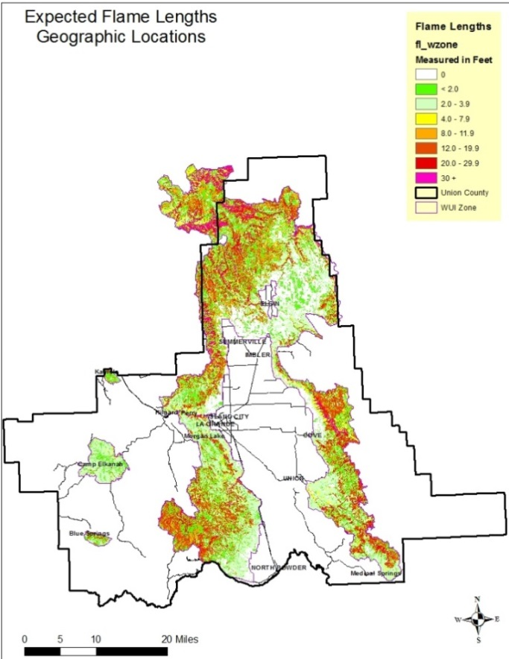

Figure VII – 8. Expected flame lengths under typical weather and fuels conditions. Weighted average of all four weather categories.

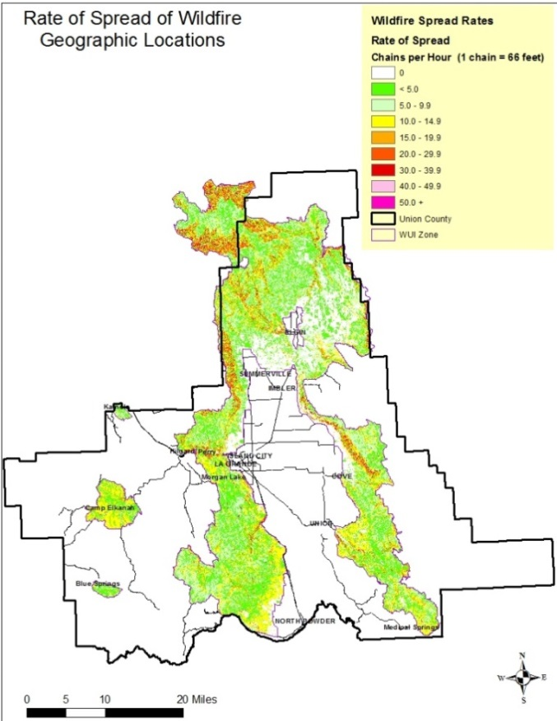

Figure VII -9. Expected fire spread rates under typical weather and fuel conditions. Weighted average of all four weather categories.

**Worst Case (Most Extreme) Flame Lengths and Rates of Spread.**

Approximately 98 percent of all ignitions in the forests of the northern Rockies and the east Cascade Range for which suppression is attempted are contained by initial attack (M. Finney, pers. comm., 4 February 2011 – Houtman May 2013). As a result, only approximately 2 percent of suppressed fires that escape initial attack spread on the landscape. Because most ignitions escape initial attack during weather events in which fire spread rates are high and fuel moisture is low (Houtman, et.al 2013), it is important to display the worst-case fire behavior during these weather events, based on the WWRA calculations. The WWRA considers extreme weather parameters to account for 1.77 percent of the fire starts with 6.17 percent of fire starts occurring under high conditions for the Union County area. Conditions for all four weather parameters, and how the weather influences fuel moisture levels which in turn impact fire behavior, can be found in WWRA Addendum I, Weather Influence Zone OR-3508, page I-8.

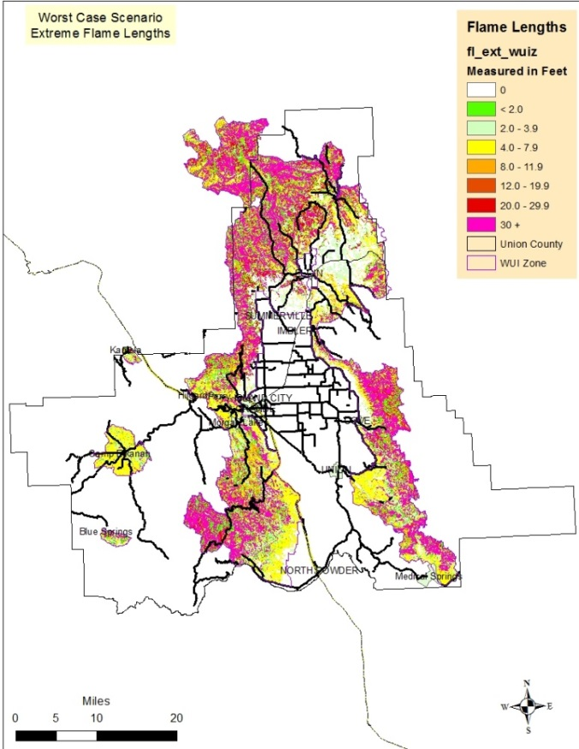 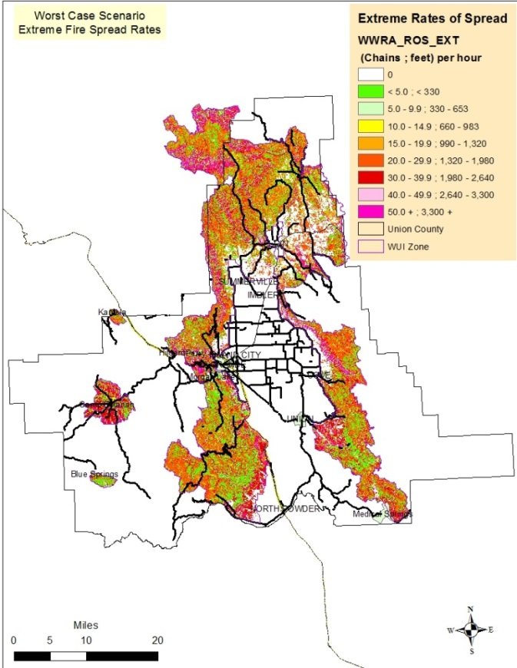

Figure VII – 10. Extreme Flame Lengths. Worst 3 percent Figure VII – 11. Extreme Wildfire Spread. Worst 3 percent of the summer weather conditions days. of the summer weather condition days.

The majority of the WUIZ under extreme weather conditions would sustain flame lengths that would prohibit hand crews and engines from successfully containing a wildfire. Live and dead fuel moisture parameters for worst-case conditions can be found in Addendum I of WWRA, weather influence zone (WIZ) OR-3508, page I-8.

**Management Considerations**

Human influences on fire behavior must focus on change to live and dead fuels on the landscape. Fuels, along with topography and weather, are the primary contributors to wildfire behavior, which leaves fuels as the primary emphasis in altering wildfire behavior. Using expected fire behavior outcomes with the canopy cover and fuels mapping can assist managers in identifying key areas that need attention.

1. Many areas of the WUIZ are expected to exhibit flame lengths that will render hand crews ineffective and necessitate water engine-type resources. Flame lengths play a significant role in tactical decisions for suppression resources. Flame length and fireline intensity are directly related to the effectiveness of control forces.
2. Surface fires that exhibit flame lengths less than four feet can often be directly attacked by hand crews, meaning close proximity to flames by firefighters can occur and crew-constructed fire lines should hold. When flames are between four and eight feet in length, suppression resources typically include pumpers, dozers, and aerial support to provide for both firefighter safety and to ensure effective suppression efforts. Flame lengths play a significant role in fire suppression strategies. See Figure VII – 12.
3. Flame lengths and are related to safety of firefighters and their susceptibility to heat exposure, playing an important role in overall suppression.

The following chart displays the impacts of flame length on what type of suppression resource is needed and the effectiveness of the resource. By addressing the various flame length heights, this CWPP adheres to Oregon Administrative Rule (OAR) 629-044-1045 (4) (a-c).

|  |  |  |
| --- | --- | --- |
| Flame Length | Fireline Intensity | Interpretation |
| Feet | BTU/ft/sec |
| < 4 | < 100 | -Fires can generally be attacked at  the head or flanks by persons using  hand tools.  - Hand line should hold the fire. |
| 4 – 8 | 100– 500 | -Fires are too intense for direct attack on the  head by persons using hand tools  -Hand line cannot be relied on to hold the fire.  -Equipment such as dozers, pumpers, and  retardant aircraft can be effective. |
| 8 – 11 | 500 – 1000 | -Fires may present serious control problems from  torching out, crowning, and spotting.  -Control efforts at the fire head will probably  be ineffective. |
| >11 | >1000 | -Crowning, spotting, and major fire runs are probable.  -Control efforts at head of fire are ineffective.* |

Figure VII - 12. Chart information from Andrews and Rothermel 1982. Suppression resources are most effective with flame lengths less than 4 feet. Engines, dozers, and air support are needed between 4 and 8-foot flame lengths. * The head of the fire is the side of the fire perimeter exhibiting the highest rates of spread (leading edge), and often associated with the location where continuous flaming combustion is taking place.

**Suppression Difficulty**

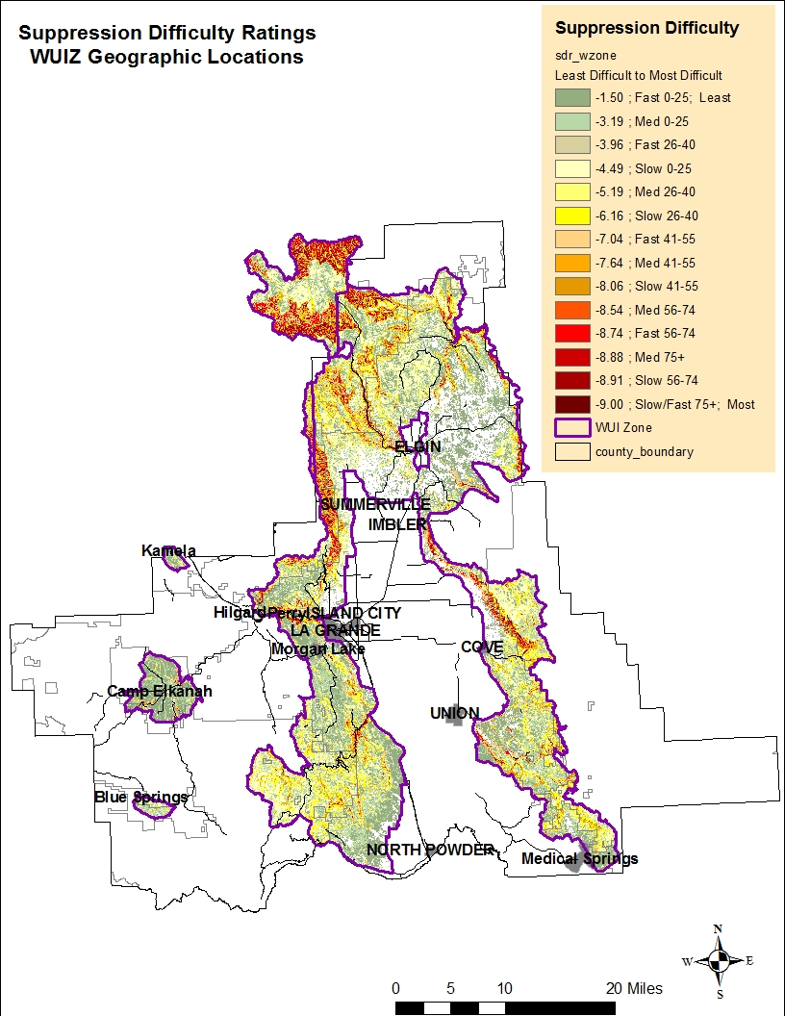

Figure VII-13. Suppression Difficulty Rating. Based on the fireline production rate categories of fast, medium, slow, with five breakouts of slope category combinations.

**Management Considerations**

Wildfire suppression capability of fire resources is primarily influenced by terrain steepness and the fuel type in which the fire is burning.

1. As slopes approach over 55 percent, suppression becomes increasingly difficult regardless of the fuels being consumed. This does not imply that fuels treatments would not be effective in modifying fire behavior but that fire resources have slower fireline production rates and are less effective due to slope steepness.
2. Modifying wildfire behavior provides a higher success of defensibility at ridge tops and roads on steep slopes.
3. Understanding where the suppression difficulty occurs provides opportunities of preplanning of initial attack resources, particularly where high fire ignitions occur. A variety of vegetation management tools can be utilized in areas in which forest conditions influence fire behavior and impact the ability of firefighting resources. Treatment of these areas can be beneficial for:

* Connecting geographic areas in which suppression difficulty is low and creating opportunities for successful fire containment.
* Application of diverse treatment types based on slope and fuels.

1. In addition, there is a higher level of successful suppression action when fighting a surface fire versus a canopy-involved fire. Canopy fires often lead to crews and engine suppression resources having to withdraw due to increased safety issues.
2. Identifying geographic locations that are critical for community protection in which treatments are not realistic and suppression efforts may be hampered. Treat areas to break up fuel continuity to slow fire progress.

**Values Impacted**

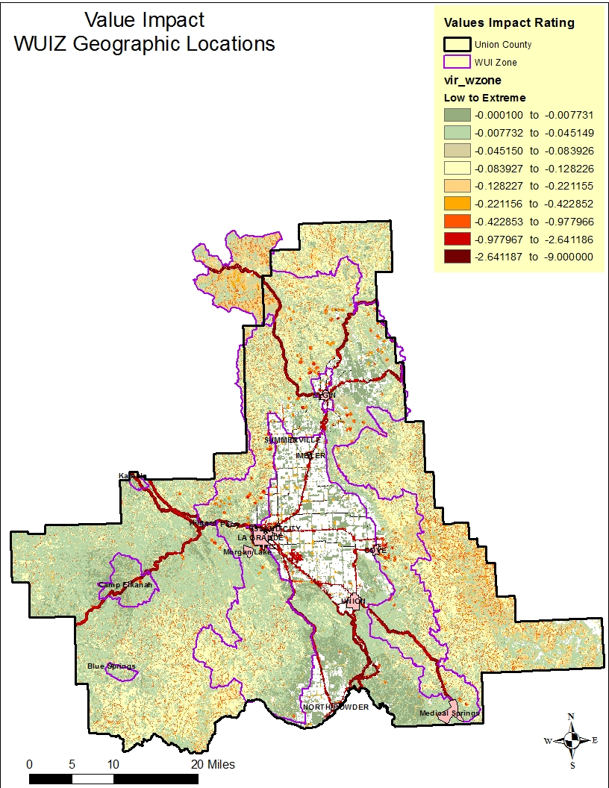

Figure VII – 14. Values Impacted Rating. Consolidation of multiple values such as wildland developed areas, drinking water, infrastructure, and forest and riparian assets.

**WUIZ and Union County Structure Densities**

Figure 15 displays the WWRA housing density and the most recent “structure” locations for Union County overlaid together. A zoomed in area of the vicinity of Elgin (Figure 16) shows a high number of structures (represented by red dots) not accounted for in the WWRA. Further review shows several of these structures are residential in nature.

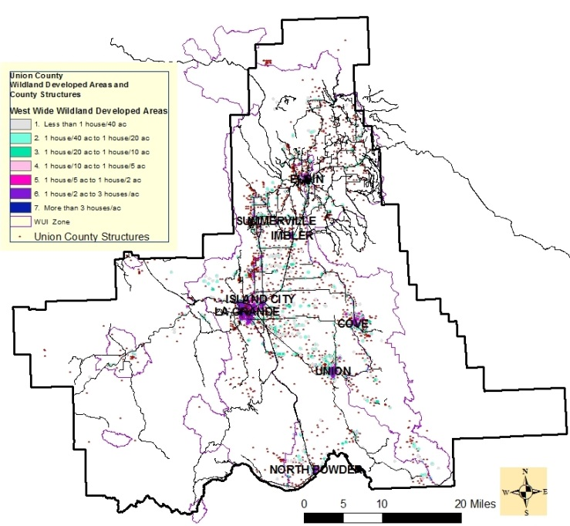

Figure VI -15 Map displays comparison of WWRA data for housing density and local data of most recent structure locations near the Community of Elgin in Union County. Close up red dots are structures from Union County local data.

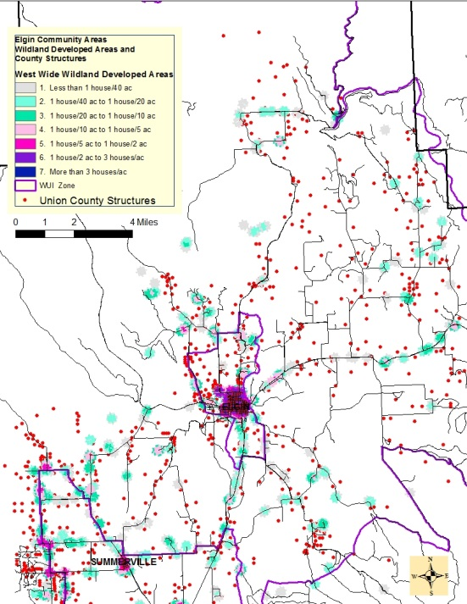

Figure VI - 16. Close up of structures surrounding the community of Elgin. Compares Union County data-structure points and WWRA. residential data.

A map density of all known structures was then developed based on Union County local data only. The density map indicates concentrations of residential areas based on houses per acres according to the WWRA Table 3-4 Housing Density in Appendix D. With the assistance of ODF Salem Office, the data was configured to show the distribution of buildings ranging from low to high concentrations. These concentrations provide a county-wide view of all known structures. Figure VI – 17 shows the density distribution of structures in Union County using best available data. This approach supports the OAR 629-044-1060 (1) approach to classification of structures as Low, Moderate, High, and Extreme densities.

Union County has roughly 11,590 housing units as of July 2015, according to U.S. Census Bureau for the State of Oregon. Forty-two percent of the county’s population lives in rural areas. Although county data does not delineate between the residential and outbuilding structures, structures are peppered throughout the county.

Figure VI – 18. Zoomed in to Elgin and vicinity Robinson Road-Palmer Junction.

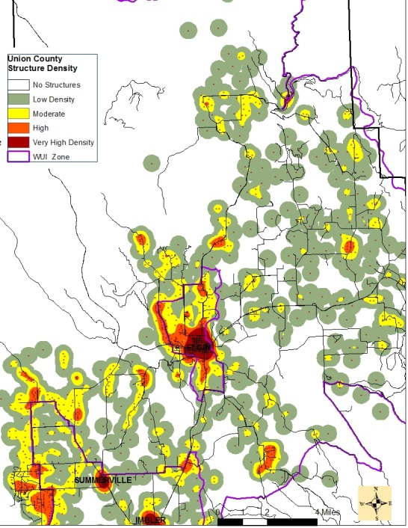

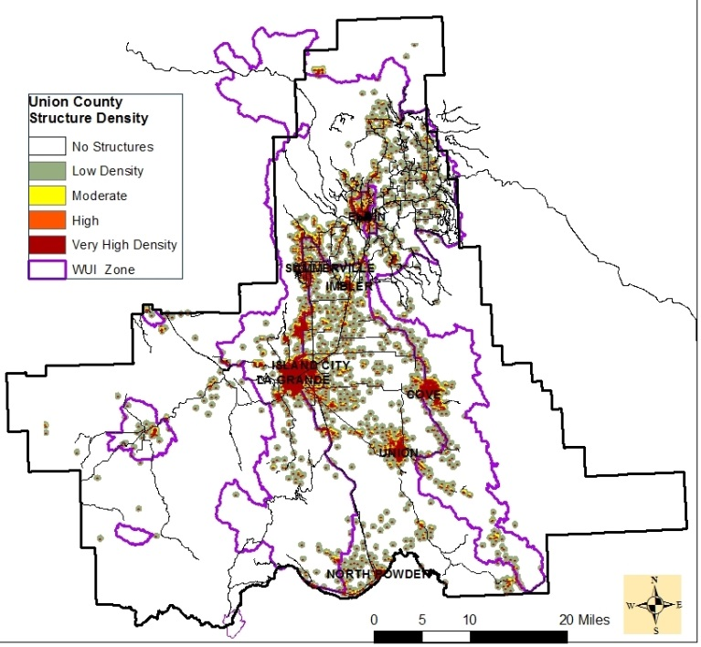

Robinson Road

Figure VI – 17. Display of structure density using *only* local data, layer does not differentiate between residence and outbuilding. Does not include WWRA data. This data provides a higher display of structure density to areas of that may otherwise be overlooked. Structure does not imply that it is a residence.

Robinson Road

Palmer Junction Rd.

Palmer Junction Rd.

**Management Considerations**

Residential homes in and near forested lands continues to increase making it increasingly difficult to assess already-existing properties and new construction. Union County recognizes the importance of accurate knowledge of property conditions to better prepare and respond to wildfires. There is currently an effort to conduct a more accurate tri-county structure assessment that may be beneficial as a future addendum to this document.

1. Collaborative efforts with local cooperators, infrastructure companies, and other stakeholders can better prepare communities for emergencies. Offers possibility to combine efforts with those proposed to protect the overall values impacted.
2. As new structures and homes are built, continue to record and update pertinent information that may be beneficial for wildfire preparedness and response. This is consistent with the Northeast Oregon Natural Hazard Mitigation Plan (NHMP) MH#12 Proposed Action for Union County.
3. Administering of programs that require standards for new development within a certain distance of forestland to meet Fire Siting Standards. Develop mitigations consistent with actions proposed in the NHMP for wildfire.
4. Utilize a workforce to:

* Record current residential locations, land conditions, access, and structures to better provide wildfire response. (Example: INTERRA)
* Maintain records as conditions change.
* Educate and assist landowners with wildfire mitigation

1. Develop avenues to reach out to homeowners to obtain property information regarding specific wildfire mitigation needs and accomplishments. Best available data leads to a higher level of wildfire response preparedness.
2. Unincorporated areas do not provide accurate data for census; these areas often have the longest fire response times.
3. Current information on residents can potentially change the CAR boundaries leading to changes in fire effects as well as changes in other attributes such as protection boundaries.

**THREE PRIMARY OUTPUTS –**

**FIRE THREAT INDEX, FIRE EFFECTS INDEX, FIRE RISK INDEX**

**Fire Threat Index**

This provides an index related to the likelihood of an acre burning. It integrates the probability of an acre burning and the expected final fire size, based on rates of spread in all four weather percentile categories into one single measure of a wildfire threat. It is a valuable input in displaying the “possibility of suffering harm or loss” (WWRA).

**Fire Effects Index**

Fire effects is used to identify those areas that have important values that can be affected by fire as well as to identify those areas that are difficult or costly to suppress.

It is a valuable input in displaying the “possibility of suffering harm or loss” (WWRA). Takes into considerate a total of seven separate attributes that could influence the potential outcome of rating scores based on values impacted and suppression difficulty.

**Fire Risk Index**

It accounts for all 19 sets of input data used in the WWRA and provides a final Fire Risk Index displays the measure of overall fire risk. The Fire Risk Index provides a number of opportunities to agencies and landowners.

1. This can be used to identify areas where mitigation options may be of value
2. Allows for agencies and landowners to work together and better define priorities
3. Displays the risks across a complex landscape and potential fire situations
4. Provides a foundation for common knowledge and improved communication for all landowners in addressing priorities and needs.

**Overall Fire Threat**

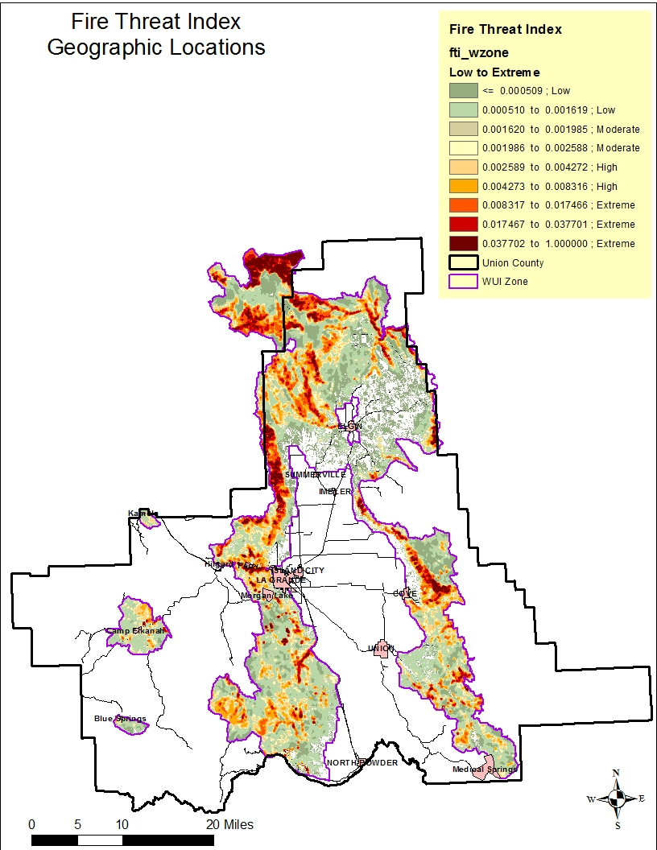

Figure VII – 19. Spatial distribution of low to extreme wildfire threat. Likelihood of an acre burning taking into account Probability of Fire Occurrence, Fire Behavior, and Suppression Effectiveness.

**Management Considerations**

Weather, fuels, and topography are the three parts of the fire behavior triangle. Although humans can develop plans based on expected weather and topographic conditions, altering them prior to ignition in an effort to influence fire behavior is unrealistic. Dead woody material and live vegetation, however, can be manipulated and treated in advance of an ignition to achieve a more desirable outcome by altering fire flame lengths and rates of spread, increasing opportunities for suppression resources effectiveness.

Fire as a threat has also been identified as one of the hazards facing Union County in the NHMP. The NHMP identifies wildfire as a common event to areas of central and eastern Oregon. It recognizes that wildfire is essential to the ecosystems, but also poses a serious threat to lives and property (Univ. of Oregon 2014).

Knowing where the fire threat exists is in itself an important tool for managers in the decision-making process. Figure VII – 24 provides several pieces of information for fire managers.

It provides knowledge of areas that can:

1. Be treated to reduce or manipulate available fuels to change fire behavior
2. Exhibit the highest threat potential near communities
3. Allow for priority setting by reducing fire ignitions, with focus on high fire start areas particularly where human caused starts occur
4. Highlight locations where fire suppression resources are likely to be most and least effective. This allows for preplanning prior to an ignition.
5. Offer opportunities to address multiple locations when utilizing funding for wildfire mitigations.

Areas of low fire threat *should not* be interpreted that these locations will not ignite and burn, it simply indicates that the threat is lower relative to the other geographic areas.

**Fire Effects**

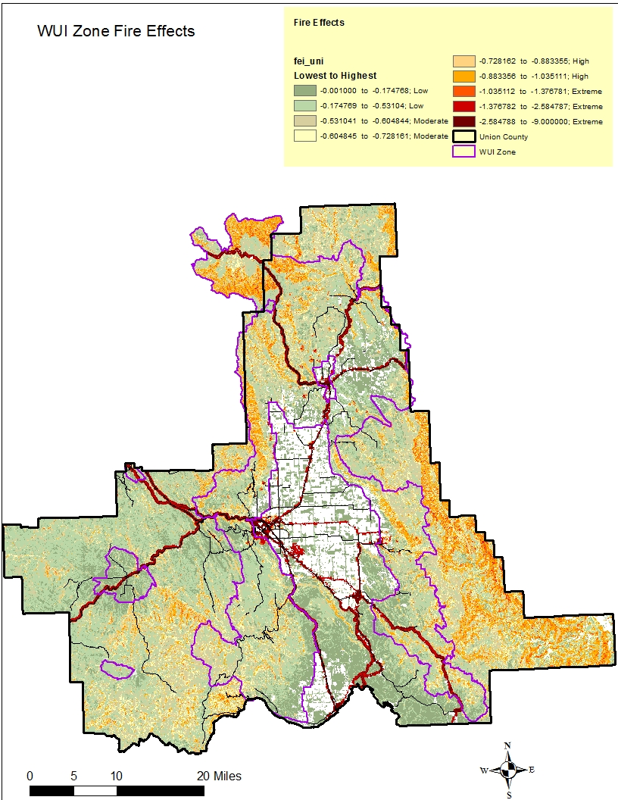

Figure VII – 20. Overall fire effects taking into consideration negatively impacted values and suppression difficulty based on fuels and topography.

**Management Considerations**

Knowledge of on-the-ground characteristics that impede fire suppression and locations of important values provides opportunities for advanced preparation to protect those values. This index can be used as a standalone tool for fire managers in the decision-making process both prior to and during wildfires for evaluating potential loss of valuable assets. Concentrating efforts to provide increased protection measures in advance of ignition will in turn decrease the likelihood of values lost. Again, fuels and vegetation are a subset of suppression difficulty and can be manipulated by management. Through examining detail mapping of communities and infrastructures, high potential locations can be identified.

Figure VI - 21 is a zoomed-in view of the La Grande/Mount Emily area, pulled from the Fire Effects Index map. It indicates where high potential values and suppression difficulty areas are located, resulting in areas of highest negative impact from wildfires

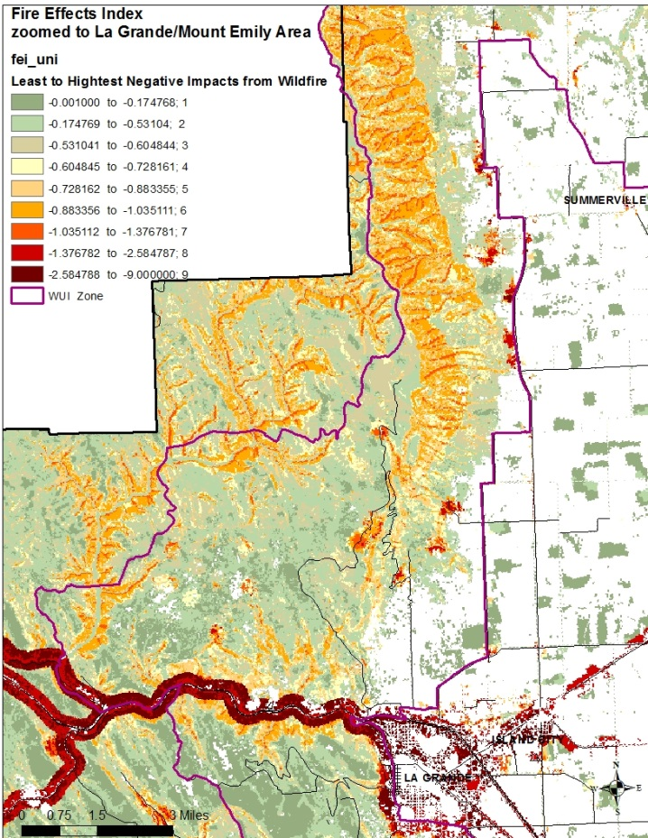

Figure VI - 21. Zoomed in view of La Grande/Mount Emily. Dark red line is Interstate 84, orange areas north of La Grande is slopes of Mount Emily on the west side of the Grande Ronde Valley.

Values with the highest potential for loss within the county can give managers a starting point for planning. Knowing crucial areas of possible negative outcomes helps for prioritizing. The Fire Effects Index can allow managers to:

1. Prioritize locations for protection based on highest negative fire impacts to values.
2. Reduce or manipulate available fuels to increase effectiveness of suppression efforts since surface fuels loads and stand conditions are related to line construction rates and flame lengths. (A component of Suppression Difficulty sub-set is fuel type.)
3. Identify communities with highest threat potential for loss.
4. Assess potential for impacts and locations for future infrastructure placement in the county.
5. Recognize outlying infrastructures and wildland-developed areas that may otherwise not be part of an identified community.
6. Communicate and educate stakeholders and partners about high loss areas.
7. Re-evaluate protection protocols with other fire protection agencies.
8. Identify forest assets that are likely to be large-scale losses on the landscape and develop opportunities for breaking up homogenous stands to preserve ecological integrity.
9. Use an approach that supports and is consistent with the NHMP’s goal to protect human welfare, property, and natural resources. Combining goals and objectives of this CWPP with the goals of the NHMP allows for consolidated efforts toward natural hazards where wildfire risk mitigation is concerned.

**Individually Mapped Fire Risk Index Levels**

The overall wildfire risk was separated out into individual maps of each fire risk levels in the WUIZ providing the best visual appreciation of the landscape distribution.

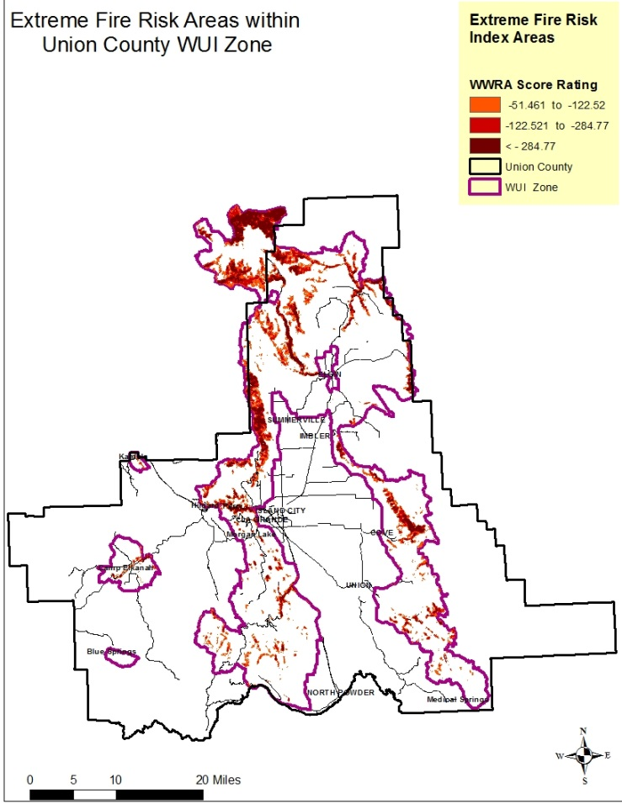 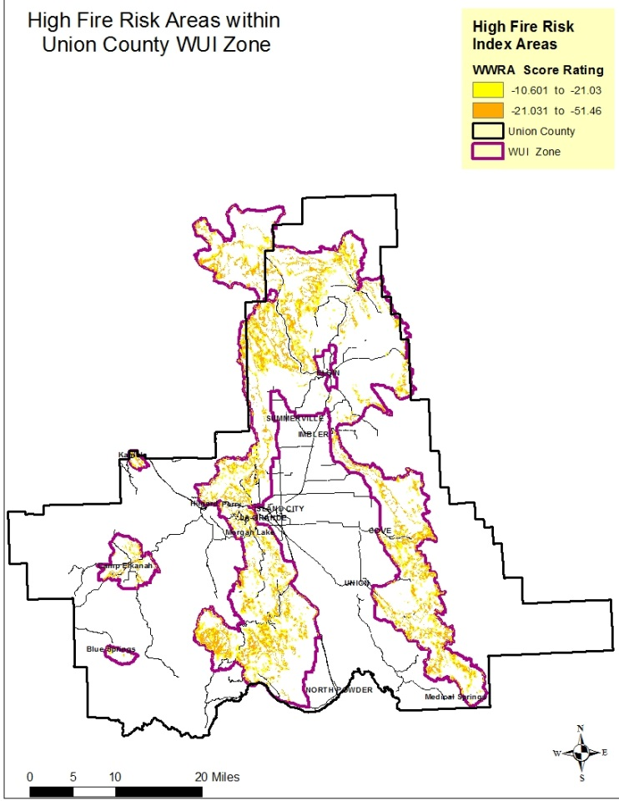

Figure VII-22. Extreme Wildland Fire Risk within the WUIZ.

Figure VII – 23. High Wildland Fire Risk within the WUIZ.

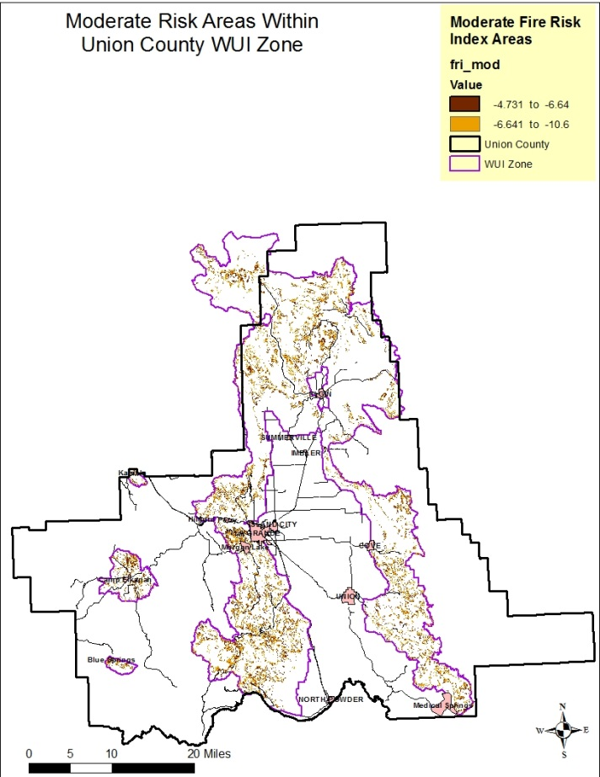 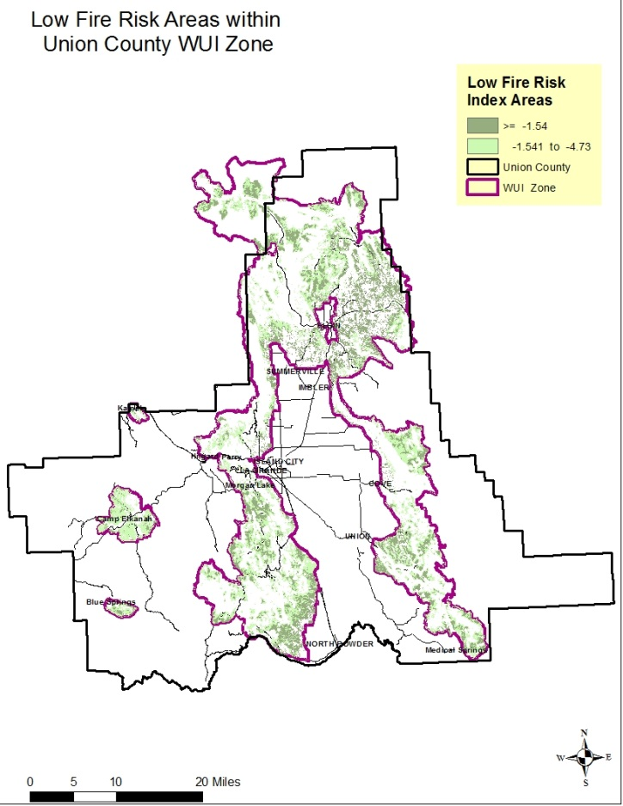

Figure VII – 24. Moderate Wildland Fire Risk within the WUIZ.

Figure VII – 25. Low Wildland Fire Risk within the WUIZ.

**Management Considerations**

The FRI can be used for multiple opportunities in efforts to reduce fire risk for the county. This allows for:

* Identifying areas where mitigation options may be of value.
* Allowing fire agencies and community members to work together and better define priorities.
* Developing a refined analysis of a complex landscape and fire situations using GIS.
* Visually communicating with local residents to address community priorities and needs.
* Placement of mitigations where multiple objectives can be achieved.
* A means of developing classifications of low, moderate, high, and extreme for subsets and the three primary outputs of Fire Threat, Fire Effects, and Fire Risk (See next section below).
* Provides rationale and justification for allocation of funds for mitigation purposes.
* Creates opportunities to incorporate maintenance of lower-risk areas with high-risk mitigation activities. Protects investments previously made and supports HFRA guidelines.
* Combining efforts with the NHMP (Univ. of Oregon 2014) to address wildfire.
* Movement in a direction that accomplishes the goals of this CWPP and the CWS of Wildfire Response: Fire Adapted Communities, and Restore and Maintain Landscapes.

To better display some of the important attributes of risk of a single area in the county the vicinity of the town of La Grande was used to zoom in and display the following conditions:

* the fire occurrence (fire start history and weather influence zones)
* the Fire Threat Index (Fire Occurrence, Fire Behavior, Fire Suppression Effectiveness)
* the Fire Effects Index (Values Impacted and Suppression Difficulty)
* the final Fire Risk Index

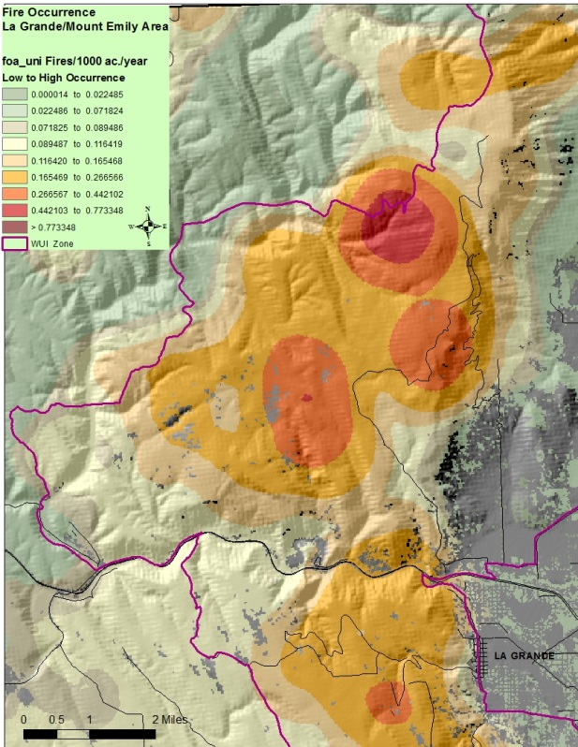

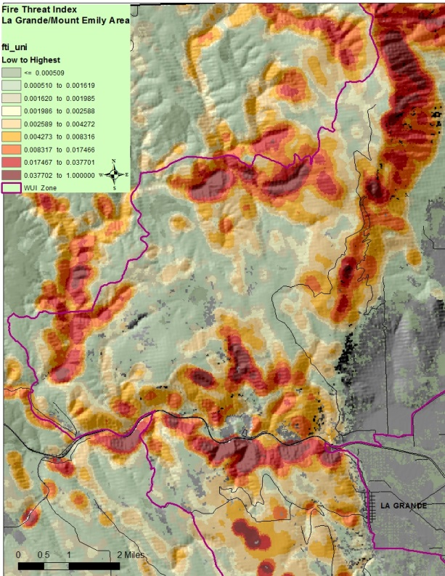

Figure VII - 27. Fire Threat Index for La Grande Area

Figure VII - 26. Fire Occurrence for La Grande Area.

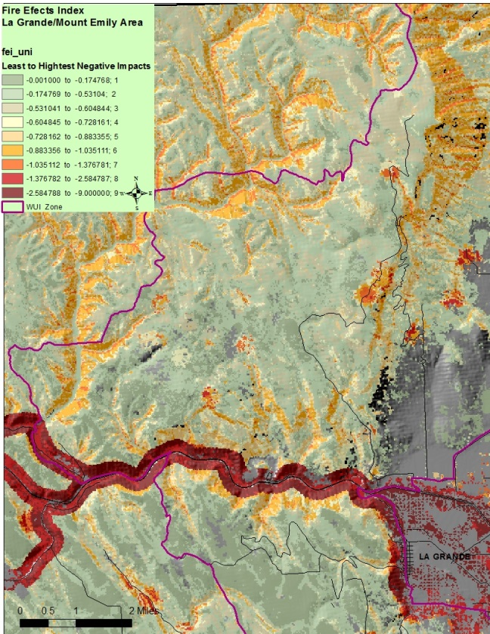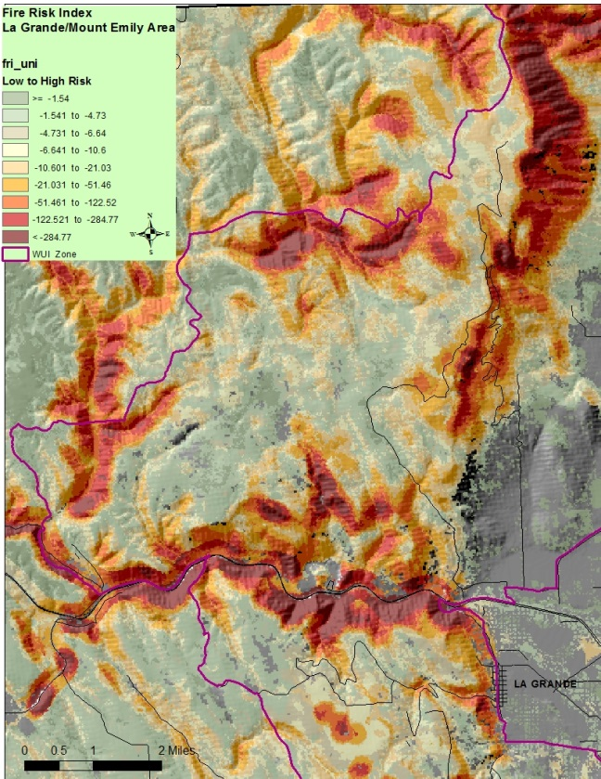

Figure VII - 29. OVERALL FIRE RISK for La Grande Area.

Figure VII - 28. Fire Effects for La Grande Area.

**WUIZ Percent of Land Coverage - Current Condition Level**

|  |  |  |  |  |  |  |  |  |  |  |  |  |  |
| --- | --- | --- | --- | --- | --- | --- | --- | --- | --- | --- | --- | --- | --- |
|  | WUI ZONE ASSESSMENT | | | | | | | | | | | | |
| Rating Level | Condition Contributing to Fire Behavior | | | | | Wildland Fire Potential  Percent (%) of WUI Zone | | | | | | |  |
| Fire  Occurrence | FRCC | Fire Type | Canopy Base Height (% of WUIZ) | Suppression Difficulty | Flame Lengths  (no data for 13%) | Rate of Fire Spread  (13% area missing dara) | Probability of Canopy Fire  (no data, or non-burn for 55%) | Values Impacted | Fire Threat | Fire Effects | Fire Risk |  |
| Extreme | 3 | CC -III  50 | Active  .1% | 86 | 6 | 26 | 1 | 40 | 54 | 14 | 6 | 17 |  |
| High | 30 | CC - II  19 | passive  47 | 10 | 19 | 10 | 8 | 0 | 34 | 22 | 15 | 24 |  |
| Moderate | 27 | CC - l  18 | Surface  42 | 2 | 31 | 27 | 47 | 0 | 7 | 16 | 31 | 17 |  |
| Low | 40 | 13 | No-burn  11 | 2 | 44 | 24 | 31 | 5 | 5 | 48 | 48 | 42 |  |

Figure VII - 30. WUI Zone Risk Level Area Coverage. All numbers reflect the % of land area covered by each of the four ratings within the WUI Zone. A breakout of county wide acres for Fire Threat, Fire Effects, and Fire Risk can be found at the end of Chapter VI.

Summary

Using the three goals of the CWS are key to successfully implementing this CWPP. Wildfire resource response can be limited when high spread rates and flame lengths are generated; resilient landscapes can be expected to have high severity (high mortality to overstory vegetation) impacts after a landscape fire under current conditions; fire adapted communities must be created to promote collaborative efforts in order to prevent loss of life and property.

Since fire behavior is directly influenced by fuels, weather, and topography, landowners and fire managers are limited to fuels modification in order to be effective in changing wildfire behavior. Fuels, for the purpose of this document included any of the following: dead forest woody material, live forest vegetation, structures, and any combustible material that may burn in the event of a wildfire. There are opportunities to modify fuels through a wide range of approaches discussed in mitigation measures.

In areas where modifications have occurred emphasis in retaining the investment and stand conditions may supersede a higher risk area if location and cost of maintenance work is justified.

Fire protection and structure vulnerability put emphasis on fire adapted communities and wildfire response with some lessor degree of emphasis on resilient landscapes. Through this design managers are able to understand the areas of wildfire response that can influence outcomes.

CARs are scattered across Union County both in and out of the WUI Zone. Recognizing that these communities, regardless of location, are challenged by their own set of wildfire issues gives protection agencies and landowners tools to create fire adapted communities and build upon existing or create new fire response programs. Distinguishing between structure protection authorities and land protection authorities allows for collaborative efforts in fire protection. Condition indicators and issues facing the CARs can be addressed together or as standalone treatment approaches for fire protection. CARs are delineated to meet management direction and to identifying protection capabilities yet recognizing that mitigation measures do not stop at property lines. This is important for successfully meeting fire adapted communities goal in Union County.

Understanding how landscape conditions are linked together to influence fire behavior, suppression success, and public and fire safety can provides critical insight for landowners during the decision making process. Landscape characteristics are the building blocks that lead to the various levels of fire risk, no characteristic is a standalone issue. To mitigate fire risk, it is important to know which characteristics can be modified, should be modified, and realistically will make a difference once modified, and what the outcome will likely look like.

The WUI Zone provides a larger geographic image of conditions, allowing for potential use of single funding sources to be applied in multiple locations on the ground that meet identified criteria. Focusing on areas across the WUI Zone, of similar issues, increases the likelihood of meeting the “all hands all lands” approach. Understanding the “big picture”, land managers can be opportunists, taking advantage of areas that currently meet the low fire risk rating by building on these locations, preserving the lower risk conditions, or linking nearby low ranked areas with high risk areas to increase potential for success with likely limited funding sources.

CARs and landscape conditions can establish increased opportunities for cross-boundary efforts with minimal funding. These conditions, along with local knowledge, provide the basis for the mitigation actions outlined in the next chapter. Application of mitigation measures can occur where multiple resource objectives can be met while meeting the three goals of the CWS.

**Bibliography**

Andrews, Patricia L. and Rothermel, Richard C. 1982. Charts for Interpreting Wildland Fire Behavior Characteristics. Intermountain Forest And Range Experiment Station Ogden, Up 84401. General Technical Report INT-131. September 1982.

Cohesive Wildfire Strategy, April 2014. The National Strategy: *The Final Phase in the Development of the National Cohesive Wildland Fire Management Strategy.* A collaborative effort by Federal, State, Local, Tribal Governments, non-government partners, and public stakeholders.

M. Finney, pers. comm., 4 February 2011. As per Houtman, R. M., C. A. Montgomery, A. R. Gagnon, D. E. Calkin, T. G. Dietterich, S. McGregor, and M. Crowley. 2013. Allowing a wildfire to burn: estimating the effect on future fire suppression costs. International Journal of Wildland Fire. Journal compilation © IAWF 2013. http://dx.doi.org/10.1071/WF12157

Finney, M.A. 2004. Chapter 9, Landscape fi re simulation and fuel treatment optimization. In: J.L. Hayes, A.A. Ager, J.R. Barbour, tech. eds. Methods for integrated modeling of landscape change: Interior Northwest Landscape Analysis System. PNW-GTR-610: 117-131.

Finney, M.A. 2001a. Design of regular landscape fuel treatment patterns for modifying fire growth and behavior. Forest Science. 47(2): 219-228.

HFRA 2004. USDA Forest Service and DOI Bureau of Land Management. The Healthy Forests Initiative and Healthy forests Restoration Act, Interim Field Guide. FS-799.

Houtman, R. M., C. A. Montgomery, A. R. Gagnon, D. E. Calkin, T. G. Dietterich, S. McGregor, and M. Crowley. 2013. Allowing a wildfire to burn: estimating the effect on future fire suppression costs. International Journal of Wildland Fire. Journal compilation © IAWF 2013. http://dx.doi.org/10.1071/WF12157

MOU 2003. Memorandum of Understanding for The Development of a Collaborative Feuls Treatment Program among the USDA Forest Service, US Department of Interior – Bureau of Land Management, U.S. Fish and Wildlife Service, National Park Service, national Associations of State Foresters, and the National Association of Counties.

Oregon Department of Forestry, 2013. *West Wide Wildfire Risk Assessment, Final Report – Addendum I*, Detailed Technical Methods March 31, 2013. The Sanborn Map Company, 2012.

Oregon Department of Forestry 2014. Senate Bill 357, Report to the Legislature, Federal Forest Management, Oregon Department of Forestry. May 2014.

University of Oregon 2014. *Northeast Oregon Multi-jurisdictional Natural Hazards Mitigation Plan.* University of Oregon’s Community Service Center: Resource Assistance to Rural Environments and Oregon Partnership for Disaster Resilience.

US Forest Service 2015. Fiscal Year 2016 Budget Overview. United States Department of Agriculture.

**Web Links:**

Merriam-Webster 2016. <http://www.merriam-webster.com/dictionary/risk>

OAR 629 – 044 <http://arcweb.sos.state.or.us/pages/rules/oars_600/oar_629/629_044.html>