**XI. Emergency Management**

**Introduction**

Regardless of protection authority, all lands in Union County are susceptible to wildland fire. Therefore, it has been important for local agencies to develop cooperative agreements outlining how agencies will respond in providing mutual aid and cost effective fire protection for public lands, private lands, and surrounding communities.

Union County is host of several emergency services with protection jurisdiction that play a key role in actively responding to, participating or supporting wildfire events. Taking the lead during fire emergencies are federal, state, city, rural firefighters, law enforcement, and emergency management, making saving lives their number one priority.

Union County communities under an “average” occurrence of wildfire, are likely to have more than 10 percent of their populations and property affected, giving them a HIGH in community vulnerability (U of O 2014).

Fire protection capabilities are most often challenged during the summer months, when thunderstorms can initiate multiple fire starts over a matter of hours or days. This type of occurrence quickly depletes available resources locally, requiring out of area assistance. Unfortunately these storms often originate over central eastern Oregon, leaving numerous fire starts in their wake prior to reaching Union County, resulting in limited outside resources, as well.

**Infrastructure**

Infrastructure plays an important role not only in Union County’s local economy, but is also critical during disasters and emergency events for proper functioning and response capabilities. Facilities such as police, fire, hospitals, and government are important to successful wildfire emergency response, while support infrastructures such as airports, utilities, and transportation systems provide play an important role as partners in the fire mission.

Damage to or inability to use infrastructure can negatively affect a community’s ability to cope, respond, and recover from a wildfire situation. Highways are a primary means of shipping access in and out of the valley for goods and supplies. Protecting and maintaining infrastructures is essential for a higher degree of wildfire suppression success. Firefighting supplies often arrive via state and federal highways. The three highways that access Union County are Interstate 84, a major transportation corridor that connects to the county westward to Portland and Boise to the east, State Highway 204, connecting Union County with Umatilla County, and State Highway 82, which connects Union County with Wallowa County in the very northeast corner of the state. Both 84 and 204 are major travel routes over the Blue Mountains.

Union Pacific Railroad is also a transportation system connecting La Grande to the adjoining states and counties. The railroad transports numerous products and goods to and from the Grande Ronde Valley.

Union County has roughly 198 bridges, with 128 bridges owned by the state that service railroad, highway, and waterways. The county owns approximately 66 bridges with the remaining scattered between State Parks and railroad.

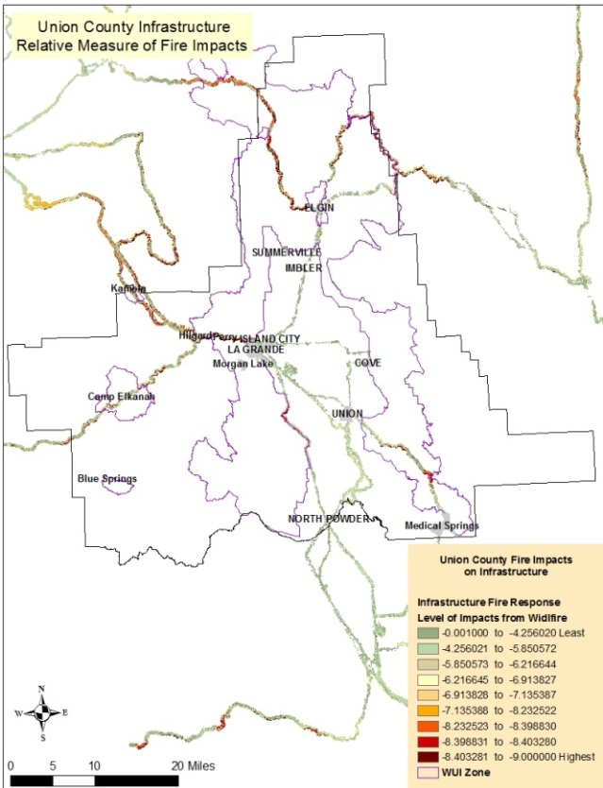

Figure XI - 2. Infrastructure most likely impacted from wildfire. Results are based on West Wide Risk Assessment.

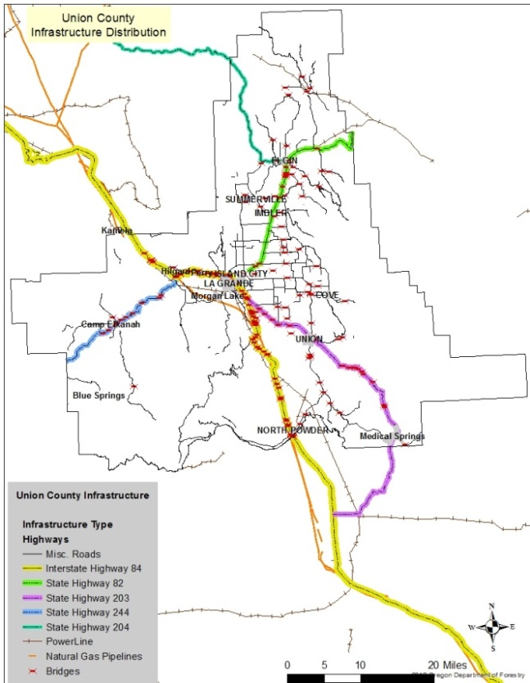

Figure XI - 1. There are approximately 124 miles of State Highway in Union County and 88 of those miles have high potential for closure due to wildfires

Avista Utilities natural gas line connects Pendleton to the west, paralleling Interstate Highway 84 through Union County, to Baker City to the southeast.

Union County hosts a number of other miscellaneous type infrastructures that are primarily situated in forested areas. These are often located either at a high point where fire will burn rapidly uphill toward its location, or in a narrow canyon where fire will be funneled due to surrounding terrain and wind patterns. These areas often have limited access, making evacuation and firefighting difficult. These areas include:

* Fire detection lookouts: Point Prominence, Johnson Rock
* Lookingglass Fish Hatchery
* Multiple developed campgrounds: Bird Track Springs, North Fork Catherine Creek, Catherine Creek State Park, etc.
* Communication sites: Mt. Emily Cell tower, Mt. Fanny Structures and Radio Towers, Mount Harris Communication site
* Wind turbine towers in the Medical Springs Area
* OSU Research Study Area
* Starkey Experimental Forest
* scattered farm/ranch communities

**Land Protection**

Union County recognizes the importance of interagency efforts in wildland fire situations. Wildland fire protection is included in the county’s Emergency Operations Plan that addresses four phases of emergency management: (1) mitigation: (2) preparedness: (3) response: and (4) recovery.

In June 2015, Union County Emergency Services updated the *Union County Emergency Operations Plan*. There are identified agencies for Emergency Support and Emergency Incident extensions. In the Emergency Operation Plan chapter 3 outlines the roles and responsibilities of the different agencies that may be involved in an urban/wildland interface fire, with the main goal of protecting life and property during a wildfire event.

In Union County fire protection can be found in three tiers:

1. Unprotected areas
2. Any area of the county that does not have fire protection for land or
3. Any area of the county that does not have fire protection for structures.
4. Single protection from rural districts, city departments, or wildland agencies (structures are protected, but not the land; or vice versa).
5. Dual protected (both structural and wildland protection).

These lands are delineated in Figure XI - 3, displaying areas of unprotected, single protection, and dual protection.

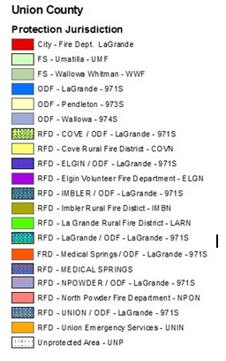

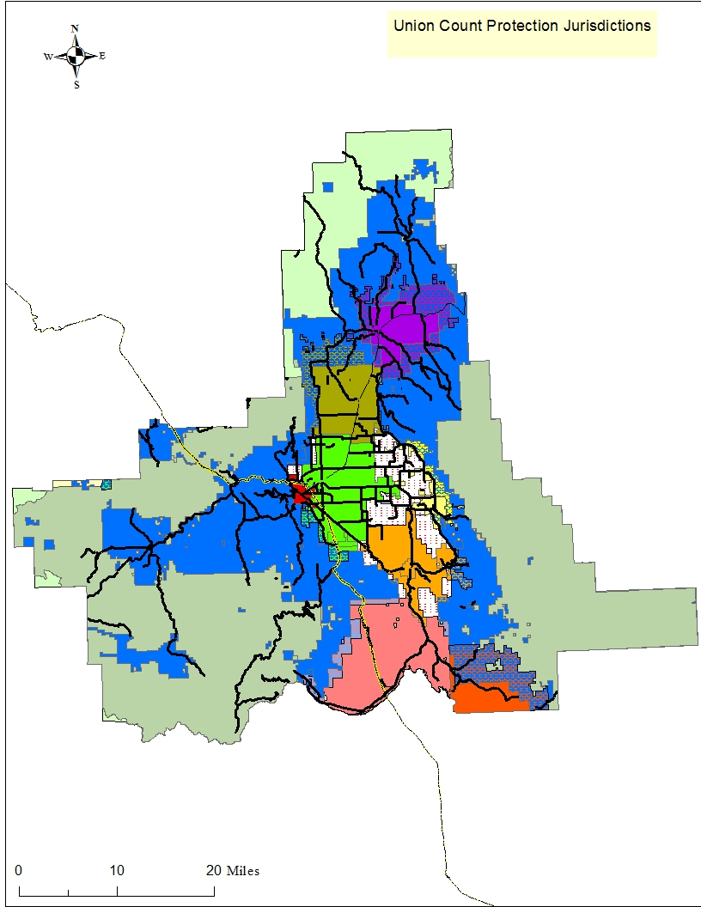

Figure XI – 3. Union County Protection Authority. Geographic coverage for Union County fire protection agencies. Types of coverage include land only, structure only, and dual protection of both land and structures.

**Unprotected Lands**

There are approximately 56,976 acres unprotected in Union County that have neither wildland nor structural protection. These areas are associated with three prime locations near La Grande, Cove, and Union/Medical Springs.

**East La Grande Valley – Cove - Unprotected Areas**

Approximately 34,185 acres (60 percent) of the unprotected lands lie between Cove Rural Fire protection area and La Grande Rural protection or Union Rural Fire protection. Although much of the unprotected areas are irrigated farmlands to the west and north of town, the area to the south is open grassland. The slopes east of Cove have one of the highest ratings for fire risk. The large amount of unprotected lands complicates already difficult existing protection issues, further elevating the fire vulnerability of Cove and its surrounding areas. An estimated 30 structures are peppered throughout the unprotected area, most of which are residential.

**North of La Grande – Uprotected Area**

This unprotected area north of La Grande includes residential communities, farmlands, forest, and grass slopes. An estimated 240 structures over 2,479 acres have neither land nor structure protection. Locations include Owsley Canyon Road, Mt. Glen, and Hunter Road north to Standley Lane area. Thirty-six structures are located near the base of Mount Emily.

**Southeastern County Area Union – Medical Springs Unprotected Areas**

The remaining 20,312 areas of unprotected lands are scattered parcels of land on the outskirts of the town of Union, with a large area near the Baker County Line in the Medical Springs area. An additional 14 structures are located in these unprotected areas. The majority of these areas are grass slopes in the Antelope and Thorn Creek area that climb toward the forested ridgelines above Catherine Creek drainage.

To the extent possible, new developments abutting fire districts can be annexed into the district via landowner petition. Oregon Revised Statue 477.225 allows State Forester to propose changes to or establishment of new protection boundaries after presenting the changes at a public meeting (Oregon 2015). Collectively working with landowners to incorporate properties into protection districts can provide benefits to both landowner and protection agencies through quickened fire responses and avoiding jurisdictional concern. As protection districts grow, so does the need for funding, equipment, and personnel to improve response capabilities.

**Land Protection Without Structure Protection**

Properties without structural protection are comprised primarily private lands; while federal lands are without structure protection there are few buildings in comparison to private lands. Both, however, encompass the largest contiguous blocks of land in the county. One of the overlying issues facing the county is these lands have unincorporated small communities scattered throughout with no structure protection, as well as some scattered farm and ranch dwellings without structure protection. The Governors Conflagration Act allows for movement of structure protection resources, however, the conflagration act is designed for land within a structural fire protections area, and typically conflagration requests occur when a fire is already posing a serious threat to the communities. Lack of structure protection is compounded by response distance and time for structure protection resources to assemble, travel, and take action in these areas.

Travel alone to some populated communities without structure protection are listed in the figure below, listing the point of origin as the closest responding City or Rural Fire Department with structure protection capabilities. Not included are home clusters spread out around the county that lack a community name.

|  |  |  |  |
| --- | --- | --- | --- |
| Structure protection response in non-structural protected areas | | | |
| Closest city/rural Fire Dept. | Destination Community/area | Distance (miles) | Estimated drive time (minutes) |
| Elgin | **Palmer Junct. Rd/Bowman Loop/Mosses Creek Ln** | 14 | 35 - 45 |
| Elgin | Spout Springs | 8.5 | 29 |
| La Grande | Kamela | 19.7 | 28 |
| La Grande | Starkey | 25 | 42 |
| La Grande | Perry | 7 | 15 |
| La Grande | Hilgard | 12 | 25 |
| La Grande | Morgan Lake | 4 | 15 |
| Union | Medical Springs | 20.3 | 25 |

Figure XI - 4. Response times are travel only and an average. Times may vary depending on

circumstances.

The majority of the small, unincorporated communities have very few population statistics available. The community of Starkey, for example, is estimated to have a population of around 304 people. A mile away from Starkey, a highly popular summer youth camp called Camp Elkanah sponsors multiple overnight sessions ranging from three to six days. These sessions occur throughout the peak of fire season, hosting well over 200 participants per gathering, mostly children.

**Oregon Department of Forestry Protection**

The bulk of the non-protected structures are located within the ODF wildland protection jurisdiction. Private lands are protected under agreements with ODF and local landowners. Oregon Department of Forestry has the largest block of single land protection that is not publicly owned. These privately owned lands are either within the La Grande or Pendleton, Oregon Department of Forestry’s protection jurisdiction. This area completely encircles the Grande Ronde Valley, taking into account much of the valley’s foothills that include both forested and grass areas, encompassing nearly 375,726 acres and 989 structures. This is a significant issue throughout the state, because the number of structures located within forest protected lands without structure protection continues to grow. Oregon Department of Forestry’s Pendleton office has 1578 acres within Union County and an additional 12,581 acres as part of the WUI Zone that stretches into Umatilla County.

Protected lands of ODF have several small clusters of unprotected structures, primarily located along the foothills of the Grande Ronde Valley. Some additional areas include:

* Mount Emily and its foothill residences along Aspen and Mount Glenn Road.
* Cove has several unprotected structures along Mount Fanny foothills that are situated between dual protection to the west and roadless areas to the east.
* Catherine Creek, east of the town of Union, both before and after the State Park.
* North of Medical Springs along the section of Oregon Highway 203 that parallels Beagle Creek

**Forest Service Protection**

The Forest Service protected public lands include the Wallowa-Whitman and Umatilla National Forests with approximately 520,423 and 132,488 acres respectively, of which 29,907 acres of Umatilla N.F. lands are within the WUI Zone area that reaches into Umatilla County. These public lands are found on the ridges above the La Grande Valley extending away from valley communities into large forested land blocks, including the Eagle Cap Wilderness and the Blue Mountains. Structures within the public lands are primarily associated with administrative sites, ski areas, privately owned small land parcels, and administrative sites, such as developed campsites, guard stations, lookouts, and communication facilities.

When looking at the WUIZ alone, approximately 79 percent of the area is without structure protection, accounting for nearly 950 structures.



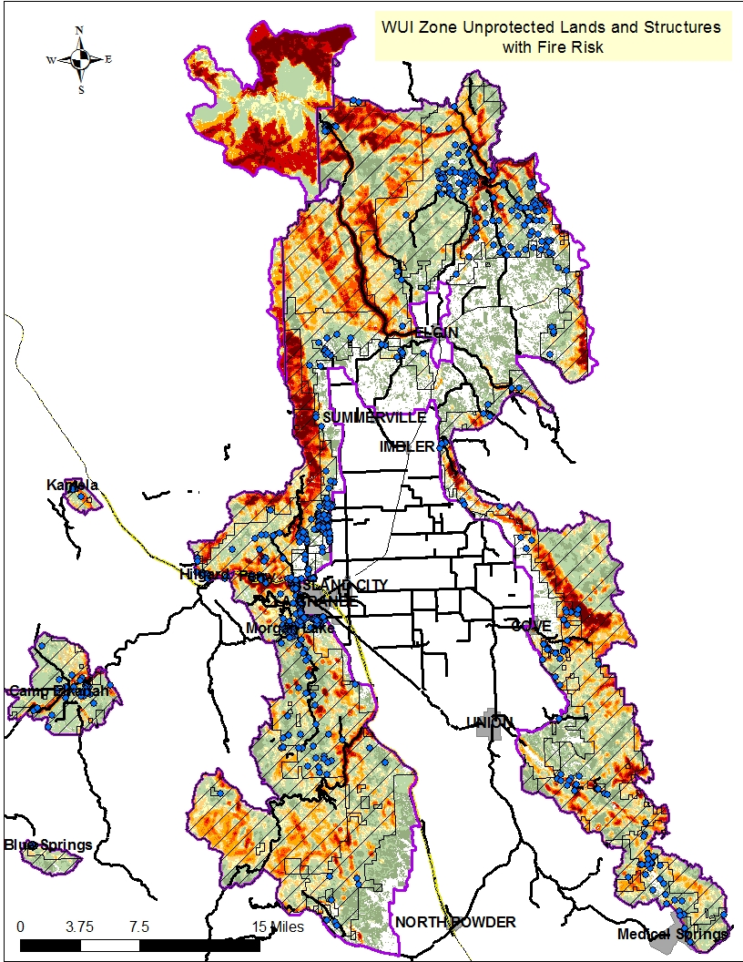

Figure XI – 5. Unprotected Structures within WUIZ against Fire Risk. The hash mark areas show landscapes in which structures (blue dots) are not under a protection jurisdiction.

Unprotected structures are scattered throughout the WUIZ with close to an additional 400 structures not shown that fall outside the WUIZ. There are a number of high and extreme fire risk areas in or near unprotected structures, leaving them particularly vulnerable.

**Dual Protection Areas**

Rural Fire Departments and ODF are working together to provide areas of dual

protection providing fire response for both land and structures. Dual protection areas increase when newly created residences are annexed into the rural protection areas. There are currently 71,613 acres of dual protection in Union County with the number expected to rise as home developments occur. These blocks of land are primarily associated with the outside borders of the rural protection areas.

|  |  |  |  |  |
| --- | --- | --- | --- | --- |
| Dual Protection Agencies | Acres |  | Dual Protection Agencies | Acres |
| RFD Cove/ODF | 5,596 |  | East Umatilla/Pendleton ODF | 9,664 |
| RFD Elgin/ODF | 27,436 |  | RFD Imbler/ODF | 13,091 |
| RFD La Grande/ODF | 4,533 |  | RFD North Powder/ODF | 7,910 |
|  |  |  | Union RFD / ODF | 3,083 |

Figure XI - 6. Dual protection coverage between Oregon Department of Forestry and Union

County Rural Fire Departments.

**Protection Capabilities**

Union County has a vast landscape of forest and a finite amount of fire protection resources, making for extended response times, prioritizing of areas, and putting emphasis on pre-fire mitigation treatments. There are a total of 2,039 square miles in Union County with eight fire protection stations, giving Union County less than one fire station per 250 square miles. Six of these fire stations are located in the Grande Ronde Valley proper, with the remaining two located in the Medical Springs and in North Powder. Response times range from 30 minutes to two hours, depending on availability of personnel, proximity to station, single or multiple fire starts, and draw down levels of local resources.

Additionally, the US Forest Service (USFS) and the Oregon Department of Forestry (ODF) provide wildland fire protection for timber resources. Though many rural fire protection districts are certified in wildland firefighting, wildland firefighters are not equipped or trained in structural protection. The Bureau of Land Management (BLM) also manages land in Union County, but is in agreement with the USFS for initial attack responsibilities on BLM land.

Protection capabilities are impacted by both response time and staffing issues. The County has five rural fire departments (RFD) that are fully staffed by volunteer firefighters, accounting for 45 percent of the county’s fire staff. Imbler RFD has 12 part-time firefighters, and La Grande RFD has one full-time firefighter. Paid part-time fire fighters make up 29 percent of the fire protection service, leaving 9 percent as full-time employees (Figure XI -7).

The following table lists Union County’s Fire Departments, and indicates protection area, number of staff, and pay status at each protection district.

|  |  |  |  |  |  |  |  |  |
| --- | --- | --- | --- | --- | --- | --- | --- | --- |
| Fire Department/  Agency | Protection Area  in Sq. Miles | No. of  Stations | Number of Staff | | | | | Estimated Structure Count |
| Firefighters (FF) | | | Non-FF | |
| PFT | PPT | V | P | V |
| Cove RFD | 36 | 1 |  |  | 25 | 1 |  | 583 |
| Elgin RFD | 71 | 1 |  |  | 23 |  |  | 1159 |
| Imbler RFD | 69 | 2 |  | 12 |  |  | 3 | 698 |
| La Grande City | 77 | 1 | 17 | 20 |  | 1 | 1 | 1013 |
| La Grande RFD | 84 | 1 | 1 |  | 16 |  | 2 | 1354 |
| Medical Springs RFD | 117 | 1 |  |  | 12 |  | 4 | 82 |
| North Powder RFD | 173 | 1 |  |  | 13 |  |  | 440 |
| Union RFD | 52 | 1 |  |  | 25 |  | 5 | 171 |
| Oregon Dept. Forestry | 683 | 1 | 2 | 11  1 -D |  |  |  | 1648 |
| U.S. Forest Service | 963 | 1* | 15 | 20 |  |  |  | Misc. Scattered Buildings |

Figure XI - 7. Non-government firefighters consist of 89 percent non-pay status volunteers. * Numbers do not reflect nationally shared resources such as hotshots, helitack rappel crews, seats. PFT = Paid Full Time, PPT = Paid Part-time, V = Volunteer, P = Paid, 1 – D = dozer. See chapter IV for city populations. RFD sq. miles include mutual protection with ODF.

It is worth mentioning that La Grande City Fire Department responds to a variety of fire types, including wildland fires. The department is staffed by 20 part-time firefighters and 17 full-time paid firefighters, including three career captains, 12 career firefighters, one administrative assistant, and one fire chief. The city fire departments respond to roughly 2,500 calls annually, of which 77 percent are medical emergencies. Fires for La Grande City averaged 13.3 per month during 2013-2014, including outdoor and wildland fires with August as the second highest fire month after December.

In rural Oregon, when fires occur in woodlands near homes, those first to arrive are often friends and neighbors acting as volunteer firefighters. Oregon rural areas depend on volunteer firefighters to maintain service to the local communities. However, recruitment both nationally and in Oregon has fallen. Between 2005 and 2010, Oregon’s volunteer firefighting numbers were in line with a national decrease of 12 percent. Oregon has 10,000 firefighters, of which approximately 8,000 (four-fifths) are volunteers (Oregonlive.com 2011). A 12 percent drop in volunteers would reduce the numbers by 960 individuals. Additionally, many of the current volunteer firefighters are required to maintain full time jobs elsewhere, resulting in fire responses not being staffed to optimum levels.

One of the topics to surface during the meeting with county fire chiefs is the low interest in firefighting from the local community. Volunteerism and low recruitment impact protection capabilities in several ways:

1. Staffing of equipment is minimal, multiple positions must be filled to meet safety standards for firefighting, i.e.: pump operator, Incident commander, safety officer, span of control, work rest protocol, etc.
2. Not all volunteers can respond to all individual calls for service
3. 72 to 80 hours minimum of training for entry-level. If training is typically during the week, causing the volunteer to miss paid work, but a weekend would require the volunteer to forgo home responsibilities.
4. Volunteers sometimes pay out of pocket for training
5. Many Structure firefighters are cross-trained for wildland fire. Structure fire regulations require firefighters to work in pairs, with two entering a building and two others staying outside. Engine staffing for wildland firefighting requires a minimum of two personnel when responding to a new fire incident. This results in a mandatory minimum number of personnel to be present.

In an attempt to attract new firefighters from the local area, this CWPP identified it as a mitigation measure with corresponding action items in Chapter VIII, to develop a firefighting recruitment program to increase level of interest. The firefighting capacity is not commensurate with the local fire workload and risks posed by wildfire in Union County. Investments into new equipment and increased firefighting workforce in conjunction with wildfire mitigations must occur to improve firefighter and public safety, and success of initial attack efforts.

**Protection Compliance**

Should a wildfire reach the threshold for declaring a conflagration (per the Oregon Conflagration Act), the Union County fire chief will request assistance and support for structure protection. In order to meet the criteria in 2016 Fire Service Mobilization Plan set forth by the Office of the State Fire Marshall for conflagration declaration, Union County is currently compiling this plan in accordance with the following:

1. National Cohesive Wildland Fire Management Strategy 2014
2. 2009 Guidance for Implementation of Federal Wildland Fire Management Policy
3. Oregon Senate Bill 360 (The Act of 1997)
4. Health Forests Restoration Act, 2003
5. FEMA National Fire Plan
6. The 10-year Comprehensive Strategy
7. Regional Natural Hazard Mitigation Plan (Baker, Grant, Union, and Wallowa Counties)
8. Union County Emergency Operations Plan
9. Federal Register, 2001 listing High Risk WUI Communities
10. Oregon Administrative Rules Chapter 477, Fire Protection of Forests and Vegetation

The Union County Board of Commissioners has adopted fire siting standards within the Union County Zoning, Partition and Subdivision Ordinance (UCZPSO). These have been modified over time using Oregon Department of Forestry fire siting standards. The County’s IT Department is working on changing the designation that appears on property tax statements from “fire patrol” to “ODF non-structural protection”. Other criteria required by the Office of the State Fire Marshall for 2006 include the active implementation of this community wildfire protection plan (Union County CWPP 2005).

**Mitigation Action Plan for Emergency Services**

The focus of this section is Union County’s Emergency Services participation and efforts regarding wildland fire. County led efforts are centered on fire fighter and public safety; increasing opportunities to promote community awareness and involvement; collaboratively working with local agencies to improve emergency response.

**Information Dissemination**

Union County has many public information options today designed to educate the public on several emergency fronts, including wildland fire. Emergency Services has developed a Facebook page titled “Union County Emergency Services” (UCES) that provides 1,423 followers with real-time updates to wildland fire events. In the summer of 2015 during the wildfire season, members of the public were able to view fire information as it was released.

Union County web site, <http://union-county.org/>, has a link to Emergency Services that provides access to Emergency Preparedness and planning for a wildland fire. This site also provides a link for the public to opt-in for the County’s emergency notification system, hosted by AlertSense. The system allows targeted, expedited public information release during emergencies that include natural disasters such as wildfires.

A blog site called, Blue Mountain Fire Information has been established for information regarding current wildfire activity in the Blue Mountains areas of northeast Oregon and southeast Washington. This site is hosted by the Blue Mountain Interagency Dispatch Center, Oregon Department of Forestry’s Northeast Oregon District, Umatilla National Forest, and Wallowa-Whitman National Forest. This site provides recent news releases as well as real time forest conditions, local and regional wildfire conditions, current activities planned, and links to several agencies’ Facebook pages and websites.

**County Wide Fire Simulation Scenarios**

County emergency and fire management agencies, along with local cooperators, have been proactive in preparing for wildfire events. In May of 2015, Emergency Services hosted a wildfire simulation event with 63 individuals in attendance. The simulation involved all fire response agencies and 17 cooperators, including local law enforcement, American Red Cross, etc. (Appendix H). This provided opportunities to filter out potential issues in advance of a wildfire threat. Simulations are planned to occur every three years, with the expectation of increased cooperator involvement.

**Zoning and Standards**

New construction and zoning opportunities will provide the best possible protection for both land and structures. As new construction occurs, defining local protection districts and wildfire mitigation needs upfront will increase opportunities for successful home protection during wildfire events. The Cohesive Wildfire Strategy emphasizes a need for assessing urban interface growth, land development, and zoning laws where communities can be proactive in developing defensible space and wildland fire risk reduction actions during new development (CWS 2014). Maintenance of previously completed fire risk reduction should also be an important topic during zoning assessments (CWS 2014).

**Fire Siting/Zoning Standards information**

Union County Planning Department has released its 2016 standards for dwellings in or near forested areas. Union County Articles 8.0 Subsection 8.06 and 9.0 Subsection 9.06 Fire Siting Standards provides information for new dwellings and related structures in the R-3 and R-4 Zones where the predominant use is forestry and where dwellings are on rangeland within one quarter mile of forest land areas (Union County 2016).

Both Articles 8 and 9 discuss new dwellings and fire protection. Subsections 8.06 (2) and 9.06 (2) state that new dwellings shall be located upon a parcel within a fire protection district. If the inclusion of the new dwelling into a fire protection district or a contract for residential fire protection is impractical, then the applicant shall provide an alternate means of protection the dwelling from fire hazards (Union County 2016).

Standards in subsections 2 thru 5 discuss multiple protection needs both in and outside the fire protection districts. Items include:

* Water resources, capacity, and access
* Road construction and access
* Turnarounds
* Signage
* Defensible space – fuels reduction, clearance, landscaping, maintenance
* Building construction

**Defensible Space**

Defensible space is an area designed to improve structures’ chances of surviving a wildfire. Defensible space provides an area that increases options for firefighting resources during a wildfire event. It includes areas in which vegetation has been altered or reduced in an effort to modify fire behavior, reduce structure ignition, and increase opportunities for firefighters to defend structures or critical infrastructure. It often increases the probability of structure survivability, even at times when fire conditions limit engagement of firefighting tactics.

There are four primary objectives when developing defensible space:

1. Safer locations for firefighters to engage wildfires.
2. Modify fire behavior through changes to vegetation.
3. Stop fire spread prior to it reaching communities, in effect reducing fire size and commitment of firefighting resources.
4. Landscape fragmentation of vegetation continuity, which accomplishes the first three.

Residential defensible space takes many forms that could include planting and maintaining a lawn, thinning/clearing underbrush and dense stands, and providing adequate road access for firefighting equipment. Residential defensible space is often in close proximity to structures. The areas can receive layered treatments of the vegetation in a vertical primary, secondary and tertiary format. Different treatments and maintenance can occur in each portion of the space depending on needs. The size of a defensible space will vary, and is dependent on many factors such as slope, fuels, climate, and fire history.

Community defensible space in the middle ground can also provide advantages to firefighting by changing fire behavior well outside the residential areas in an effort to prevent direct threats to communities. The primary purpose of a fuel treatment is to change fire behavior if a wildfire should enter a fuel-altered zone, thus lessening the impact of the fire to communities as well as ecosystems. This change in fire behavior is often quantified as a reduction in flame length, intensity, or rate-of-spread, and manifested as a change in severity or growth of the fire. This is best achieved by fragmenting the fuel complex and repeatedly disrupting or locally blocking fire growth, thus increasing the likelihood that suppression will be effective or until weather conditions change (Finney 2001). In other words, by treating areas on the landscape in order to break up the fuel continuousness of both standing live and dead down material, these treated areas will disrupt the wildfire behavior and modify the fire growth to allow suppression resources to be effective. Vertical and horizontal vegetation treatments, vegetation modification along primary roads, and strategically placing treatments as part of a defensible plan all provide a means of fragmenting the fuels to disrupt fire spread.

The number of resources needed to protect a structure that has a properly maintained defensible space is usually lower. Union County is prone to multiple lightning fire starts and has the potential for a major fire in a WUI, thus, conserving resources will be a priority in an effort to defend as much property as possible.

**Interoperability Between Dispatch Centers**

The county currently has two primary dispatch centers that notify emergency resources, including wildland fire, of needed assistance at an incident. The Blue Mountain Interagency Dispatch Center (BMIDC) is designed with wildland fire in mind. The  
Dispatch Center employs personnel from both the U.S. Forest Service and ODF dispatchers, who handle both wildfire initial attack dispatching and wildfire logistical support.

The Communications Division for the City of La Grande includes the emergency 9-1-1 center for all of Union County dispatching both emergency and non-emergency calls for service including La Grande Police Department, La Grande Fire and Ambulance and through cooperative agreements the Union County Sheriff's Office, La Grande Rural and QRT, Imbler Rural and QRT, Elgin Rural Fire and Ambulance, Cove Rural and QRT, Union City Fire and Ambulance, Union Rural Fire, North Powder Rural Fire and QRT and Medical Springs Rural Fire and QRT. The 9-1-1 Center is the 9-1-1 Public Safety Answering Point (PSAP) for all of Union County and provides emergency dispatch services for 22 Law Enforcement, Fire and EMS agencies throughout the County (City of La Grande 2016).

A Computer Aided Dispatch (CAD) link between dispatch centers does not currently exist, and as wildland fire response continues to evolve to include more interagency involvement CAD connections are needed at a minimum. The development of compatible computer systems and/or software between Union County and the Blue Mountain Interagency Dispatch Center will assist emergency services in a number of ways.

* Allows for real time information between Emergency 911 and wildland fire dispatch offices.
* Provides for a centralized data base where all information can be obtained
* Increases efficiency in communication between the county, state, and federal agencies.
* Disseminates consistent information between dispatch centers and fire response agencies.

**Training**

Most wildland fires are either on State protected private lands or Federal lands, which often results in reciprocal agreements between agencies on training requirements to qualify for wildland firefighting. This provides consistent training qualifications for wildland fires. The Forest Service and ODF offer a variety of opportunities to help rural firefighters with wildland fire training.

The State of Oregon has the Department of Public Safety Standards and Training that serves career and volunteer structural fire fighters, providing entry-level, specialized, leadership, and maintenance training to Oregon’s fire service professionals (Oregon State 2016). Many of the Forest Service and ODF training classes provide student classroom space for structural firefighting personnel.

The U.S. Forest Service, BLM, and ODF provide a wide range of courses for wildland fire professionals to update their knowledge and skills. Many of these courses are interagency in nature.

Rural Fire Departments are hired for fire response and training under the State of Oregon because there is no avenue for the Forest Service to develop a mutual response agreement with Rural fire departments. Currently, Rural Fire departments cannot be hired directly by the Forest Service. This creates obstacles when Rural Fire departments are the closest resource for initial attack on public lands, resulting in inefficient uses of resources, slowed response times, and more acres burned.

Training can also be an obstacle for rural fire departments, since they are not on an agreement for federal training program. Rural fire departments must find qualified instructors and sponsors to conduct classes or pay for classes at local community colleges. This requires time and money for individuals who are also holding down other full-time jobs. Developing local trainings where rural departments can maintain and increase their qualification would benefit the local, state, and federal partners. Developing a program through the Northwest Coordination Training Group (NWCG) to include rural firefighters will result in increased state and federal response capacity.

Union County fire response may differ depending on agency and burnable material involved, however, to assist on publicly owned lands, federal wildland fire standards for training must be met. This training provides consistent safety procedures, language, processes, and knowledge.

**Summary**

Union County is 2,039 square miles (1.3 million acres) in size, supporting an estimated population of 25,652 people. The larger percentage of infrastructure and communities are centered within the Grande Ronde Valley and its surrounding foothills with some isolated outlying communities that currently have no structure protection.

Fire protection in the county ranges from wildlands only, structures only, to no protection at all. The lack of fire protection for all structures is Union County’s highest concern in this CWPP. A total 432,701acres of privately owned property lacks structural fire protection, where the bulk of the structures exist. The 652,911acres of Forest Service managed public lands is under wildland protection only. These lands have very few structures, most of which are not residential. .

Rural fire departments are the most affected in maintaining response capabilities for several reasons. Rural fire departments are hired for wildland firefighting through ODF, they have had low recruitment, they are almost entirely volunteers, and have limited access to training.

Collaborative efforts are continually being built upon through countywide fire simulations that provide fire scenario situations before they occur in which cooperators and agencies have an opportunity to understand their roles prior to a wildfire occurring. New technology has improved outreach to county residents through Facebook, blog sites, and agency-specific websites to engage them in risk reduction and defensible space measures.

Several opportunities exist through this CWPP that will improve fire response capabilities. Collaborative working together to advance information sharing, fire siting, communications, and training can save lives and property.

**Bibliography:**

Finney, Mark A. 2001. *Design of Regular Landscape Fuel Treatment Patterns for Modifying Fire Growth and Behavior.* Forest Science 47(2) 2001. Research Forester, USDA Forest Service, Rocky Mountain Research Station, PO Box 8089, Missoula MT 59807

U of O 2014. University of Oregon, February 2014. *Regional Natural Hazards Mitigation Plan Northeast Oregon,* Counties of Baker, Grant, Union, and Wallowa and Addenda for Baker City, Enterprise, Halfway, John Day, and La Grande. Northeast Oregon Multi-jurisdictional Natural Hazards Mitigation Plan.

**Web Links:**

Fire Department.net.

<http://www.firedepartment.net/nearest-fire-department#location=Union+County%2C+OR>

City of La Grande 2016. <http://www.cityoflagrande.org/muraProjects/muraLAG/lagcity/index.cfm/city-offices/police/about-us/misson-statement/>

<http://www.cityoflagrande.org/muraProjects/muraLAG/lagcity/?LinkServID=503DB9EA-5056-A32F-D56E2C04484807B1&showMeta=0>

National Interagency Fire Center 2016. <https://www.nifc.gov/training/training_main.html>

Oregonlive. 2011. <http://www.oregonlive.com/news/index.ssf/2011/04/shrinking_ranks_of_volunteers.html>

Oregon 2015. <https://www.oregonlegislature.gov/bills_laws/ors/ors477.html>

Oregon 2016. <http://www.oregonlaws.org/ors/chapter/476>

Oregon State 2016. <http://www.oregon.gov/dpsst/FT/pages/index.aspx> and http://www.oregon.gov/DPSST/Pages/index.aspx

Oregon Volunteer Firefighters Association 2016. <http://ovfa.org/>

Union County 2016. <http://union-county.org/planning/> and <http://union-county.org/wp-content/uploads/2013/08/ARTICLE-9.00-R-4-Forest-Residential-Zone.pdf> and <http://union-county.org/wp-content/uploads/2013/08/ARTICLE-8.00-R-3-Farm-Residential-Zone.pdf>