IX. Fuels Treatment, Maintenance, and Biomass

Introduction

Fire is an important regulatory phenomenon in forest communities of the Blue Mountains as well as most areas of the intermountain western United States (Gast et al. 1991). Historically, in pre-European settlement periods, the Blue Mountains burned with relative frequency in a variety of forest types including ponderosa pine/Douglas-fir stand structures to moist mixed conifer type forests that under today’s vegetation composition may not have necessarily been the same as vegetation that would have developed with historic disturbance regimes (Stine et al 2014). Drier sites generally experienced fires every 0 – 25 years, retaining predominately fire-tolerant species, while the historical vegetation of the moister mixed forest was controlled by frequent to moderately frequent fires (every <20 to 50 years) that burned with mixed severity, containing both low- and high-severity patches (Stine et al 2014).

During the dry season, wildland fires frequented the landscapes of Eastern Oregon, giving the area a blue tint from the smoke and haze, earning the mountains east of the Columbia Basin the Blue Mountains name. Many sites of the low and mid elevation areas where these fires burned, forests were park-like, dominated by fire-resistant pine, and on wetter sites, western larch (Mutch et al. 1993). Settlers in the nineteenth century reported riding horseback and pulling wagons or miles through the area (Wickman 1992).

Fire disturbance on the landscape is an important component for ecological process and promoting healthy forests. Through history, wildfire acted as a cleansing mechanism, shaping stand structures and characteristics across the landscapes. Historically, fire interaction in Union County’s ecosystems accomplished several things.

- Fire consumed dead material on the forest floor and prevented build-up of large quantities of forest debris.
- Acting as a cleansing agent, fire killed some newly established regeneration, naturally thinning stands and preventing overstocking of landscapes and high competition for water.
- Historic fires often burned as surface fires pruning lower limbs off the overstory trees thereby raising the height of the tree crown above the ground level (canopy base height). This sets the stage for future fires to actively burn with very little impact to overstory tree crowns.
- Spatial extents of fires were often left unchecked, creating burning patterns that were mosaic, covered large areas with low intensities, and set the stage for minimal impact when another fire occurred in the area.
- Frequent fires are often associated with lower smoke emissions due to shorter burning duration in grasses and fine fuels, versus current fires that exhibit high emissions from heavy ground fuels and fire-involved canopies.
- Wildfires conducted periodic maintenance of the landscapes by killing non-fire tolerant species through natural thinning, leaving species that were fire resilient.

The wildland fire environment is directly related to fuel availability, which is directly related to fire frequency. Successful fire suppression brought to the forests in Union County and throughout the northwest an absence of wildfires that historically acted as a cleansing agent by removing both live and dead fuel.

When early explorers, missionaries, and settlers first entered the Blue Mountains in the mid-1800s, they encountered a vegetation mosaic that was the result of long-term wildfire interaction. Many areas were dominated by open, park-like forests of ponderosa pine, often with a luxuriant undergrowth of tall grasses reaching as high as their horse’s belly. Those attractive landscapes had been created and maintained by low-intensity surface fires occurring at frequent intervals, usually every 8–20 years (Agee 1993, Anderson and others 1987, Cooper 1961, Franklin and Dyrness 1973, Hall 1977, Marouka 1993, Weaver 1947b).

The western United States has seen several shifts in the wildland fire environment. Forests historically experienced frequent low intensity surface fires. Then in 1910 large landscape wildfires occurred throughout the Northwest causing a change in fire suppression policies across the west. Wildfire starts were under the guidance of full suppression removing its interaction from the ecosystem. Through the mid-1970s to the present, there has continued to be a level of successful fire suppression. However, those that have escaped initial attack (about two percent) are exhibiting unprecedented fire behavior, resulting in stand replacement fires in locations that once supported low surface fires. As a result, Northeast Oregon currently has an overwhelming number of acres in need of forest management to transition the ecosystems to a closer representation of pre-European settlement open forests.

Forest Health

Fire exclusion in forests of the Blue Mountain Region of northeast Oregon has resulted in significant changes since European-American settlement. The forests of the Blue Mountains have evolved in the context of a disturbance regime dominated by fire (Agee 1996). Fire suppression over the past 80 years has led to significant accumulation of fuel, increasing the probability of catastrophic wildfire over much of the Blue Mountains landscape (Gast et al. 1991, Agee 1996). Inadvertently, the absence of fire over an 80 to 100-year period allowed Douglas-fir, grand or white fir to take over the forests, slowly replacing the pine and larch (Oester, et al. 1992. Forest Health in eastern Oregon).

A drastic change in the ecology of the Blue Mountains ecosystems began as a consequence of fire suppression, which became increasingly effective after the 1930s (Agee 1990). Changes to landscape environments over the last several decades resulted in unprecedentedly poor ecological conditions today. These negative impacts are often interrelated, producing a ripple effect resulting in multifaceted contributing factors. These factors include: encroachment of shade-tolerant, fire-intolerant species, stands at very high stocking levels in spaces which historically were open with a low number of trees per acre, high tree stress due to competition for water, and widespread impacts from insect and disease. Exacerbated by an extended drought in the Blue Mountains, they have led to unprecedented wildfire behavior on the landscape.

Overstocking created ideal microclimate conditions across the Blue Mountains for insect infestation and disease. As early as the 1980s, landscape conditions in and around Union County experienced high levels of tree mortality. In northeast Oregon, including Union County, 655 million board feet of timber were lost to bark beetle between 1986 and 1991. An estimated 4 million acres were defoliated in 1991 alone by the western spruce budworm (Oester et. al 1992).

The lack of fire activity on the landscape allowed for additional increases in both stand density and fuels accumulation. Stand structure composition and spatial patterns on the landscape have also shifted. Today’s landscapes are now more consistently uniform in nature, with most timbered stands exhibiting characteristics that contribute to extreme fire behavior.

Patch sizes of high severity have increased, leaving less low and moderate severity patterns on the landscape. Fire intensity (amount of heat energy generated) has increased, surpassing the past fire-intensity range, because of fuel buildup and “ladder” fuels enabling surface fires to move into the canopy (Agee 1994). Landscapes that were once accustomed to surface fires are now experiencing thousands and thousands of acres of stand replacement fire. The Windy/Cornet fire south in Baker County, and the Grizzly Fire north in Wallowa/Umatilla County both burned with extreme fire behavior and exceeded 40,000 acres. If left untreated, stands will continue to experience larger patches of torching and crown fires and the potential for non-historical unprecedented extreme fire behavior.

Eliminating wildfire from the landscape is not realistic, particularly in a fire prone ecosystem where natural fires are the predominate source of ignition. Changing how fire burns on the landscape, however, is possible. A century of fire suppression, low pace and scale, delays in project implementations, treatment restrictions based on land base and limited commercial logging opportunities have compounded landscape conditions. Proactive management toward the goals of this CWPP will provide mechanisms for living with fire.

Importance of Fuels

Wildland fuel has always been classified as vegetative material that will burn during a wildfire. These fuels include dead and down material, live vegetation, lichen, mosses, and organic material such as duff (organic material immediately above the soil) and roots. Recently however, the increase of homes in forested areas has compounded an already complex fuel composition. As a result, fire and land managers have combined efforts to address the increasing difficulties of pre-fire planning, fuel modifications, and fire suppression.

Landscape fuels play a significant role in wildland fire fighting. Stand and fuels structure influence several aspects of the wildfire environment such as: the likelihood of a fire ignition, fire behavior characteristics on the land including flame lengths and rates of spread, and how fire will spread on the landscape once an ignition does occur. In the wildland fire setting, fuel is the only constant in both the fire triangle requirements for ignition (heat, fuel, oxygen) and the fire behavior triangle (fuel, weather, and topography), referencing the influences of wildfire behavior characteristics.

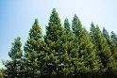
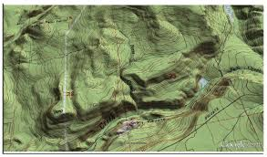
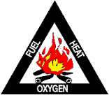
FUEL
WEATHER
TOPOGRAPHY
Fire Triangle Fire Behavior Triangle
Figure IX – 1. Fire Triangle – components needed for an ignition to occur. Fire Behavior Triangle – components that dictate how a fire will burn. Fuel is the common denominator between the two.

Even more importantly, fuel is the one component of both fire triangles where management activities can manipulate part of the fire equations and influence the fires interaction on the landscape through planning and implementation well in advance of an ignition. It is important to know how fuel arrangements can affect fire behavior and what impacts fuels modifications can have on wildfire behavior. There are several layers of a forest fuel bed that influence wildfire.

Ground Fuels
- Duff - organic matter just above the soil such as some rotten logs and needle mat
- Mosses, litter, needle cast
Surface Fuels
- Woody fuel – small limb wood, logs, dead down fuels (large quantities can act as ladder fuels)
- Low vegetation – grasses, shrubs, herbs
Aerial Fuels
- Ladder Fuels - Tall shrubs/brush, suppressed understory
- Tree canopy – dominant and co-dominant overstory, suppressed understory, snags

Each of these fuel layers can be can be manipulated to create a change in the fire behavior environment. However, the focus of this document is on how management can play a role in altering the influence of surface fuels and aerial fuels on fire behavior.

SURFACE FUELS

Surface fuels consist of grasses, shrubs, litter, and woody material lying on, or in contact with the ground surface (Sandberg and others 2001). These fuels are often used as indicators of surface fire spread rates. Dead woody material is critical in predicting fire potential because they are controlled exclusively by their exposure to environmental conditions such as humidity, shading, proximity to soil that influence fuel moistures levels.

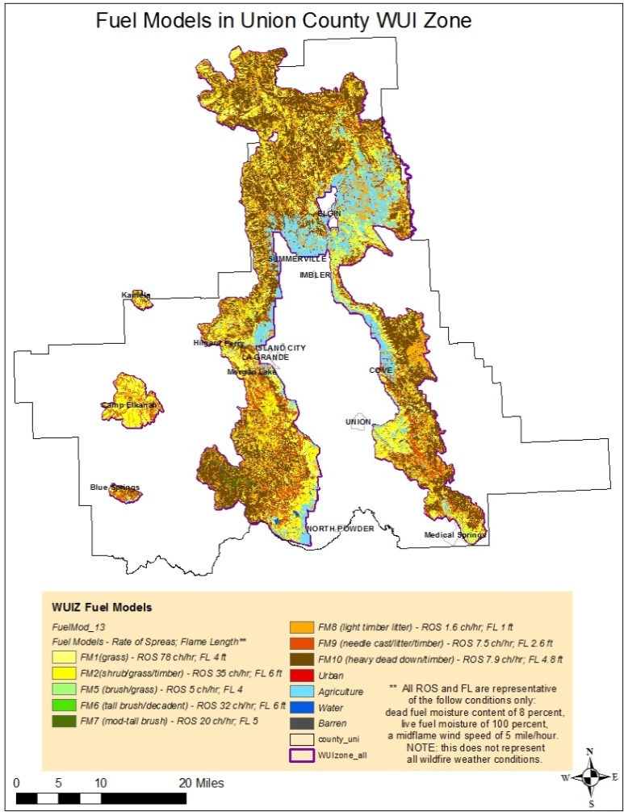
Live fuels in the category are considered a dynamic type fuel because fuel moisture levels will differ depending on which growing season phase is occurring. Live fuels have a high fuel moisture content in the spring growing season and begin to cure throughout the fire season, eventually losing most if not all their moisture by mid-summer into the fall season. Many of the live surface fuels, particularly grasses, eventually transition into the dead woody material category increasing the available dead fuel component and potential fire behavior as the season progresses.
Table IX-2. Fuel Model composition within the WUIZ. Data from the WWRA. Fire Behavior is based on Anderson 1982. Aids to Determining Fuel Models for Estimating Fire Behavior.

Because there has been a shift in stand conditions, there has been a direct effect on fuel loadings. As stands become denser, there is more available woody material to contribute to the forest floor (Oliver et al., 1996). The shifting of stand condition has contributed to higher than historic accumulations of dead, down woody material. Stand characteristics are directly related to and influence the amount, size and arrangement, and distribution of surface fuels at ground level, both live and dead. These surface fuels are often at the heart of crown fires since most ignitions initially begin as ground fires and transition to the canopy.

Different fuel treatment approaches can be designed for targeting various components of the fuel bed and stand structures. Prescribed burning and piling and burning woody debris will target surface fuels, while pruning and stand thinning will mainly treat aerial fuels.

Fuel models are broken out into four groups: grasses, brushes, timber, and slash. Surface fuel mapping shows approximately 86 percent of the WUIZ is comprised of a variety of fuels including: grass, grass/brush, brush or timber litter with a down woody fuel component. Nine percent of the WUIZ is non-timbered grass or brush with the remaining 77 percent of the surface fuel nestled within timber. Timbered stands that have been allowed to transition through the last 80 years without disturbance have a higher likelihood of exhibiting a fuel model 10. This fuel model supports the highest component of fuel size classes with a high level of large fuels.

Fuel model 10 often displays greater fire intensity than the other timber models. The larger quantities of both fine fuels (0 – 3 inch) combined with greater amounts of large woody material from three inches in diameter to large logs increase fire behavior. Stands that support large woody material size and amounts also exhibit long residence times (when a fire sustains itself in one location for extended periods), resulting in possible additional fire effects in terms of destruction of organic soil material (soil sterilization), an increase erosion potential, and the loss of site productivity.

Sixty-seven percent of the WUIZ is timbered, and 67 percent of the timbered areas in the WUIZ are supporting fuel loads that are outside of historic conditions. Crowning out, spotting, and torching of individual trees are all more frequent in this fuel situation, leading to potential fire control difficulties (Anderson 1982). Figure IX - 2 displays the landscape distribution of fuel model 10 within the WUIZ.

Aerial Fuels

Heavy down fuels, ladder fuels, and poor health of the overstory are prime conditions for high-severity fires. Crown fires caused by excessive fuel accumulation are generally a severe threat to ecological and human values as well as to infrastructure; they pose a major challenge to fire management (USDA Forest Service 2003).

Identifying attributes that contribute to torching/crowning during wildfire is important in order to successfully create conditions that allow for protection of life and property, create resilient landscapes, and satisfy the three goals of the Cohesive Strategy.

Aerial fuels are typically trees and other vegetation suspended above the ground, often in the form of tree foliage such as branches, needles, lichen, leaves, tall bushes, etc. Tree boles are included, but often play less of a role in fire behavior. Stand characteristics such as tree canopy cover, canopy cover distribution, tree crown ratio, and forest composition interact and influence the amount, composition and distribution of live and dead ground-level vegetation (Barnes and others 1998, Oliver and Larson 1990).

Historically, fires pruned the lower limbs of trees as they matured or killed the trees entirely, leaving primarily healthy stands where large spacing occurred from tree to tree and open spaces from lower tree limbs to the ground. Suppressed understory, when allowed to persist in stands, creates a continuous fuel bed both horizontally and vertically across the landscape. The lower limb distance from the tree boles to the ground is known as the canopy base height. As fire-intolerant vegetation continues to accumulate on the landscape, forest stands become increasingly denser, creating a homogeneous structure with low crown base heights resulting in an increased potential for crown fires in many forests of the Western United States (Cooper 1960, Dodge 1972, Van Wagner 1977, Parsons and DeBenedetti 1979, Bonnickesen and Stone 1982, Arno and Brown 1991, Agee 1993, Mutch and others 1993, Hann and others 1997). Changes in structure and composition have dramatically altered how wildfires now burn in these forests versus how they burned historically (Graham et al. 2004).

An increase in stand density also creates an increase of available fuels suspended above ground. These continuous aerial fuels escalate the likelihood of sustained crown fires, whereas breaks in stand continuity and structure can interrupt fire spread. The closer the gap from surface fuels to aerial fuels, the higher the potential for canopy involvement during wildfires. The greater the distance between surface fuels and the base of tree crowns, the more difficult it is for surface fires to torch trees or become crown fires. The increase in canopy bulk density (available canopy fuel in a stand) will increase the potential for a crown ignition to become an “independent” crown fire in which surface fuels no longer are needed to generate crown fire spread.

Photo 1 Photo 2
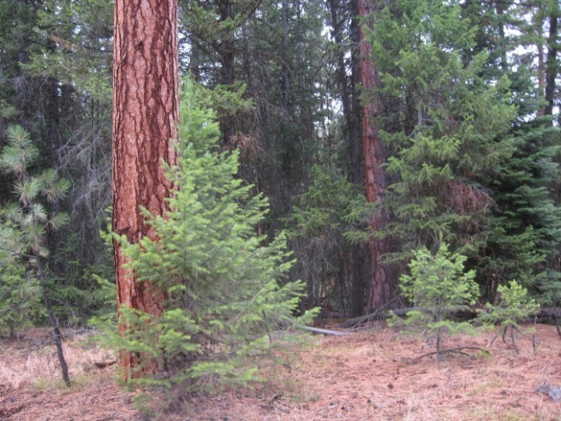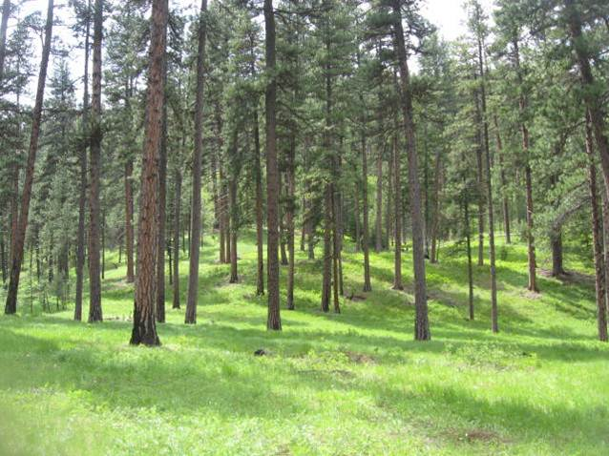
Figure IX - 3. Heavy crown fuels and low canopy base height provide pathway for overstory mortality and crown fire (photo 1), compared to high canopy base height and lower crown density (photo 2) where stands are likely to withstand a wildfire.

Ladder Fuels

Ladder fuels can be comprised of both surface and aerial fuels. Heavy down woody material, brush, understory growth, or overstory with low hanging foliage can provide a path for fire to move from a surface spread into the canopy. These stand characteristics can be a single contributory factor to canopy involvement during wildfires, or as more commonly seen, they can function as one of multiple conditional factors working in concert to generate canopy involvement.

The shrub/small tree stratum is also involved in crown fires by increasing surface fire line intensity (heat/energy release) and serving as “ladder fuels” that provide continuity from the surface fuels to canopy fuels, thereby facilitating crown fires. These intermediary fuels essentially bridge the vertical gap between surface and crown strata. The size of this vertical gap is critical to ignition of crown fire from a surface fire below (Van Wagner 1977).

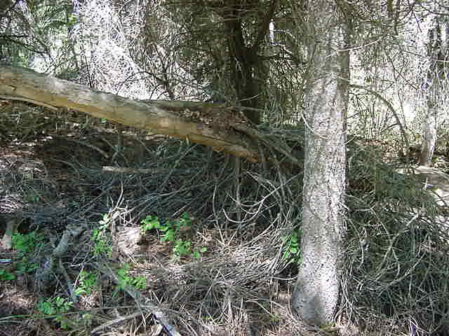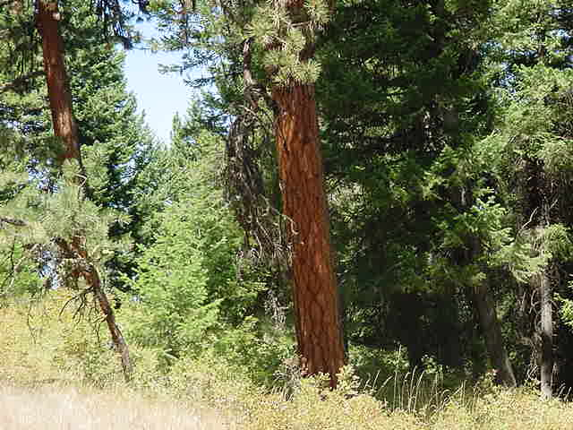
Down Woody (Fuel Model 10) Combination brush/second growth
Figure IX - 4. Examples of ladder fuels that promote the transition of surface fires to crown fires.

A century of widespread fire exclusion combined with the reduction of active forest management has resulted in a buildup of surface fuels and the overstocking of forests with trees and ladder fuels (CWS 2014). As a result, forest and rangeland health problems in the West are widespread and increasing, affecting wildlife habitat, water quality and quantity, and long-term soil productivity, while providing conditions for uncharacteristically large, severe, and costly wildfires, with increasing threats to human life and property (CWS 2014). Union County’s WUIZ is comprised of an extensive amount of area with a canopy base height in close proximity to the surface fuels at ground level. Approximately 32 percent of the WUIZ is non-forested and is predominately located within the Grande Ronde Valley agricultural area. The remaining WUIZ is comprised of a high percentage of low forest canopy vegetation. Vegetation that supports canopy from forest floor to two feet (24 inches) above ground accounts for 41 percent of the forested areas, 13 percent between two and four feet above ground, 4 percent between four and six feet above ground level, 7 percent between six and seven feet with only a total of 3 percent extending seven feet above ground level. Figure IX-5.

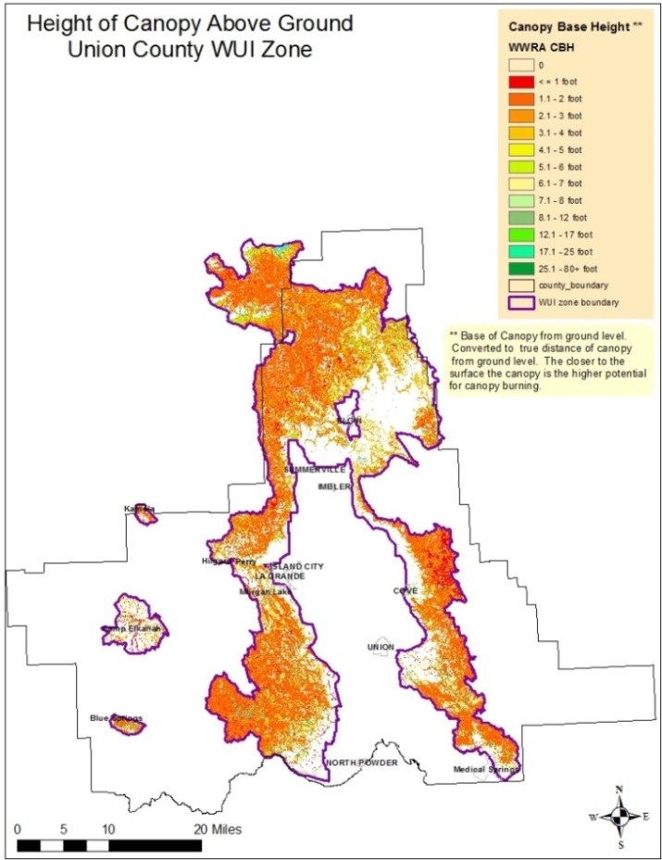
Figure IX - 5. The closer the canopy base height is to ground level, the higher the probability of canopy involvement during wildfire events.

A forest with heavy down woody material in combination with low canopy base heights not only has an increased potential for canopy involvement during wildfires, but also has a higher likelihood of long range spotting and large scale landscape fires.

The probability of a canopy fire in or near the county’s communities is very high, as well as widely distributed throughout the WUIZ. Locations where the probability of canopy fire is highest are areas that support heavy down woody fuels in timbered stands, a low canopy base height or both (Figure IX – 6).

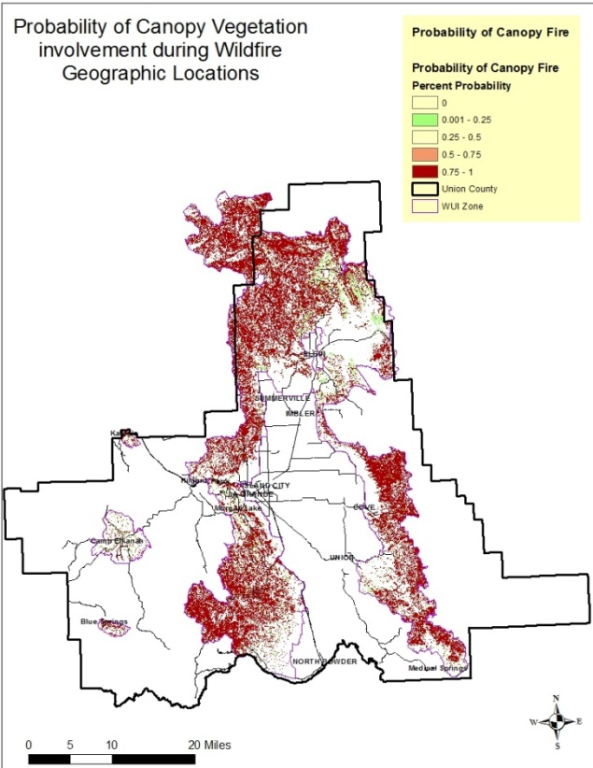
Figure IX - 6. The highest probability of canopy fires account for 60 percent of WUI Zone.

Fuels Treatment

Modification of any dead down woody fuel or live vegetative layers has implications for fire behavior, fire suppression, and fire severity (Graham et al. 2004). Active forest management, including thinning, reduces flammability in the mid-story and over-story, while treating surface fuels, including those resulting from thinning, decreases surface fire potential (Forest Service, 2003). The most effective strategy for reducing crown fire occurrence and severity is to (1) reduce surface fuels, (2) increase height to live crown, (3) reduce canopy bulk density, and (4) reduce continuity of the forest canopy (Agee 1996, Graham and others 1999, Scott and Reinhardt 2001, Cruz and others 2002).

WUIZ and Communities at Risk assessments show a need for treatment for several reasons, including expected fire flame lengths, fire spread rates, and probability of canopy fire, as outlined in Chapter VII of this CWPP. These expected behaviors do not reflect the worst-case weather conditions; under extreme weather it is expected that behaviors will be worse. Again, fire behavior is a reflection of the weather, topography, and fuels (burnable material). Manipulation of fuels is the option that can be realistically accomplished through management efforts. Fuels treatment to alter fire behavior is supported by several case studies, scientific communities, research laboratories, fire management, leaders of federal, state, and local agencies and community members. A detailed table of the implication of stand conditions and fuel types along with wildfire behavior and management considerations is located in Appendix K.
Union County is part of the Pilot Project for the National Cohesive Wildfire Strategy. The Northern Blue Mountain-Cohesive Strategy Pilot Project Action Plan has recommended actions for fuels management in an effort to meet the goals of the Cohesive Wildland Fire Management Strategy. Actions associated specifically with fuels management are identified below. Tasks to accomplish these actions are located in The Northern Blue Mountain-Cohesive Strategy Pilot Project Action Plan:

- Action: Promote forest restoration/fuels treatment in and around communities. Also promote wildfire mitigation efforts in the “middle ground” further from communities.
- Action: Promote collaborative forest management and restoration planning.
- Action: Identify and Prioritize Landscapes for Treatment.
- Action: Improve efficiencies and economics of forest biomass removal and marketing; improve understanding of biomass utilization resources, opportunities, and challenges; and improve understanding, acceptance and support and of biomass utilization as a tool for enhancing forest health and fuels reduction.
- Action: Seek understanding, acceptance and support for managed wildfire (prescribed and natural).

There are several fuels management options available to modify fire behavior and reduce crown fire occurrence and overstory post burn severity. Appendix K describes the influence of fuel characteristics on fire behavior and management considerations. Current fuel characteristics have multiple influences on fire behavior that are counterproductive to meeting the CWS goals. Management considerations should include a variety of treatment objectives intended to improve suppression efforts, modify fire behavior, and mitigate fire effects while working toward a sustainable community that is designed to adapt to fire-prone environments.

Through landscape treatments of stand characteristics treatments have proven successful in modifying fire behavior. Some vegetation treatments may solely focus on one or more fuel stratums (layers) while other options may change dead fuel and vegetation both horizontally and vertically. Management treatments may also focus on altering forest species composition and stand structure to improve landscape resiliency by promoting healthy stands that include fire-tolerant species that can survive after a wildfire.

Four principles exist when considering treatments of forest fuels for fire resistant ecosystems, particularly in dry forest types like Union County’s forests: reduce surface fuels, reduce ladder fuels, reduce crown density, and retain large fire-tolerant tree species (Agee and Skinner 2005). These principles also apply to altering fire behavior for protection of life and property and creating fire adapted communities.

Several case study reports are included in the CWPP files for reference. These include:
- The Hayman Fire Case Study where wildfire burned into previously treated mechanical and prescribed burning units.
- The Mountain Fire burned through approximately five types of fuels treatment. The document discusses how effectively fuels treatments reduced fire behavior or immediate effects on vegetation and soil.
- The Cone Fire, Blacks Mountain Experimental Forest burned over 2000 acres in an area where a large project was being conducted to study ecological responses to different stand structures. All treatments were less than 6 years old when the wildfire occurred.
- Evaluation of fuel treatment effectiveness and suppression costs. The case study focuses on the landscape on the Deschutes National Forest.

Aerial Vegetation Treatment

Thinning

The term “thinning”, for the purpose of this document, refers to stand treatments designed to modify standing vegetation where residual stems are distributed in such a manner that wildfire behavior and its effects on overstory vegetation is reduced and where suppression resources have increased the opportunities for successful fire suppression. Ladder and overstory vegetation stratum are often the target layers within a stand where thinning occurs, including: overstory, second growth or co-dominant species, suppressed understory, and brush. Several types of approaches or combinations of approaches may be used to accomplish management objectives. Depending on desired results, these include: cleaning, sanitation, selection cuttings, thinning from below, pre-commercial thinning, overstory harvest, species modification/eradication, etc. These applied approaches can alter fire behavior by meeting objectives that prevent surface fires and isolated tree torching from transitioning to crown fires. These treatments interrupt fire spread across the landscape by breaking up the homogenous stands and continuity, decreasing mortality of overstory from wildfire, and preventing insect infestation and disease, which contribute to the available dead fuel component. Available tool options include hand tools, machinery, prescribed fire, or a combination of methods.

Timber stand thinning of both commercial and non-commercial material is prudent for changing wildfire behavior on the landscape. High density canopy fuels if ignited can result in a spreading crown fire than low density canopies (Graham et. al. 2004). Canopy base height (distance of lower limbs from ground level), canopy bulk density (canopy weight for a given volume), and canopy continuity (continuous) are key characteristics of forest structure that affect the initiation and propagation of crown fires (Albini 1976, Rothermel 1991). Mechanical thinning is a more precise method that can target specific stand structures. It allows for accuracy in selecting both removal and retention of stand components. Used alone, mechanical thinning, especially emphasizing the smaller trees and shrubs, can be effective in reducing the vertical fuel continuity that fosters initiation of crown fires (Graham et. al. 2004). Thinning to reduce continuous canopy horizontally can interrupt crown fire spread and reduce spot fire ignition probability.

Stand thinning provides benefits in wildfire behavior modifications and should be conducted in conjunction with follow up treatments of surface fuels. Without follow up treatment there is potential for an increase surface fuels loadings from thinning. Therefore, when considering stand thinning, due to the high percentage of heavy fuel loads within the WUIZ stands may require multiple treatment approaches to address residual surface fuels that may have previously existed or were generated during thinning. Unless the resultant thinning fuels slash is removed or treated, fire behavior could potentially increase in some areas.

Combining stand thinning with surface fuels reduction is the most effective approach in altering fire behavior on the landscape. The most appropriate fuel treatment strategy is usually thinning (removing ladder fuels and decreasing tree crown density) followed by prescribed fire, piling and burning of fuels, or other mechanical treatments that reduce surface fuel amounts. This approach reduces canopy, ladder, and surface fuels, thereby reducing both the intensity and severity of potential wildfires (Graham et al. 2004).

Pruning

Torching occurs when the surface flame length provides convective heating to tree limbs, and moisture content in the crown and the vertical distance to live crown from the ground supports ignition. This distance from ground to lower crown height of the tree is called canopy base height. Historically, low-intensity fires would burn as surface fires through the stands and scorch lower tree limbs, leaving the majority of the tree crown intact. Natural pruning has been largely absent from forests for more than 80 years due to successful fire suppression and a lack of active management.

Thinning of small-diameter material and pruning branches are more precise methods for reducing the likelihood of a surface fire transitioning into a tree crown or stand canopy. Manually pruning trees is a viable option in and near communities and structures. Prescribed burning is beneficial for targeting ladder fuels and surface fuel components at the same time, especially in the middle ground areas. The effect of removing ladder fuels is that surface fires burning through treated stands are less likely to ignite the overstory canopy fuels (Graham et. al. 2004).

Surface Fuel Reduction

Models and observations of landscape-scale fire behavior and the impacts of fuel treatments clearly suggest that a landscape approach is more likely to have significant overall impacts on fire spread, intensity, perimeters, and suppression capability than an approach that treats individual stands in isolation (Graham et. al. 2004). Application of fuel reduction techniques prior to a wildfire can affect fire behavior.

Reducing the amount of fuel and changing its arrangement before a wildfire erupts can affect fire behavior. Recent examinations of wildfires in the West show that where fuels have been reduced beforehand, fire intensity and severity are usually reduced. Thus, removing or reducing fuels in strategic locations on your property can lower fire risk and help make your property more resistant to wildfire.

Surface fuel reduction alone can change fire behavior; however, in cases where stand structures support low canopy base height and high crown density, a combination of thinning and surface fuel reductions may be needed. Environmental conditions such as remote, steep areas with limited access may limit the treatment tool options available due to management direction, remoteness, and cost effectiveness.

Prescribed Fire

Prescribed fire is a useful tool that can effectively alter potential fire behavior by influencing multiple fuel bed characteristics (Graham et al. 2004). Frequently used and cost effective, prescribed fire treatment is highly effective for surface fuel reduction, raising the canopy base height, and promoting fire tolerant species. Fire can be applied under specific management-identified environmental conditions that apply to weather and fuel (moisture) conditions allowing for control of fire.

Prescribed fire can target the surface fuels, increase canopy base height by scorching lower tree bole limbs, and reduce the amount of ladder fuels. It also has benefits through promoting fire-tolerant species and groundcover vegetation such as grass and forbs over woody debris that support the CWS goals.

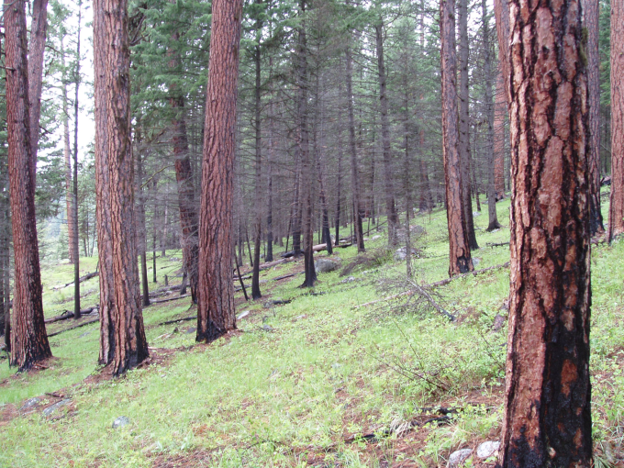
Figure IX - 7. Yellow arrow indicates the canopy base height (1-3 feet) of the stand prior to prescribed burning; white arrow indicates post-burn canopy base height. Photo was taken in the Minam wilderness approximately six years (2010) after burning.

Biomass Utilization

The forests in Union County continue to exhibit an overabundance of material considered to be forest biomass, with a great percentage of this material in the form of woody residues such as tree tops, limbs, non-merchantable logs, small-diameter trees and heavy down woody fuels. Forest biomass is generated by fire and fuels reduction activities, conventional timber management such as harvesting, non-commercial thinning, timber stand improvement (TSI) activities, and natural accumulation. Non-commercial thinning includes pruning, tree removal or thinning designed to help shape and guide development of forest stands, and ladder fuel reduction. It generally does not result in removal of trees that can be used to manufacture products, but it could be used in renewable energy production (heat, steam, electricity, and fuel).

Concerned about the health of Oregon's forestlands, increasingly large and frequent wildfires, and associated expenditures and impacts, the 2005 Oregon Legislature passed Senate Bill 1072 (Chapter 772, Oregon Laws, 2005). In November of 2005 the Oregon Forest Biomass Working Group (OFBWG) was established to meet the directives in established by that bill and subsequent law, as well as to accomplish the biomass goals in then-Governor Kulongoski’s 2005 Renewable Energy Action Plan (Oregon.gov 2005).​

The utilization of woody biomass has the potential to provide Union County with both direct and indirect societal, economic, and environmental benefits. These include:

- Creates jobs for local companies hired for removal.
- Reduces fire risk through vegetation and fuels management.
- Improves air quality, lessen impacts on public health.
- Reduces the cost of hazardous fuels treatments in the future.
- Encourages economic development by supplying material to local mills, and creates opportunities for innovative/new infrastructure for processing and using the material.
- Enhances and/or preserves ecosystems.
- Reduces smoke emissions during landscape burning, improving fire-related health and safety issues.
- Provides a market for insect- or disease-infested trees, invasive species, and other woody biomass removed, and improves forest health.
- Increases availability of renewable fuel through bioenergy, promoting energy independence, and rural economic development.

Union County currently supports three Boise Cascade-owned processing facilities: a plywood plant located in the town of Elgin, a sawmill, and a particleboard plant in La Grande (Boise Cascade 2016). The closest facility for biomass product is located in Wallowa County, with an expansion in progress to include the production of wood bricks at Integrated Biomass Resources in Wallowa County next to a post-and-pole plant owned by Community Smallwood Solutions (Davis et. al. 2010).

Union County Economic Development Corporation is focusing business recruitment efforts on transportation equipment manufacturing and forestry and wood products sectors. The strength of these sectors is largely influenced by environmental regulations. The forestry and wood products sector (including biomass and other diversification strategies) could grow if more timber resources were harvested from federal forests (NEOEDD 2013 – 2018).

Most of the material generated from fuels reduction activities is not suitable for commercial wood products manufacturing, so many times the biomass from these activities is left on site and burned. There is currently a strong push in Oregon by county commissioners, industry leaders, local businesses, agencies, landowners, and some conservation groups to create opportunities from forest biomass while achieving the goals of the community wildfire protection plan for fire risk reduction.

The program distributes firewood to limited capacity citizens across Baker, Union, and Wallowa Counties. Unfortunately, the program utilizes only a small percentage of the biomass generated and usually utilizes smaller thinning projects. An additional alternative outlet for small diameter wood could help reduce the costs of thinning and help mitigate environmental impacts associated with prescribed burning and wildfires.

Timber stand improvement can accomplish similar goals, but often results in removal of some commercially valuable trees. Wood manufacturing residues including bark, sawdust, chips, and veneer cores are additional sources of raw material for renewable energy production. A biomass plant is currently operating in Grant County, but high transportation cost makes the exportation of small diameter wood material cost-prohibitive.

Hand and Machine Piling

Hand and machine piling are effective ways to achieve surface fuel and ladder fuel reduction that is not marketable. Hand piling even though not the most cost effective, can be very effective in fuels reduction. Hand piling often requires manual labor with chainsaws, handsaws, and a substantial workforce (depending on acreage) making it more time consuming. This option allows choices on pile placement to reduce damage to residual vegetation for the future. Machine piling can handle larger numbers of acres, and is more cost-effective than hand piling, however it requires machinery large enough to be efficient and still have maneuverability within designated areas. Residual trees can be preserved with machinery but some damage may occur. Debris piles are typically larger than hand piles and emit more radiant heat.

In urban interface areas, piling of fuels is a common approach to reducing surface and small-diameter ladder fuels near structures. This is beneficial particularly in areas where smoke issues are present or prescribed burning is not a favored option

Summary

Three primary components impact how a fire behaves on the landscape: fuels, weather, and topography. Management efforts are most effective through altering fuels composition and characteristics. There are multiple tools available, based on stand conditions, providing options for diverse treatments. In order to protect our firefighters, communities, and natural resources a “one shoe fits all” approach cannot be used. A variety of vegetation mitigation methods should be considered and utilized to promote the three goals of the CWS. Emphasis should be placed on landscape-level projects, maintaining the local mill, and skilled workforce infrastructure.

Continuing to use and improve treatment methods through new and innovative approaches will advance Union County’s fire management efforts and landscape resiliency. Developing activities and treatments that can be tailored to meet local needs increases opportunities for homeowner and community proactive actions.

Fuels treatment has an added benefit beyond reducing danger. Thinning overstocked stands will increase tree diameter growth and enhance tree vigor. Healthier trees are more resistant to pests, disease, and increase in value both ecologically and commercially. Treatment should be site- and species-specific, while keeping the goals in mind.

Forests are dynamic, and reducing competition often promotes increases in diameter, height, and crown width. Fuels reduction activities that include thinning are very beneficial for modifying fire behavior, but thinning without consideration for forest health doesn’t provide the benefits of pest resistance or healthy, resilient landscapes. Management for risk reduction should be linked to a future maintenance program to protect first entry investments.

The National Strategy’s first and highest priority is safe and effective response preparedness. The second priority, also the most challenging, is vegetation and fuels management. Fuels management approaches that are strategically placed to interrupt fire spread across the landscape (CWS 2014) provide opportunities for successful suppression and lessen negative impacts. Several supporting case studies have proven successful in which previously managed areas have had a crown fire encountered a treated area, resulting in fire transition to a surface fire in pre-treated areas. Learning from others’ success stories can provide Union County with a foundation for landscape treatments.

Bibliography

Abella, S. R., W. W. Covington, P. Z. Fulé, L. B. Lentile, A. J. Sánchez Meador, and P. Morgan. 2007. Past, present, and future old growth in frequent-fire conifer forests of the western United States. Ecology and Society 12(2): 16. [online] URL: http://www.ecologyandsociety.org/vol12/iss2/art16/

Agee, J.K., 1990. The Historical Role of Fire in Pacific Northwest Forests. Oregon State University Press, Corvallis, OR

Agee, James K. 1993. Fire ecology of Pacific Northwest Forests.
Washington, DC: Island Press. 493 p.

Agee, James K. 1994. Fire and weather disturbances in terrestrial ecosystems of the eastern Cascades. Gen.Tech. Rep. PNW-GTR-320. Portland, OR: U.S. Department of Agriculture, Forest Service, Pacific
Northwest Research Station. 52 p. (Everett, Richard L., assessment team leader; Eastside forest ecosystem health assessment; Hessburg, Paul F., science team leader and tech. ed., Volume III: assessment.

Agee, J.K. 1996. The influence of forest structure on fire behavior. In: Proceedings, 17th
Annual Forest Vegetation Management Conference. Redding, CA. January 16-18, 1996:
52-68.

Agee, J. K. 1996a. Fire in the Blue Mountains: a history, ecology, and research agenda. In: Jaindl, Raymond G.; Quigley, Thomas M., eds. Search for a solution: sustaining the land, people, and economy of the Blue Mountains. Washington, DC: American Forests, Blue Mountains Natural Resources Institute: 119-145.

Agee, J.K.; Skinner, C.N. 2005. Basic principles of forest fuel reduction treatments. Forest Ecology and Management. 211(2005): 83-96. College of Forest Resources, Box 352100, University of Washington, Seattle, WA 98195, USA b USDA Forest Service, Pacific Southwest Research Station, 3644 Avtech Parkway, Redding, CA 96002, USA

Anderson, Hal E. 1982. Aids to Determining Fuel Models For Estimating Fire Behavior. USDA Forest Service Intermountain Forest and Range Experiment Stations, Ogden, Utah 84401. General Technical Report INT-122

Anderson, Leslie; Carlson, Clinton E.; Wakimoto, Ronald H. 1987. Forest fire frequency and western spruce budworm outbreaks in western Montana. Forest Ecology and Management. 22: 251–260.

Arno, S.F., and Brown, J.K. 1991. Overcoming the paradox in managing wildland fire.
Western Wildlands 171: 40-46.

Barnes, Burton V.; Zak, Donald R.; Denton, Shirely R.; Spurr, Stephen H. 1998.
Forest Ecology 4th edition. New York: John Wilely & Sons, Inc. 774 p.

Bonnicksen, T.M. and Stone, E.P. 1982. Reconstruction of a pre-settlement giant sequoia mixed
conifer forest community using the aggregation approach. Ecology 63: 1134-1148.

Cooper, C.F. 1960. Changes in vegetation, structure and growth of southwestern pine forest
since white settlement. Ecological Monographs 30: 129-164.

Cooper, Charles F. 1961. The ecology of fire. Scientific American.
204: 150–158.

Cruz, M.G., Alexander, M.E., and Wakimoto, R.H. 2002. Predicting crown fire behavior to
support forest fire management decision-making. Forest Fire Research and Wildland Fire
Safety. Millpress, Rotterdam, p. 1-10.
CWS 2014. Cohesive Wildfire Strategy, April 2014. The National Strategy: The Final Phase in the Development of the National Cohesive Wildland Fire Management Strategy. A collaborative effort by Federal, State, Local, Tribal Governments, non-government partners, and public stakeholders.

Davis, Emily Jane; Moseley, Cassandra; Nielsen-Pincus, Max; Abrams, Jesse; Brady, Cullen; Christoffersen, Nils; Davis, Chad; Enzer, Maia J.;Gordon, Josef; Goulette, Nick; Jungwirth, Lynn; Jungwirth, Jim; Kauffman, Marcus; McCarthy, Tyler; Shannon, Patrick; Sundstrom, Shiloh. 2010. The State of the Dry Forest Zone and its Communities. https://scholarsbank.uoregon.edu/xmlui/handle/1794/10802

Dodge, M. 1972. Forest fuel accumulation-A growing problem. Science 177: 139-142.

Forest Service, USDA 2003. Influence of Forest Structure on Wildfire Behavior and the Severity of Its Effects. An Overview.

Franklin, Jerry F.; Dyrness, C.T. 1973. Natural vegetation of Oregon and Washington. Gen. Tech. Rep. PNW–8. Portland, OR: U.S.Department of Agriculture, Forest Service, Pacific Northwest Forest
and Range Experiment Station. 417 p.

GAO 2015. United States Government Accountability Office, Report to Congressional Requesters. Forest Restoration – Adjusting Agencies’ Information-Sharing Strategies Could Benefit Landscape Scale Projects. GAO-15-398. April 2015.

Gast, William R., Dr. Donald Scott, C. Schmitt, D. Clemens, S. Howes, Dr. Charles G. Johnson, R. Mason, F. Mohr, R. A. Clapp. 1991. Blue Mountain Forest Health Report “New Perspectives in Forest Health” Portland, OR: USDA Forest Service, Pacific Northwest Region, Malheur, Umatilla, and Wallowa-Whitman National Forests.

Graham, Russell T.; McCaffrey, Sarah; Jain, Theresa B. (tech. eds.) 2004. Science basis for changing forest structure to modify wildfire behavior and severity. Gen. Tech. Rep. RMRS-GTR-120. Fort Collins, CO: U.S. Department of Agriculture, Forest Service, Rocky Mountain Research Station. 43 p.

Gruell, George E. 1983. Fire and Vegetative Trends in the Northern Rockies: Interpretation from 1871-1982 Photographs. Intermountain Forest and Range Experiment Station Ogden, Utah. General Technical Report INT-158.

Hall, Frederick C. 1977. Ecology of natural underburning in the Blue
Mountains of Oregon. R6–ECOL–79–001. Portland, OR: U.S.
Department of Agriculture, Forest Service, Pacific Northwest Region.
11 p.

Hann, W.J., Jones, J.L., Karl, M.G.S., Hessburg, P.F., Keane, R.E., Long, D.G., Menakis, J.P., McNicoll, C.H., Leonard, S.G., Gravenmier, R.A., and Smith, B.G. 1997. Chapter 3: Landscape dynamics of the Basin. In: Quigley, Thomas M.; Arbelbide, Sylvia J. Tech. Eds. An assessment of ecosystem components in the Interior Columbia Basin and Portions of the Klamath and Great Basins: Volume II. Gen. Tech. Rep. PNW-GTR-405. Portland, OR: U.S. Department of Agriculture, Forest Service, Pacific Northwest Research Station. 338-1055.

Maruoka, Kathleen R. 1993. A fire history survey in selected Pseudotsuga menziesii and Abies grandis stands in the Blue Mountains of Oregon and Washington. Preliminary Results. Report Prepared for
USDA Forest Service Coop. Agreement No. PNW92–0179. Seattle, WA: University of Washington, College of Forest Resources. 28 p.

Mutch, Robert W.; Arno, Stephen F.; Brown, James K.; Carlson, Clinton E. 1993;
NEOEDD 2013 – 2018. Northeast Oregon Economic Development District. Comprehensive Economic Development Strategy 2013 – 2018.

Mutch, R.W., Arno, S.F., Brown, J.K., Carlson, C.E., Ottmar, R.D., and Peterson, J.L. 1993.
Forest health in the Blue Mountains: a management strategy for fire-adapted ecosystems.
USDA Forest Service Pacific Northwest Research Station General Technical Report PNWGTR-
310. Portland, OR.

Northeast Oregon Economic Development District - NEOEDD, September 24, 2013. Comprehensive Economic Development Strategy, 2013 – 2018

ODF 2014. Oregon Department of Forestry, Senate Bill 357 Report to the Legislature, Federal Forest Management

Ottmar, Roger D.; Peterson, Janice L. 1993. Forest health in the Blue Mountains:
a management strategy for fire-adapted ecosystems. Gen. Tech. Rep.

Oester, P.T.; Fitzgerald, S.A.; Emmingham W.H.; Cambell 3rd, A.; Filip, G.M. 1992. Forest Health in eastern Oregon, November 1992. Oregon State University Extension Service.

Oliver, C. D.; Larson, B. C. 1990. Forest stand dynamics. New York: McGraw-Hill
Inc. 467 p.

Oliver, C.D.; Larson, B.C. 1996. Forest stand dynamics. Updated edition. New York:
John Wiley and Sons, Inc. 520 p.

Parsons, D.J. and DeBenedetti, S. 1979. Impact of fire suppression on a mixed-conifer forest.
Forest Ecology and Management 2:21-33.

PNW-GTR-310. Portland, OR: U.S. Department of Agriculture, Forest Service,
Pacific Northwest Research Station. 14 p. (Quigley, Thomas M., ed, Forest health
in the Blue Mountains: science perspectives).

Sandburg, D. V.; Ottmar, R. D.; Carlson, G. H. 2001. Characterizing fuels in the 21st century.
International Journal of Wildland Fire. 10: 381-387.

Scott, J. H. and Reinhardt, E.D. 2001. Assessing crown fire potential by linking models of
surface and crown fire behavior. USDA Forest Service Rocky Mountain Research Station
Research Paper RMRS-RP-29. Fort Collins, CO.

Stine, Peter; Hessburg, Paul; Spies, Thomas; Kramer, Marc; Fettig, Christopher
J.; Hansen, Andrew; Lehmkuhl, John; O’Hara, Kevin; Polivka, Karl;
Singleton, Peter; Charnley, Susan; Merschel, Andrew; White, Rachel. 2014.
The ecology and management of moist mixed-conifer forests in eastern Oregon
and Washington: a synthesis of the relevant biophysical science and implications
for future land management. Gen. Tech. Rep. PNW-GTR-897. Portland, OR: U.S.
Department of Agriculture, Forest Service, Pacific Northwest Research Station.
254 p.

Tidwell, Tom 2013. Before the House Committee on Appropriations, Subcommittee on Interior, Environment, and Related Agencies Concerning President’s Fiscal Year 2014 Proposed budget for the USDA Forest Service April 26, 2013.

USDA Forest Service 2003. Influence of Forest Structure on Wildfire Behavior and the Severity of Its Effects, an Overview. United States Department of Agriculture, Forest Service May 2003.

Van Wagner, C.E. 1977. Conditions for the start and spread of crown fire. Canadian Journal
of Forest Research: 7: 23-34.

Weaver, Harold. 1947b. Management problems in the ponderosa pine
region. Northwest Science. 21 (4): 160–163.

Weaver, Harold. 1957. Effects of prescribed burning in

Wickman, Boyd E. 1992. Forest health in the Blue Mountains: the influence of
insects and diseases. Gen Tech. Rep PNW-GTR-295 Portland, OR: U S
Department of Agriculture, Forest Service, Pacific Northwest Research Station
15 p. (Quigley, Thomas M., ed.; Forest health in the Blue Mountains science
perspectives)

Web sites:

Boise Cascade, 2016. http://www.bc.com/locations/

Senate Bill 1072, http://www.oregon.gov/Pages/index.aspx#search?q=Senate%20Bill%201072

H.R. 2647. 2015. House of Representative - Resilient Federal Forests Act of 2015, House-Agricuture; Natural Resources | Senate – Agriculture, Nutrition, and Forestry https://www.congress.gov/bill/114th-congress/house-bill/2647

Oregon.gov Oregon’s Renewable Entergy Action Plan, Oregon Department of Energy for Governor Ted Kulongoski. https://www.oregon.gov/energy/P-I/docs/FinalREAP.pdf

