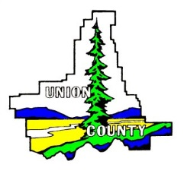

UNION COUNTY

B2H Advisory Committee
1001 4th Street, Suite C La Grande, OR 97850 PHONE (541)963-1014 FAX (541)963-1039 TTY 1-800-735-1232

Scott Hartell, Planning Director

B2H ADVISORY COMMITTEE
DRAFT A G E N D A

REGULAR SESSION, October 6th, 2016 6:30 P.M. Misener Conference Room 1001 Fourth St., La Grande Oregon

I. Call to Order

II. Approval of Agenda

III. Approval of previous Minutes- July 28, 2016

IV. Staff Report & Committee Member Updates

V. Public Comment Period

VI. Old Business
A. Process for considering Public Comments
B. Motion on B2H Costs & Electricity rates impacts (tabled)
C. Commissioners August 4, 2016 Letter to BLM
D. Follow up on two Motions sent to the County Commissioners from last meeting
E. Status of Final EIS

VII. New Business

VIII. Public Comment Period

X. Set Next Meeting Date

XI. Adjourn

Purpose of the Committee
1. Gather citizen concerns and comments regarding the B2H Transmission Line.
2. Develop an understanding of the evaluation criteria to be considered by BLM and ODOE.
3. Develop suggested comments based on citizen input and evaluation criteria.
4. Present suggested comments to the Board of Commissioners for potential submission to the BLM and ODOE.

