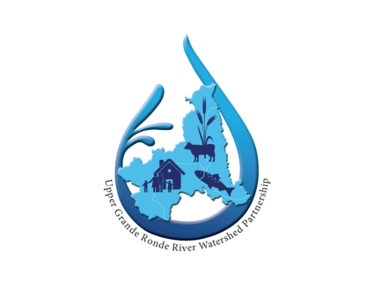
Upper Grande Ronde River Watershed Partnership
Place-Based Integrated Water Resources Planning
Quarterly Implementation Meeting
Conference Call/Misener Room
June 7, 2023 (4pm to 6pm)

- Welcome (10 minutes) (Donna)
  - Introductions
  - Meeting Guidelines Review

- Organizational Updates (15 minutes) (Donna)
  - Open to anyone that would like to 1) share relevant updates from your organization related to place-based planning or 2) make any requests to the group

- Strategy Group Updates/Action Items (90 minutes)
  - Project Management
    - OWRD and ARPA Grant update (Dana)
    - Other Grants (Joe)
    - Legislative update (Alexandria and Donna)
  - Outreach
    - Union County Crops and Conservation Tour (June 27) (Darrin)
    - Any upcoming events we should participate in?
  - Municipal – N/A
  - Administrative – N/A
  - Infrastructure
    - BOR hydraulic study update (Jim)
  - Public Land
    - Field Trip Debrief (Dana)
  - Habitat
    - OWEB SAP development (Dana)
  - Data
    - Instream Demand Calculation Meeting Summary (Dana)
    - IFIM study update – Catherine Creek (Janna/Anton) and Grande Ronde (Dana)
  - Agricultural Land
    - Locally led voluntary floodplain easement concept (Nick)
    - Frequently flooded areas – potential tour? (Curt)
  - Built Storage
    - OWRD White Paper about Storage Requirements (Alexandria)
    - Update on flow calculations for top four sites (Dana)
    - Kaizen Meeting Summary March 15 (Dana)
- Conclusion (5 minutes) (Donna)
  - Next Quarterly meetings tentatively scheduled for September 6, 2023 and December 6, 2023 Misener Room (4-6)

